**IFT 530 Advanced Database Management Systems**

**Professor Robert Rucker**

**Written Document of Project**

**Project – Syllabus Generator**

**Trilok Navya Dubaka**

**Synopsis**

The proposed Syllabus Generator system is department centric and is intended to have least susceptibility to errors and mismanagements. Phase 1 of the project is developed using NORMA. The seven stages of Conceptual Schema Design Procedure are implemented, and corresponding SQL code is created. Stored procedures and triggers are defined. Data is loaded into the tables. After integration of all these the final database is created.

In ORM diagram, the subtypes are added. Course can be of type – iCourse and Inperson

Each course have two syllabus – Fall and Spring

Additionally, details of the professor like name, professor ID, phone number, syllabus. The ID of professors’ are added as mandatorily unique so that data redundancy can be reduced.

A database is information that is set up for easy access, management and updating. Databases are used for storing, maintaining and accessing any sort of data. Information is gathered in one place so that it can be observed and analyzed. Databases can be thought of as an organized collection of information. We have used SQL Server Management Studio to create syllabus generator database and added the data to the tables. Also, we have represented Entity Relation diagram and executed queries against the data in SSMS.

We used Couchbase-NoSQL for implementing the Syllabus Generator database in JSON format. Here we created new buckets and inserted the data same as the SQL database but with a JSON file tables. NOSQL databases are classified according to their data model. Document, key-value, wide-column and graph are the most common types. NoSQL databases don't require a predetermined schema, you can interact with "unstructured data" more freely. The JSON stores semi-structured data: objects which contain their own relevant information sets that can be completely different from each other.

**Section 1**

**Introduction and Importance**

Syllabus Generator is a tool that generates and maintains the Syllabus of the courses in a university. It is a useful application for the instructors in the university to add, update or modify the existing syllabus under the supervision of Program Chair. Syllabus Generator is powerful, flexible, and easy to use and is designed and developed to provide real conceivable benefits to the university instructors.

The Project Syllabus Generator is based on SQL Database. SQL Server easily integrate data into applications and takes advantage of a broad set of cognitive services to leverage the potential of newly developing applications.

The purpose of this project is to automate the house keeping task of the professor which is updating or keeping track of the syllabus on day-to-day basis. Instructor can access the textbooks needed for the course as we have added Textbook table which stores the relevant textbooks of the courses. Syllabus generator provides the instructor to update the syllabus for the professor at any point in time and program chair is always aware of the changes that are being made to the syllabus by the professor.

In the traditional way, professor maintains the hardcopies of the syllabus for a class and then seek the approval to update the syllabus manually from the program chair and get the syllabus updated.

It was a manual task to maintain the text books and keep track of the topics in the current syllabus.

Some times when the syllabi have many topics professor might overlook a few topics.

After conduction a thorough research, we understood that Syllabus Generator concept is a ubiquitous concept. As we decided to develop a database system for professor for syllabus management, we have worked on identifying the entities and the relationships between them so that a meaningful and strong structure can be provided for the system without any flaws. The importance of ORM is understood in this activity. As we have practised using NORMA during our lab activities in the coursework and have implemented the same in this Syllabus Generator project.

The relational view gave us a good understanding of joins between the tables. Moreover, we have implemented our SQL queries by having the complete knowledge of joins, stored procedures, triggers and user-defined functions.

**Main Idea and Background:**

Syllabus Generator includes profile creation for the professors, storing their contacts details of the professors, textbooks required for the course, details for the program chair, existing syllabus.

The software is facilitated to assign a unique id to the department, program chair, course. Software includes the semester wise information ie., the course schedule for the in-person class and the icourse (offline course) and the semester wise schedule example - fall semester, spring semester and summer semester.

Syllabus Generator is designed for the universities to cover admin task of the course instructors and management process of the Syllabus for every course every semester. It is integrated end-to-end Syllabus management system that provides relevant information across the university to support effective decision making for carefully handcrafted syllabus for the students for their seamless academic success.

This software will help the university to be more efficient in handling the monotonous task of the professor and program chair. The purpose of the project is to give a complete requirement, documentation, design and implementation of the software.

Syllabus generator is a smart system designed to increase the quality of administrative services provided to department staff in a university. Recent attempts have been made to design and build a user-friendly and dependable database system to meet the needs of the department staff but this house keeping task of course instructors had been remained unexplored.

Database systems are required by all large businesses in order to manage information. Universities are one of them.

Data processing becomes more important in university courses due to large intake of the students and faculty members each year. In a university, program chair will have access to the syllabus and department. When ever professor add, update or modify the existing syllabus for a course, the program chair gets a notification that he/she would need to review and approve, decline or suggest modifications to the syllabus.

Once the Syllabus is approved by the program Chair the final Syllabus will be posted and the updated syllabus can be generated at any point in time by the professor. Finally, the same syllabus will be provided to the students.

**Jobflow**

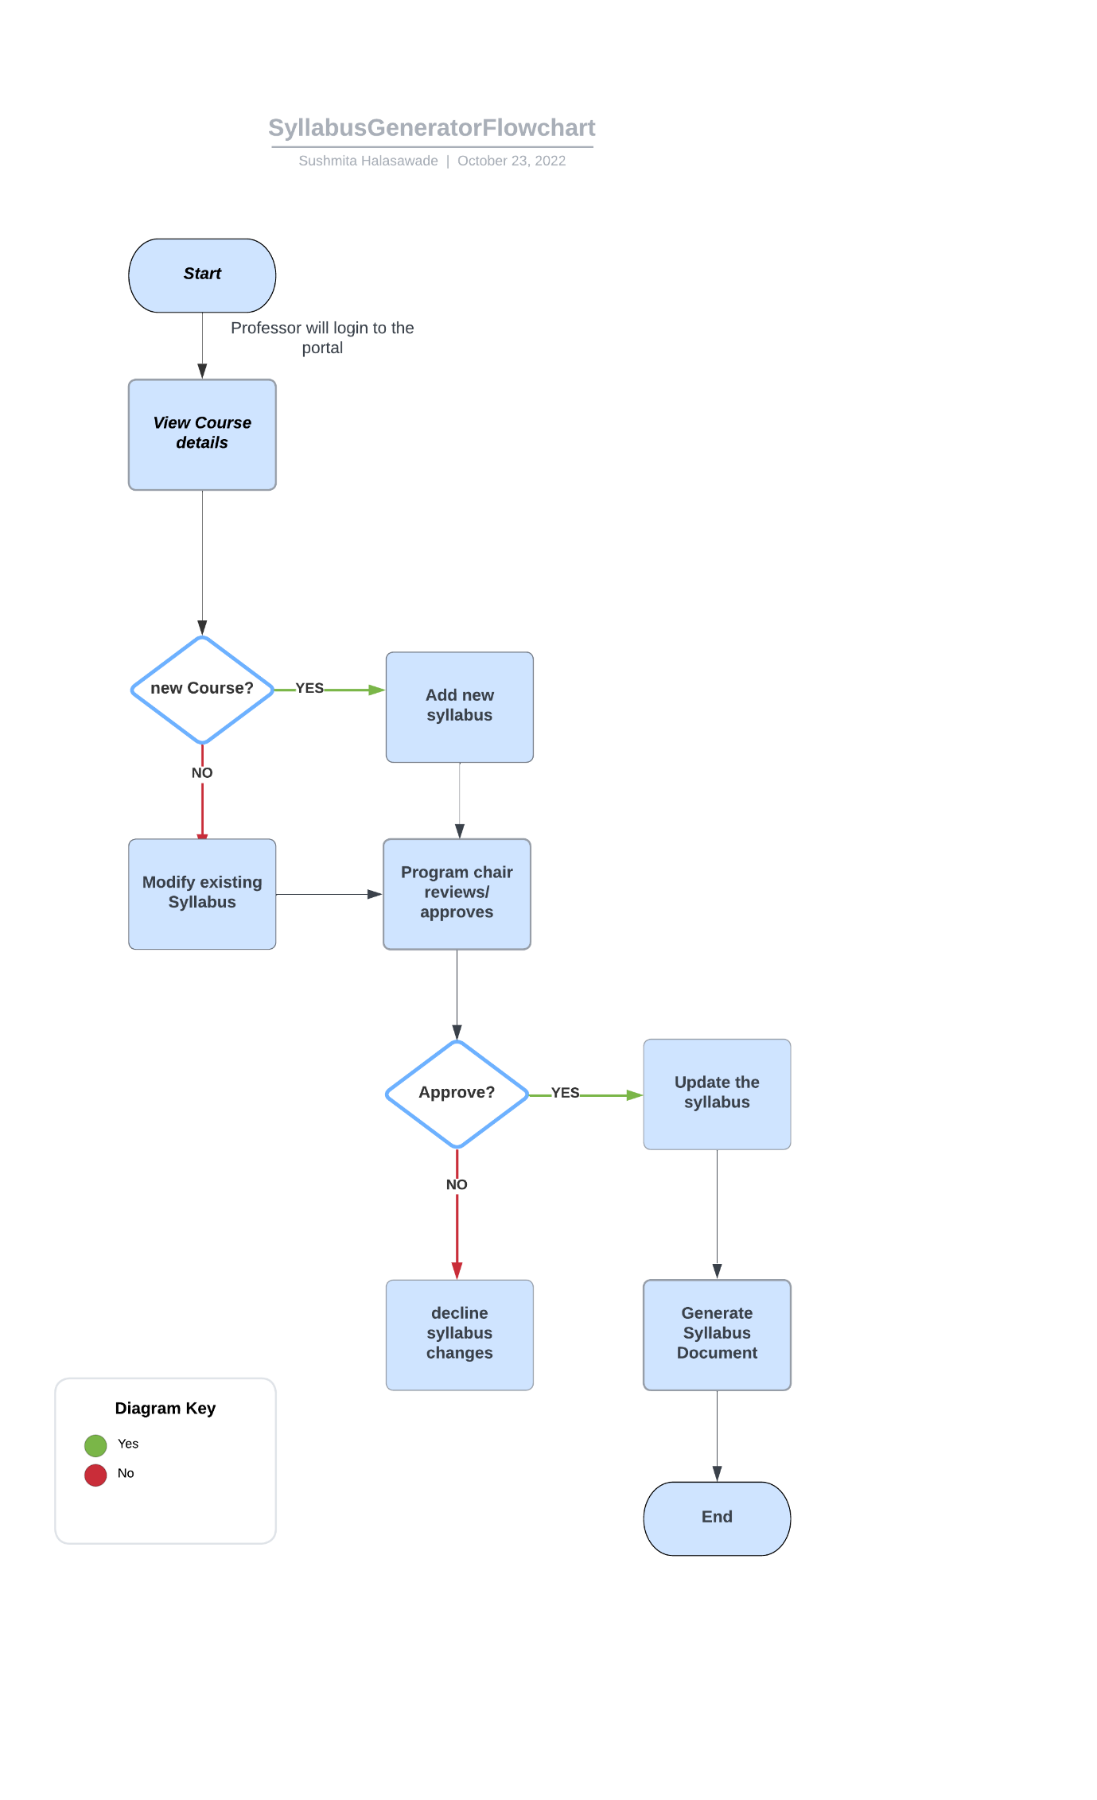

**Database Description**

**Entities and Attributes:**

**1.Department Table**

This entity represents the departments present in the university. Attributes of this entity are given below –

**Attributes and its datatypes**

DepartmentID: It is the primary key of the entity. It is a unique identifier and distinct from other departments in the university. Datatype is int.

DepartmentName: Every Department will have a name. This attribute stores the name of the department. Datatype is varchar.

DepartmentCode: Every Department will have a department code. This attribute stores the unique code of the department. Datatype is varchar.

**2. Program Chair**

Program Chair entity stores the details of the program chair. Attributes of this entity are given below –

ProgramChairID: This attribute holds the ID of the program chair.

DepartmentID: This attribute holds the ID of the Department.

Name: This attribute holds the name of the Program Chair

EmailID: This attribute holds the values for the email ID of the program chair

**3. Professor Table**

This table is for storing the details of the professor. Attributes of this table are given below –

Professor ID: This is the unique ID of the professor. It is the primary key in this table

DepartmentID: This is the foreign key. This is the primary key in Department table.

Name: This column holds the values for professor name. Datatype is varchar

EmailID: This column holds the values for professor’s emailID. Datatype is varchar

ContactNumber: This is to store the contact number of the professor. Datatype is int.

**4. TextBook Table**

TextBook entity stores the details about the textbooks that professor can refer to design the syllabus for the class. Attributes of this entity are given below –

TextBookID: This attribute holds the values for TextBookID. Datatype is int. This is the primary key.

TextBookName: This attribute holds the values for TextBookName. Datatype is int.

Category: This attribute holds the value for domain of the text book. Datatype is varchar.

**5. Course Table**

This entity stores the information about the course details. Attributes of this entity are given below –

**Attributes and its datatypes**

CourseID: It is the primary key of the entity. It is a unique identifier and distinct from other departments in the university. Datatype is int.

DepartmentID: It is the foreign key of the entity. This is the primary key in Department table.

CourseName: This attribute stores the values for name of the course

CourseType: This attribute stores the values for the type of the course i.e., icourse or the in-person course.

Professor ID: It is the foreign key of the entity. This is the primary key in the professors table. This attribute stores the unique id of the professor

**6. Syllabus Table**

This entity stores the stores the information about syllabus. Attributes of this entity are given below –

SyllabusID: Syallabus ID is the unique ID for syllabus. Datatype is int.

CourseID: CourseID is the foreign key for syllabus table. This is a unique id for course. This is the primary key in course table. Datatype is int.

ProfessorID: It is the foreign key of the entity. This is the primary key in the professor table. This column stores the unique id of the professor. Datatype is int.

Semester: This attribute stores the values whether the semester is the fall semester or spring semester. Datatype is varchar.

LearningObjective: This attribute stores the values for Learning Objectives or value addition to the students by taking the course. Datatype is varchar.

Prerequisite: This attribute stores the values for prerequisites to take a particular course. Datatype is varchar.

TextBookID: This attribute stores the TextBook ID. Datatype is int. It is a foreign key. It is the primary key in TextBook Table

**7. Course Schedule**

This Course Schedule entity stores the details of the course schedule. Attributes of this entity are given below –

CourseScheduleID: This attribute holds the values for Course Schedule ID. This is the primary key in this entity. Datatype is int.

Syllabus ID : This attribute holds the values for Syllabus ID. This is the primary key in this entity. Datatype is int.

Course ID: This attribute holds the values for Course ID. This is the foreign key in this entity. Datatype is int.

Module: This attribute holds the values for the module name. Datatype is varchar.

CourseContent: This attribute holds the information about the course content. Datatype is varchar.

StartDate: This holds the values for the start date of the semester. Datatype is date.

EndDate: This holds the values for the end date of the semester. Datatype is date.

**8. SyllabusAudit Table**

This table is to store the syllabus that is deleted by the professor.

**Questions**

1. How to retrieve the Current Department Details
2. How to retrieve department wise Course Program Chair, Professor Details
3. How to retrieve the Professor name of Professor teaching particular course
4. How to retrieve Professor and program chair contact details
5. How to retrieve Course/Department Textbook list
6. How to retrieve start and end date of the semester

**Triggers and Stored Procedures**

**Trigger**

Delete Trigger to log the data/syllabus that is deleted by the professor.

Update Trigger – On updating the syllabus table, it will add entry in SyllabusAudit table with remark of updated field.

**Stored Procedure**

spFetchCourses - Stored procedure to fetch all courses of professor

spFetchSyllabusDetails - Stored procedure to fetch Syllabus details of course taught by professor

spInsertorUpdateSyllabus - Stored Procedure to insert or update the syllabus

spDeleteSyllabus - Stored Procedure to delete complete syllabus

**User defined functions –**

fnGettextbookdetails - Function to get textbook requirements of course

fnGetPrerequisite - Function to get prerequisite course list of course

**Section 2**

Object Role Modeling more semantically expressive than all other conceptual modeling languages in existence today.

ORM diagrams are more semantically verbose, it is easy to translate ORM diagrams into other diagrams.

It is easy to map an injection or surjection from ORM to other modeling languages and it is likely not possible with the others.

The following ORM Diagram represents the Syllabus Generator model which includes the entity types. ORM Diagrams are used to depict the relationships between objects in a database. Through notions like objects and roles, ORM Diagrams provide a conceptual approach to database modeling.

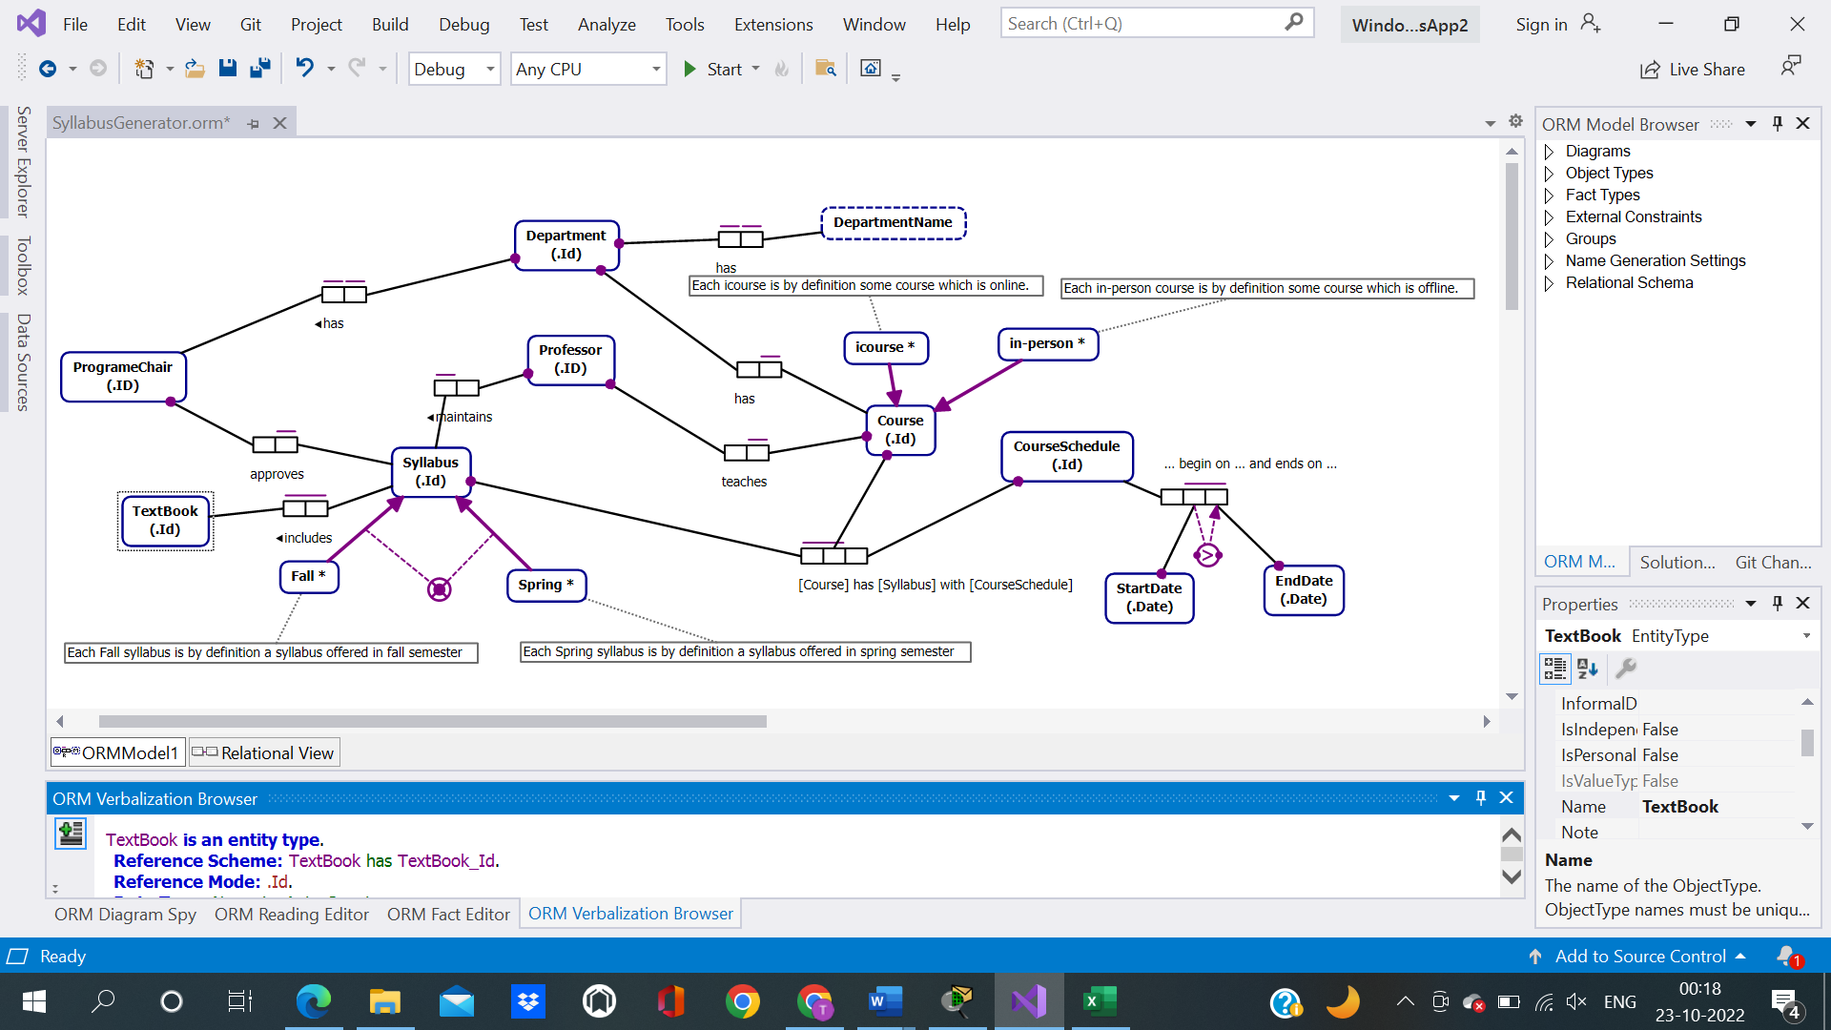

1. Seven Entities that exist include Department, Course, Syllabus, Professor, Program Chair, Course Schedule, TextBook

2. One Many to Many Relationship exists between TextBook and Syllabus as one text book can be referred for more than one course syllabus and vice versa.

3. Two Ternary relations defined can be verbalized as follows:

a. Syllabus has a course Schedule that begin on start date and end on end date.

b. Every Course has a syllabus with defined course schedule

4. Two subtypes defined include:

a. Course can be of type – iCourse or Inperson

b. Each course will have two Syllabus – Fall and Spring

**Verbalization**

[DepartmentName](elementid:0a1411e4-4ab9-4faf-af83-0e98b93dcb80) **is a value type**.  
**Data Type:** Text: Variable Length (0).  
  
**Fact Types:**  
[Department](elementid:65ed20c3-29de-46e5-ba9e-b4122522aa0f) [has](elementid:a939528c-19b6-4b09-a0c9-ec6dbbd6567c) [DepartmentName.](elementid:0a1411e4-4ab9-4faf-af83-0e98b93dcb80)

[Department](elementid:65ed20c3-29de-46e5-ba9e-b4122522aa0f) [has](elementid:a939528c-19b6-4b09-a0c9-ec6dbbd6567c) [DepartmentName.](elementid:0a1411e4-4ab9-4faf-af83-0e98b93dcb80)  
**Each** [Department](elementid:65ed20c3-29de-46e5-ba9e-b4122522aa0f) [has](elementid:a939528c-19b6-4b09-a0c9-ec6dbbd6567c) **exactly one** [DepartmentName.](elementid:0a1411e4-4ab9-4faf-af83-0e98b93dcb80)  
**For each** [DepartmentName](elementid:0a1411e4-4ab9-4faf-af83-0e98b93dcb80), **at most one** [Department](elementid:65ed20c3-29de-46e5-ba9e-b4122522aa0f) [has](elementid:a939528c-19b6-4b09-a0c9-ec6dbbd6567c) **that** [DepartmentName.](elementid:0a1411e4-4ab9-4faf-af83-0e98b93dcb80)

[Course](elementid:bb7575d9-1e2e-4e5b-af6f-fabe6937e94e) **is an entity type**.  
**Reference Scheme:** [Course](elementid:bb7575d9-1e2e-4e5b-af6f-fabe6937e94e) [has](elementid:fdec4665-79b2-4250-a51c-d9172d989a19) [Course_Id.](elementid:a13c2554-4f58-4816-93f1-b8a3da2ec859)  
**Reference Mode:** .Id.  
**Data Type:** Numeric: Auto Counter.  
  
**Fact Types:**  
[Course](elementid:bb7575d9-1e2e-4e5b-af6f-fabe6937e94e) [has](elementid:fdec4665-79b2-4250-a51c-d9172d989a19) [Course_Id.](elementid:a13c2554-4f58-4816-93f1-b8a3da2ec859)  
[Department](elementid:65ed20c3-29de-46e5-ba9e-b4122522aa0f) [has](elementid:a39efa6b-bee4-4b8e-8543-1d0153e5388a) [Course.](elementid:bb7575d9-1e2e-4e5b-af6f-fabe6937e94e)  
[Professor](elementid:5f4a2f81-f92f-4764-a638-a187bac0caf3) [teaches](elementid:e3ae861f-935a-4495-9182-e5d323056e24) [Course.](elementid:bb7575d9-1e2e-4e5b-af6f-fabe6937e94e)  
[Course](elementid:bb7575d9-1e2e-4e5b-af6f-fabe6937e94e) [has](elementid:e6ebcffa-c9a3-4901-b894-55a18966cea8) [Syllabus](elementid:d76695ef-77f2-4120-881f-73bd6efa505c) [with](elementid:e6ebcffa-c9a3-4901-b894-55a18966cea8) [CourseSchedule.](elementid:d5d1af7a-7899-4308-835a-6ca42429628e)  
**Each** [icourse](elementid:0d3adb17-672e-406a-9328-9b689722076c) [is an instance of](elementid:0a7eb1aa-ca40-41fa-9bc5-ec13497c97b8) [Course.](elementid:bb7575d9-1e2e-4e5b-af6f-fabe6937e94e)  
**Each** [in-person](elementid:52602410-6652-4892-ae7b-eb2df18e6ccd) [is an instance of](elementid:a1ef5d85-7215-4ec0-8b85-7e72bd186134) [Course.](elementid:bb7575d9-1e2e-4e5b-af6f-fabe6937e94e)

[Department](elementid:65ed20c3-29de-46e5-ba9e-b4122522aa0f) [has](elementid:a39efa6b-bee4-4b8e-8543-1d0153e5388a) [Course.](elementid:bb7575d9-1e2e-4e5b-af6f-fabe6937e94e)  
**Each** [Department](elementid:65ed20c3-29de-46e5-ba9e-b4122522aa0f) [has](elementid:a39efa6b-bee4-4b8e-8543-1d0153e5388a) **some** [Course.](elementid:bb7575d9-1e2e-4e5b-af6f-fabe6937e94e)  
**For each** [Course](elementid:bb7575d9-1e2e-4e5b-af6f-fabe6937e94e), **at most one** [Department](elementid:65ed20c3-29de-46e5-ba9e-b4122522aa0f) [has](elementid:a39efa6b-bee4-4b8e-8543-1d0153e5388a) **that** [Course.](elementid:bb7575d9-1e2e-4e5b-af6f-fabe6937e94e)  
**It is possible that** **some** [Department](elementid:65ed20c3-29de-46e5-ba9e-b4122522aa0f) [has](elementid:a39efa6b-bee4-4b8e-8543-1d0153e5388a) **more than one** [Course.](elementid:bb7575d9-1e2e-4e5b-af6f-fabe6937e94e)

[ProgrameChair](elementid:7c5408c4-a018-456b-8d1b-be8fe4a1d2dd) **is an entity type**.  
**Reference Scheme:** [ProgrameChair](elementid:7c5408c4-a018-456b-8d1b-be8fe4a1d2dd) [has](elementid:273d3eac-9868-4df7-bc0a-7d01a87847cd) [ProgrameChair_ID.](elementid:e04a0921-4dda-428c-93ed-8c037519ffc5)  
**Reference Mode:** .ID.  
**Data Type:** Numeric: Auto Counter.  
  
**Fact Types:**  
[ProgrameChair](elementid:7c5408c4-a018-456b-8d1b-be8fe4a1d2dd) [has](elementid:273d3eac-9868-4df7-bc0a-7d01a87847cd) [ProgrameChair_ID.](elementid:e04a0921-4dda-428c-93ed-8c037519ffc5)  
[Department](elementid:65ed20c3-29de-46e5-ba9e-b4122522aa0f) [has](elementid:e1edf1d9-b06c-4e70-bb1c-7b5f97982c1e) [ProgrameChair.](elementid:7c5408c4-a018-456b-8d1b-be8fe4a1d2dd)  
[ProgrameChair](elementid:7c5408c4-a018-456b-8d1b-be8fe4a1d2dd) [approves](elementid:ac409c47-bd26-414d-8905-197c6f680205) [Syllabus.](elementid:d76695ef-77f2-4120-881f-73bd6efa505c)

[Department](elementid:65ed20c3-29de-46e5-ba9e-b4122522aa0f) [has](elementid:e1edf1d9-b06c-4e70-bb1c-7b5f97982c1e) [ProgrameChair.](elementid:7c5408c4-a018-456b-8d1b-be8fe4a1d2dd)  
**Each** [Department](elementid:65ed20c3-29de-46e5-ba9e-b4122522aa0f) [has](elementid:e1edf1d9-b06c-4e70-bb1c-7b5f97982c1e) **exactly one** [ProgrameChair.](elementid:7c5408c4-a018-456b-8d1b-be8fe4a1d2dd)  
**For each** [ProgrameChair](elementid:7c5408c4-a018-456b-8d1b-be8fe4a1d2dd), **at most one** [Department](elementid:65ed20c3-29de-46e5-ba9e-b4122522aa0f) [has](elementid:e1edf1d9-b06c-4e70-bb1c-7b5f97982c1e) **that** [ProgrameChair.](elementid:7c5408c4-a018-456b-8d1b-be8fe4a1d2dd)

[Professor](elementid:5f4a2f81-f92f-4764-a638-a187bac0caf3) **is an entity type**.  
**Reference Scheme:** [Professor](elementid:5f4a2f81-f92f-4764-a638-a187bac0caf3) [has](elementid:970e21fd-f729-43d8-a231-0802a6b55b85) [Professor_ID.](elementid:20fa6c5b-692f-40de-9eb2-157ef10e47a2)  
**Reference Mode:** .ID.  
**Data Type:** Numeric: Auto Counter.  
  
**Fact Types:**  
[Professor](elementid:5f4a2f81-f92f-4764-a638-a187bac0caf3) [has](elementid:970e21fd-f729-43d8-a231-0802a6b55b85) [Professor_ID.](elementid:20fa6c5b-692f-40de-9eb2-157ef10e47a2)  
[Professor](elementid:5f4a2f81-f92f-4764-a638-a187bac0caf3) [teaches](elementid:e3ae861f-935a-4495-9182-e5d323056e24) [Course.](elementid:bb7575d9-1e2e-4e5b-af6f-fabe6937e94e)  
[Professor](elementid:5f4a2f81-f92f-4764-a638-a187bac0caf3) [maintains](elementid:d2d17b9b-f79c-4443-a5e4-25e998f22426) [Syllabus.](elementid:d76695ef-77f2-4120-881f-73bd6efa505c)

[Professor](elementid:5f4a2f81-f92f-4764-a638-a187bac0caf3) [teaches](elementid:e3ae861f-935a-4495-9182-e5d323056e24) [Course.](elementid:bb7575d9-1e2e-4e5b-af6f-fabe6937e94e)  
**Each** [Professor](elementid:5f4a2f81-f92f-4764-a638-a187bac0caf3) [teaches](elementid:e3ae861f-935a-4495-9182-e5d323056e24) **some** [Course.](elementid:bb7575d9-1e2e-4e5b-af6f-fabe6937e94e)  
**For each** [Course](elementid:bb7575d9-1e2e-4e5b-af6f-fabe6937e94e), **exactly one** [Professor](elementid:5f4a2f81-f92f-4764-a638-a187bac0caf3) [teaches](elementid:e3ae861f-935a-4495-9182-e5d323056e24) **that** [Course.](elementid:bb7575d9-1e2e-4e5b-af6f-fabe6937e94e)  
**It is possible that** **some** [Professor](elementid:5f4a2f81-f92f-4764-a638-a187bac0caf3) [teaches](elementid:e3ae861f-935a-4495-9182-e5d323056e24) **more than one** [Course.](elementid:bb7575d9-1e2e-4e5b-af6f-fabe6937e94e)

[Syllabus](elementid:d76695ef-77f2-4120-881f-73bd6efa505c) **is an entity type**.  
**Reference Scheme:** [Syllabus](elementid:d76695ef-77f2-4120-881f-73bd6efa505c) [has](elementid:ae7f7343-8548-4982-bc4c-b6db42cc6b69) [Syllabus_Id.](elementid:358d1fa2-154f-49a5-aa7f-5e50c96a471e)  
**Reference Mode:** .Id.  
**Data Type:** Numeric: Auto Counter.  
  
**Fact Types:**  
[Syllabus](elementid:d76695ef-77f2-4120-881f-73bd6efa505c) [has](elementid:ae7f7343-8548-4982-bc4c-b6db42cc6b69) [Syllabus_Id.](elementid:358d1fa2-154f-49a5-aa7f-5e50c96a471e)  
[Course](elementid:bb7575d9-1e2e-4e5b-af6f-fabe6937e94e) [has](elementid:e6ebcffa-c9a3-4901-b894-55a18966cea8) [Syllabus](elementid:d76695ef-77f2-4120-881f-73bd6efa505c) [with](elementid:e6ebcffa-c9a3-4901-b894-55a18966cea8) [CourseSchedule.](elementid:d5d1af7a-7899-4308-835a-6ca42429628e)  
[Professor](elementid:5f4a2f81-f92f-4764-a638-a187bac0caf3) [maintains](elementid:d2d17b9b-f79c-4443-a5e4-25e998f22426) [Syllabus.](elementid:d76695ef-77f2-4120-881f-73bd6efa505c)  
[ProgrameChair](elementid:7c5408c4-a018-456b-8d1b-be8fe4a1d2dd) [approves](elementid:ac409c47-bd26-414d-8905-197c6f680205) [Syllabus.](elementid:d76695ef-77f2-4120-881f-73bd6efa505c)  
**Each** [Fall](elementid:86b613aa-c4ad-480c-9f49-76d2dff2c5cb) [is an instance of](elementid:56783c43-2124-4255-a3e3-bc0ce972c54e) [Syllabus.](elementid:d76695ef-77f2-4120-881f-73bd6efa505c)  
**Each** [Spring](elementid:d5447188-db09-4a73-98e5-9757c60576a7) [is an instance of](elementid:eca131e0-4db2-440f-a1b3-2ec1ccf32d5f) [Syllabus.](elementid:d76695ef-77f2-4120-881f-73bd6efa505c)  
[Syllabus](elementid:d76695ef-77f2-4120-881f-73bd6efa505c) [includes](elementid:4939d337-b30a-4bd8-a5a6-f2af7c258576) [TextBook.](elementid:da30caaa-6b06-4239-9f10-3449635d5a83)

[CourseSchedule](elementid:d5d1af7a-7899-4308-835a-6ca42429628e) **is an entity type**.  
**Reference Scheme:** [CourseSchedule](elementid:d5d1af7a-7899-4308-835a-6ca42429628e) [has](elementid:0bd21e02-ed79-4f61-b436-c25e50e087dc) [CourseSchedule_Id.](elementid:d4f4f037-3cbf-4eaa-a404-883d694a89fc)  
**Reference Mode:** .Id.  
**Data Type:** Numeric: Auto Counter.  
  
**Fact Types:**  
[CourseSchedule](elementid:d5d1af7a-7899-4308-835a-6ca42429628e) [has](elementid:0bd21e02-ed79-4f61-b436-c25e50e087dc) [CourseSchedule_Id.](elementid:d4f4f037-3cbf-4eaa-a404-883d694a89fc)  
[Course](elementid:bb7575d9-1e2e-4e5b-af6f-fabe6937e94e) [has](elementid:e6ebcffa-c9a3-4901-b894-55a18966cea8) [Syllabus](elementid:d76695ef-77f2-4120-881f-73bd6efa505c) [with](elementid:e6ebcffa-c9a3-4901-b894-55a18966cea8) [CourseSchedule.](elementid:d5d1af7a-7899-4308-835a-6ca42429628e)  
[CourseSchedule](elementid:d5d1af7a-7899-4308-835a-6ca42429628e) [begin on](elementid:cadbdd57-d483-4aaf-8fb1-56df6955a402) [StartDate](elementid:bf902b84-fd1c-4be7-aec4-96d29a518f0b) [and ends on](elementid:cadbdd57-d483-4aaf-8fb1-56df6955a402) [EndDate.](elementid:c6d611c6-679b-4c6f-9954-b246ebf490c5)

[Course](elementid:bb7575d9-1e2e-4e5b-af6f-fabe6937e94e) [has](elementid:e6ebcffa-c9a3-4901-b894-55a18966cea8) [Syllabus](elementid:d76695ef-77f2-4120-881f-73bd6efa505c) [with](elementid:e6ebcffa-c9a3-4901-b894-55a18966cea8) [CourseSchedule.](elementid:d5d1af7a-7899-4308-835a-6ca42429628e)  
**For each** [Course](elementid:bb7575d9-1e2e-4e5b-af6f-fabe6937e94e) **and** [Syllabus](elementid:d76695ef-77f2-4120-881f-73bd6efa505c),  
**that** [Course](elementid:bb7575d9-1e2e-4e5b-af6f-fabe6937e94e) [has](elementid:e6ebcffa-c9a3-4901-b894-55a18966cea8) **that** [Syllabus](elementid:d76695ef-77f2-4120-881f-73bd6efa505c) [with](elementid:e6ebcffa-c9a3-4901-b894-55a18966cea8) **at most one** [CourseSchedule.](elementid:d5d1af7a-7899-4308-835a-6ca42429628e)  
**This association with** [Course](elementid:bb7575d9-1e2e-4e5b-af6f-fabe6937e94e), [Syllabus](elementid:d76695ef-77f2-4120-881f-73bd6efa505c) **provides the preferred identification scheme for** [CourseHasSyllabusWithCourseSchedule.](elementid:eeebd45f-6264-4205-a221-84684a2046d6)  
**For each** [CourseSchedule](elementid:d5d1af7a-7899-4308-835a-6ca42429628e),  
**some** [Course](elementid:bb7575d9-1e2e-4e5b-af6f-fabe6937e94e) [has](elementid:e6ebcffa-c9a3-4901-b894-55a18966cea8) **some** [Syllabus](elementid:d76695ef-77f2-4120-881f-73bd6efa505c) [with](elementid:e6ebcffa-c9a3-4901-b894-55a18966cea8) **that** [CourseSchedule.](elementid:d5d1af7a-7899-4308-835a-6ca42429628e)  
**For each** [Syllabus](elementid:d76695ef-77f2-4120-881f-73bd6efa505c),  
**some** [Course](elementid:bb7575d9-1e2e-4e5b-af6f-fabe6937e94e) [has](elementid:e6ebcffa-c9a3-4901-b894-55a18966cea8) **that** [Syllabus](elementid:d76695ef-77f2-4120-881f-73bd6efa505c) [with](elementid:e6ebcffa-c9a3-4901-b894-55a18966cea8) **some** [CourseSchedule.](elementid:d5d1af7a-7899-4308-835a-6ca42429628e)  
**Each** [Course](elementid:bb7575d9-1e2e-4e5b-af6f-fabe6937e94e) [has](elementid:e6ebcffa-c9a3-4901-b894-55a18966cea8) **some** [Syllabus](elementid:d76695ef-77f2-4120-881f-73bd6efa505c) [with](elementid:e6ebcffa-c9a3-4901-b894-55a18966cea8) **some** [CourseSchedule.](elementid:d5d1af7a-7899-4308-835a-6ca42429628e)

[Professor](elementid:5f4a2f81-f92f-4764-a638-a187bac0caf3) [maintains](elementid:d2d17b9b-f79c-4443-a5e4-25e998f22426) [Syllabus.](elementid:d76695ef-77f2-4120-881f-73bd6efa505c)  
**Each** [Professor](elementid:5f4a2f81-f92f-4764-a638-a187bac0caf3) [maintains](elementid:d2d17b9b-f79c-4443-a5e4-25e998f22426) **some** [Syllabus.](elementid:d76695ef-77f2-4120-881f-73bd6efa505c)  
**For each** [Syllabus](elementid:d76695ef-77f2-4120-881f-73bd6efa505c), **at most one** [Professor](elementid:5f4a2f81-f92f-4764-a638-a187bac0caf3) [maintains](elementid:d2d17b9b-f79c-4443-a5e4-25e998f22426) **that** [Syllabus.](elementid:d76695ef-77f2-4120-881f-73bd6efa505c)  
**It is possible that** **some** [Professor](elementid:5f4a2f81-f92f-4764-a638-a187bac0caf3) [maintains](elementid:d2d17b9b-f79c-4443-a5e4-25e998f22426) **more than one** [Syllabus.](elementid:d76695ef-77f2-4120-881f-73bd6efa505c)

[ProgrameChair](elementid:7c5408c4-a018-456b-8d1b-be8fe4a1d2dd) [approves](elementid:ac409c47-bd26-414d-8905-197c6f680205) [Syllabus.](elementid:d76695ef-77f2-4120-881f-73bd6efa505c)  
**Each** [ProgrameChair](elementid:7c5408c4-a018-456b-8d1b-be8fe4a1d2dd) [approves](elementid:ac409c47-bd26-414d-8905-197c6f680205) **some** [Syllabus.](elementid:d76695ef-77f2-4120-881f-73bd6efa505c)  
**For each** [Syllabus](elementid:d76695ef-77f2-4120-881f-73bd6efa505c), **at most one** [ProgrameChair](elementid:7c5408c4-a018-456b-8d1b-be8fe4a1d2dd) [approves](elementid:ac409c47-bd26-414d-8905-197c6f680205) **that** [Syllabus.](elementid:d76695ef-77f2-4120-881f-73bd6efa505c)  
**It is possible that** **some** [ProgrameChair](elementid:7c5408c4-a018-456b-8d1b-be8fe4a1d2dd) [approves](elementid:ac409c47-bd26-414d-8905-197c6f680205) **more than one** [Syllabus.](elementid:d76695ef-77f2-4120-881f-73bd6efa505c)

[Icourse](elementid:0d3adb17-672e-406a-9328-9b689722076c) **is an entity type**.  
**Reference Scheme:** [Course](elementid:bb7575d9-1e2e-4e5b-af6f-fabe6937e94e) [has](elementid:fdec4665-79b2-4250-a51c-d9172d989a19) [Course_Id.](elementid:a13c2554-4f58-4816-93f1-b8a3da2ec859)  
**Reference Mode:** .Id.  
**Data Type:** Numeric: Auto Counter.  
  
**Fact Types:**  
**Each** [icourse](elementid:0d3adb17-672e-406a-9328-9b689722076c) [is an instance of](elementid:0a7eb1aa-ca40-41fa-9bc5-ec13497c97b8) [Course.](elementid:bb7575d9-1e2e-4e5b-af6f-fabe6937e94e)  
**Derivation Note:** *Each icourse is by definition some course which is online.*

[In-person](elementid:52602410-6652-4892-ae7b-eb2df18e6ccd) **is an entity type**.  
**Reference Scheme:** [Course](elementid:bb7575d9-1e2e-4e5b-af6f-fabe6937e94e) [has](elementid:fdec4665-79b2-4250-a51c-d9172d989a19) [Course_Id.](elementid:a13c2554-4f58-4816-93f1-b8a3da2ec859)  
**Reference Mode:** .Id.  
**Data Type:** Numeric: Auto Counter.  
  
**Fact Types:**  
**Each** [in-person](elementid:52602410-6652-4892-ae7b-eb2df18e6ccd) [is an instance of](elementid:a1ef5d85-7215-4ec0-8b85-7e72bd186134) [Course.](elementid:bb7575d9-1e2e-4e5b-af6f-fabe6937e94e)  
**Derivation Note:** *Each in-person course is by definition some course which is offline.*

**Notes:** *Each icourse is by definition some course which is online.*

**Notes:** *Each in-person course is by definition some course which is offline.*

[Fall](elementid:86b613aa-c4ad-480c-9f49-76d2dff2c5cb) **is an entity type**.  
**Reference Scheme:** [Syllabus](elementid:d76695ef-77f2-4120-881f-73bd6efa505c) [has](elementid:ae7f7343-8548-4982-bc4c-b6db42cc6b69) [Syllabus_Id.](elementid:358d1fa2-154f-49a5-aa7f-5e50c96a471e)  
**Reference Mode:** .Id.  
**Data Type:** Numeric: Auto Counter.  
  
**Fact Types:**  
**Each** [Fall](elementid:86b613aa-c4ad-480c-9f49-76d2dff2c5cb) [is an instance of](elementid:56783c43-2124-4255-a3e3-bc0ce972c54e) [Syllabus.](elementid:d76695ef-77f2-4120-881f-73bd6efa505c)  
**Derivation Note:** *Each Fall syllabus is by definition a syllabus offered in fall semester.*

[Spring](elementid:d5447188-db09-4a73-98e5-9757c60576a7) **is an entity type**.  
**Reference Scheme:** [Syllabus](elementid:d76695ef-77f2-4120-881f-73bd6efa505c) [has](elementid:ae7f7343-8548-4982-bc4c-b6db42cc6b69) [Syllabus_Id.](elementid:358d1fa2-154f-49a5-aa7f-5e50c96a471e)  
**Reference Mode:** .Id.  
**Data Type:** Numeric: Auto Counter.  
  
**Fact Types:**  
**Each** [Spring](elementid:d5447188-db09-4a73-98e5-9757c60576a7) [is an instance of](elementid:eca131e0-4db2-440f-a1b3-2ec1ccf32d5f) [Syllabus.](elementid:d76695ef-77f2-4120-881f-73bd6efa505c)  
**Derivation Note:** *Each Spring syllabus is by definition a syllabus offered in spring semester.*

**Notes:** *Each Fall syllabus is by definition a syllabus offered in fall semester.*

**Notes:** *Each Spring syllabus is by definition a syllabus offered in spring semester.*

[StartDate](elementid:bf902b84-fd1c-4be7-aec4-96d29a518f0b) **is an entity type**.  
**Reference Scheme:** [StartDate](elementid:bf902b84-fd1c-4be7-aec4-96d29a518f0b) [has](elementid:12301861-d7ad-436c-ab28-5a5802a7e0ff) [StartDate_Date.](elementid:b615a99c-ddd0-4a9f-ab98-30b7b4cc5ff5)  
**Reference Mode:** .Date.  
**Data Type:** Temporal: Date.  
  
**Fact Types:**  
[StartDate](elementid:bf902b84-fd1c-4be7-aec4-96d29a518f0b) [has](elementid:12301861-d7ad-436c-ab28-5a5802a7e0ff) [StartDate_Date.](elementid:b615a99c-ddd0-4a9f-ab98-30b7b4cc5ff5)  
[CourseSchedule](elementid:d5d1af7a-7899-4308-835a-6ca42429628e) [begin on](elementid:cadbdd57-d483-4aaf-8fb1-56df6955a402) [StartDate](elementid:bf902b84-fd1c-4be7-aec4-96d29a518f0b) [and ends on](elementid:cadbdd57-d483-4aaf-8fb1-56df6955a402) [EndDate.](elementid:c6d611c6-679b-4c6f-9954-b246ebf490c5)

[EndDate](elementid:c6d611c6-679b-4c6f-9954-b246ebf490c5) **is an entity type**.  
**Reference Scheme:** [EndDate](elementid:c6d611c6-679b-4c6f-9954-b246ebf490c5) [has](elementid:41e0fbab-158e-44d8-80a7-1defcc917e3c) [EndDate_Date.](elementid:44b3e960-3baf-4326-a4c9-b5e9932d2de0)  
**Reference Mode:** .Date.  
**Data Type:** Temporal: Date.  
  
**Fact Types:**  
[EndDate](elementid:c6d611c6-679b-4c6f-9954-b246ebf490c5) [has](elementid:41e0fbab-158e-44d8-80a7-1defcc917e3c) [EndDate_Date.](elementid:44b3e960-3baf-4326-a4c9-b5e9932d2de0)  
[CourseSchedule](elementid:d5d1af7a-7899-4308-835a-6ca42429628e) [begin on](elementid:cadbdd57-d483-4aaf-8fb1-56df6955a402) [StartDate](elementid:bf902b84-fd1c-4be7-aec4-96d29a518f0b) [and ends on](elementid:cadbdd57-d483-4aaf-8fb1-56df6955a402) [EndDate.](elementid:c6d611c6-679b-4c6f-9954-b246ebf490c5)

[CourseSchedule](elementid:d5d1af7a-7899-4308-835a-6ca42429628e) [begin on](elementid:cadbdd57-d483-4aaf-8fb1-56df6955a402) [StartDate](elementid:bf902b84-fd1c-4be7-aec4-96d29a518f0b) [and ends on](elementid:cadbdd57-d483-4aaf-8fb1-56df6955a402) [EndDate.](elementid:c6d611c6-679b-4c6f-9954-b246ebf490c5)  
**For each** [StartDate](elementid:bf902b84-fd1c-4be7-aec4-96d29a518f0b),  
**some** [CourseSchedule](elementid:d5d1af7a-7899-4308-835a-6ca42429628e) [begin on](elementid:cadbdd57-d483-4aaf-8fb1-56df6955a402) **that** [StartDate](elementid:bf902b84-fd1c-4be7-aec4-96d29a518f0b) [and ends on](elementid:cadbdd57-d483-4aaf-8fb1-56df6955a402) **some** [EndDate.](elementid:c6d611c6-679b-4c6f-9954-b246ebf490c5)  
**For each** [EndDate](elementid:c6d611c6-679b-4c6f-9954-b246ebf490c5),  
**some** [CourseSchedule](elementid:d5d1af7a-7899-4308-835a-6ca42429628e) [begin on](elementid:cadbdd57-d483-4aaf-8fb1-56df6955a402) **some** [StartDate](elementid:bf902b84-fd1c-4be7-aec4-96d29a518f0b) [and ends on](elementid:cadbdd57-d483-4aaf-8fb1-56df6955a402) **that** [EndDate.](elementid:c6d611c6-679b-4c6f-9954-b246ebf490c5)  
**For each** [StartDate](elementid:bf902b84-fd1c-4be7-aec4-96d29a518f0b) **and** [EndDate](elementid:c6d611c6-679b-4c6f-9954-b246ebf490c5),  
**at most one** [CourseSchedule](elementid:d5d1af7a-7899-4308-835a-6ca42429628e) [begin on](elementid:cadbdd57-d483-4aaf-8fb1-56df6955a402) **that** [StartDate](elementid:bf902b84-fd1c-4be7-aec4-96d29a518f0b) [and ends on](elementid:cadbdd57-d483-4aaf-8fb1-56df6955a402) **that** [EndDate.](elementid:c6d611c6-679b-4c6f-9954-b246ebf490c5)  
**This association with** [StartDate](elementid:bf902b84-fd1c-4be7-aec4-96d29a518f0b), [EndDate](elementid:c6d611c6-679b-4c6f-9954-b246ebf490c5) **provides the preferred identification scheme for** [CourseScheduleBeginOnStartDateAndEndsOnEndDate.](elementid:d1b0d3aa-0bbe-41d5-b31c-07322c6bae4d)

**If some** [CourseSchedule](elementid:d5d1af7a-7899-4308-835a-6ca42429628e) [begin on](elementid:cadbdd57-d483-4aaf-8fb1-56df6955a402) [StartDate](elementid:bf902b84-fd1c-4be7-aec4-96d29a518f0b) [and ends on](elementid:cadbdd57-d483-4aaf-8fb1-56df6955a402) **some** [EndDate](elementid:c6d611c6-679b-4c6f-9954-b246ebf490c5)  
**then** [StartDate](elementid:bf902b84-fd1c-4be7-aec4-96d29a518f0b) **is greater than** [EndDate.](elementid:c6d611c6-679b-4c6f-9954-b246ebf490c5)

**For each** [Syllabus](elementid:d76695ef-77f2-4120-881f-73bd6efa505c), **exactly one of the following holds:**   
**that** [Syllabus](elementid:d76695ef-77f2-4120-881f-73bd6efa505c) [is](elementid:56783c43-2124-4255-a3e3-bc0ce972c54e) **some** [Fall](elementid:86b613aa-c4ad-480c-9f49-76d2dff2c5cb);   
**that** [Syllabus](elementid:d76695ef-77f2-4120-881f-73bd6efa505c) [is](elementid:eca131e0-4db2-440f-a1b3-2ec1ccf32d5f) **some** [Spring.](elementid:d5447188-db09-4a73-98e5-9757c60576a7)

[TextBook](elementid:da30caaa-6b06-4239-9f10-3449635d5a83) **is an entity type**.  
**Reference Scheme:** [TextBook](elementid:da30caaa-6b06-4239-9f10-3449635d5a83) [has](elementid:ad850ceb-3603-4747-8494-12a908b746b3) [TextBook_Id.](elementid:d334fce0-875a-46a8-a769-6b2daec9cb33)  
**Reference Mode:** .Id.  
**Data Type:** Numeric: Auto Counter.  
  
**Fact Types:**  
[TextBook](elementid:da30caaa-6b06-4239-9f10-3449635d5a83) [has](elementid:ad850ceb-3603-4747-8494-12a908b746b3) [TextBook_Id.](elementid:d334fce0-875a-46a8-a769-6b2daec9cb33)  
[Syllabus](elementid:d76695ef-77f2-4120-881f-73bd6efa505c) [includes](elementid:4939d337-b30a-4bd8-a5a6-f2af7c258576) [TextBook.](elementid:da30caaa-6b06-4239-9f10-3449635d5a83)

[Syllabus](elementid:d76695ef-77f2-4120-881f-73bd6efa505c) [includes](elementid:4939d337-b30a-4bd8-a5a6-f2af7c258576) [TextBook.](elementid:da30caaa-6b06-4239-9f10-3449635d5a83)  
**It is possible that** **for some** [TextBook](elementid:da30caaa-6b06-4239-9f10-3449635d5a83), **more than one** [Syllabus](elementid:d76695ef-77f2-4120-881f-73bd6efa505c) [includes](elementid:4939d337-b30a-4bd8-a5a6-f2af7c258576) **that** [TextBook](elementid:da30caaa-6b06-4239-9f10-3449635d5a83)  
**and that some** [Syllabus](elementid:d76695ef-77f2-4120-881f-73bd6efa505c) [includes](elementid:4939d337-b30a-4bd8-a5a6-f2af7c258576) **more than one** [TextBook.](elementid:da30caaa-6b06-4239-9f10-3449635d5a83)  
**In each population of** [Syllabus](elementid:d76695ef-77f2-4120-881f-73bd6efa505c) [includes](elementid:4939d337-b30a-4bd8-a5a6-f2af7c258576) [TextBook](elementid:da30caaa-6b06-4239-9f10-3449635d5a83), **each** [TextBook](elementid:da30caaa-6b06-4239-9f10-3449635d5a83), [Syllabus](elementid:d76695ef-77f2-4120-881f-73bd6efa505c) **combination** **occurs at most once**.  
**This association with** [TextBook](elementid:da30caaa-6b06-4239-9f10-3449635d5a83), [Syllabus](elementid:d76695ef-77f2-4120-881f-73bd6efa505c) **provides the preferred identification scheme for** [SyllabusIncludesTextBook.](elementid:b6992445-fed2-4d90-b4d2-da11751cac88)

[Department](elementid:65ed20c3-29de-46e5-ba9e-b4122522aa0f) **is an entity type**.  
**Reference Scheme:** [Department](elementid:65ed20c3-29de-46e5-ba9e-b4122522aa0f) [has](elementid:3a4e4bbf-15f6-42b0-a7e8-073d1ec41500) [Department_Id.](elementid:7684ed49-59d8-4cee-8899-33e0f9107efd)  
**Reference Mode:** .Id.  
**Data Type:** Numeric: Auto Counter.  
  
**Fact Types:**  
[Department](elementid:65ed20c3-29de-46e5-ba9e-b4122522aa0f) [has](elementid:3a4e4bbf-15f6-42b0-a7e8-073d1ec41500) [Department_Id.](elementid:7684ed49-59d8-4cee-8899-33e0f9107efd)  
[Department](elementid:65ed20c3-29de-46e5-ba9e-b4122522aa0f) [has](elementid:a939528c-19b6-4b09-a0c9-ec6dbbd6567c) [DepartmentName.](elementid:0a1411e4-4ab9-4faf-af83-0e98b93dcb80)  
[Department](elementid:65ed20c3-29de-46e5-ba9e-b4122522aa0f) [has](elementid:a39efa6b-bee4-4b8e-8543-1d0153e5388a) [Course.](elementid:bb7575d9-1e2e-4e5b-af6f-fabe6937e94e)  
[Department](elementid:65ed20c3-29de-46e5-ba9e-b4122522aa0f) [has](elementid:e1edf1d9-b06c-4e70-bb1c-7b5f97982c1e) [ProgrameChair.](elementid:7c5408c4-a018-456b-8d1b-be8fe4a1d2dd)

**Section 3**

**Relational Schema Diagram**

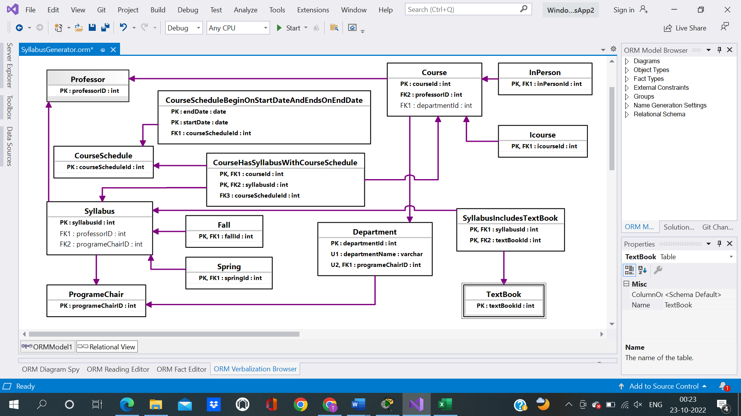

**SQL Code**

CREATE SCHEMA ORMModel1

GO

GO

CREATE TABLE ORMModel1.Department

(

departmentId int IDENTITY (1, 1) NOT NULL,

departmentName nvarchar(max) NOT NULL,

programeChairID int NOT NULL,

CONSTRAINT Department_PK PRIMARY KEY(departmentId),

CONSTRAINT Department_UC1 UNIQUE(departmentName),

CONSTRAINT Department_UC2 UNIQUE(programeChairID)

)

GO

CREATE TABLE ORMModel1.Course

(

courseId int IDENTITY (1, 1) NOT NULL,

professorID int NOT NULL,

departmentId int,

CONSTRAINT Course_PK PRIMARY KEY(courseId)

)

GO

CREATE TABLE ORMModel1.ProgrameChair

(

programeChairID int IDENTITY (1, 1) NOT NULL,

CONSTRAINT ProgrameChair_PK PRIMARY KEY(programeChairID)

)

GO

CREATE TABLE ORMModel1.Professor

(

professorID int IDENTITY (1, 1) NOT NULL,

CONSTRAINT Professor_PK PRIMARY KEY(professorID)

)

GO

CREATE TABLE ORMModel1.Syllabus

(

syllabusId int IDENTITY (1, 1) NOT NULL,

professorID int,

programeChairID int,

CONSTRAINT Syllabus_PK PRIMARY KEY(syllabusId)

)

GO

CREATE TABLE ORMModel1.CourseSchedule

(

courseScheduleId int IDENTITY (1, 1) NOT NULL,

CONSTRAINT CourseSchedule_PK PRIMARY KEY(courseScheduleId)

)

GO

CREATE TABLE ORMModel1.CourseHasSyllabusWithCourseSchedule

(

courseId int NOT NULL,

syllabusId int NOT NULL,

courseScheduleId int NOT NULL,

CONSTRAINT CourseHasSyllabusWithCourseSchedule_PK PRIMARY KEY(courseId, syllabusId)

)

GO

CREATE TABLE ORMModel1.Icourse

(

icourseId int NOT NULL,

CONSTRAINT Icourse_PK PRIMARY KEY(icourseId)

)

GO

CREATE TABLE ORMModel1.InPerson

(

inPersonId int NOT NULL,

CONSTRAINT InPerson_PK PRIMARY KEY(inPersonId)

)

GO

CREATE TABLE ORMModel1.Fall

(

fallId int NOT NULL,

CONSTRAINT Fall_PK PRIMARY KEY(fallId)

)

GO

CREATE TABLE ORMModel1.Spring

(

springId int NOT NULL,

CONSTRAINT Spring_PK PRIMARY KEY(springId)

)

GO

CREATE TABLE ORMModel1.CourseScheduleBeginOnStartDateAndEndsOnEndDate

(

endDate date NOT NULL,

startDate date NOT NULL,

courseScheduleId int NOT NULL,

CONSTRAINT CourseScheduleBeginOnStartDateAndEndsOnEndDate_PK PRIMARY KEY(startDate, endDate)

)

GO

CREATE TABLE ORMModel1.TextBook

(

textBookId int IDENTITY (1, 1) NOT NULL,

CONSTRAINT TextBook_PK PRIMARY KEY(textBookId)

)

GO

CREATE TABLE ORMModel1.SyllabusIncludesTextBook

(

syllabusId int NOT NULL,

textBookId int NOT NULL,

CONSTRAINT SyllabusIncludesTextBook_PK PRIMARY KEY(textBookId, syllabusId)

)

GO

ALTER TABLE ORMModel1.Department ADD CONSTRAINT Department_FK FOREIGN KEY (programeChairID) REFERENCES ORMModel1.ProgrameChair (programeChairID) ON DELETE NO ACTION ON UPDATE NO ACTION

GO

ALTER TABLE ORMModel1.Course ADD CONSTRAINT Course_FK1 FOREIGN KEY (departmentId) REFERENCES ORMModel1.Department (departmentId) ON DELETE NO ACTION ON UPDATE NO ACTION

GO

ALTER TABLE ORMModel1.Course ADD CONSTRAINT Course_FK2 FOREIGN KEY (professorID) REFERENCES ORMModel1.Professor (professorID) ON DELETE NO ACTION ON UPDATE NO ACTION

GO

ALTER TABLE ORMModel1.Syllabus ADD CONSTRAINT Syllabus_FK1 FOREIGN KEY (professorID) REFERENCES ORMModel1.Professor (professorID) ON DELETE NO ACTION ON UPDATE NO ACTION

GO

ALTER TABLE ORMModel1.Syllabus ADD CONSTRAINT Syllabus_FK2 FOREIGN KEY (programeChairID) REFERENCES ORMModel1.ProgrameChair (programeChairID) ON DELETE NO ACTION ON UPDATE NO ACTION

GO

ALTER TABLE ORMModel1.CourseHasSyllabusWithCourseSchedule ADD CONSTRAINT CourseHasSyllabusWithCourseSchedule_FK1 FOREIGN KEY (courseId) REFERENCES ORMModel1.Course (courseId) ON DELETE NO ACTION ON UPDATE NO ACTION

GO

ALTER TABLE ORMModel1.CourseHasSyllabusWithCourseSchedule ADD CONSTRAINT CourseHasSyllabusWithCourseSchedule_FK2 FOREIGN KEY (syllabusId) REFERENCES ORMModel1.Syllabus (syllabusId) ON DELETE NO ACTION ON UPDATE NO ACTION

GO

ALTER TABLE ORMModel1.CourseHasSyllabusWithCourseSchedule ADD CONSTRAINT CourseHasSyllabusWithCourseSchedule_FK3 FOREIGN KEY (courseScheduleId) REFERENCES ORMModel1.CourseSchedule (courseScheduleId) ON DELETE NO ACTION ON UPDATE NO ACTION

GO

ALTER TABLE ORMModel1.Icourse ADD CONSTRAINT Icourse_FK FOREIGN KEY (icourseId) REFERENCES ORMModel1.Course (courseId) ON DELETE NO ACTION ON UPDATE NO ACTION

GO

ALTER TABLE ORMModel1.InPerson ADD CONSTRAINT InPerson_FK FOREIGN KEY (inPersonId) REFERENCES ORMModel1.Course (courseId) ON DELETE NO ACTION ON UPDATE NO ACTION

GO

ALTER TABLE ORMModel1.Fall ADD CONSTRAINT Fall_FK FOREIGN KEY (fallId) REFERENCES ORMModel1.Syllabus (syllabusId) ON DELETE NO ACTION ON UPDATE NO ACTION

GO

ALTER TABLE ORMModel1.Spring ADD CONSTRAINT Spring_FK FOREIGN KEY (springId) REFERENCES ORMModel1.Syllabus (syllabusId) ON DELETE NO ACTION ON UPDATE NO ACTION

GO

ALTER TABLE ORMModel1.CourseScheduleBeginOnStartDateAndEndsOnEndDate ADD CONSTRAINT CourseScheduleBeginOnStartDateAndEndsOnEndDate_FK FOREIGN KEY (courseScheduleId) REFERENCES ORMModel1.CourseSchedule (courseScheduleId) ON DELETE NO ACTION ON UPDATE NO ACTION

GO

ALTER TABLE ORMModel1.SyllabusIncludesTextBook ADD CONSTRAINT SyllabusIncludesTextBook_FK1 FOREIGN KEY (syllabusId) REFERENCES ORMModel1.Syllabus (syllabusId) ON DELETE NO ACTION ON UPDATE NO ACTION

GO

ALTER TABLE ORMModel1.SyllabusIncludesTextBook ADD CONSTRAINT SyllabusIncludesTextBook_FK2 FOREIGN KEY (textBookId) REFERENCES ORMModel1.TextBook (textBookId) ON DELETE NO ACTION ON UPDATE NO ACTION

GO

GO

**Output**

**Tables Creation**

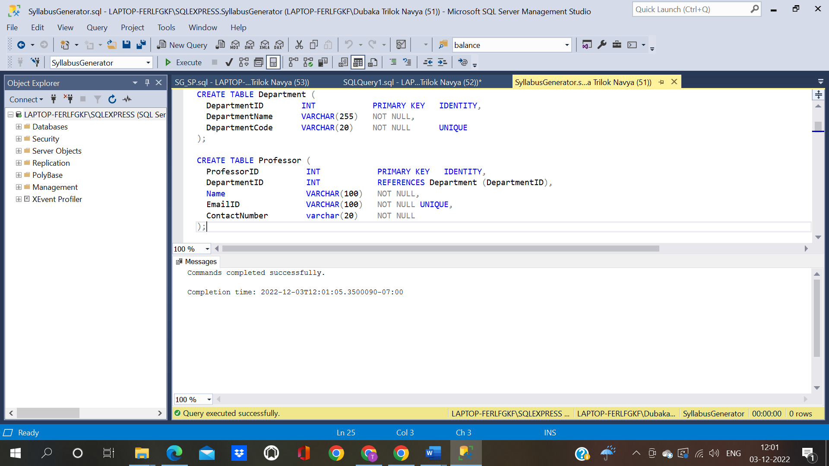

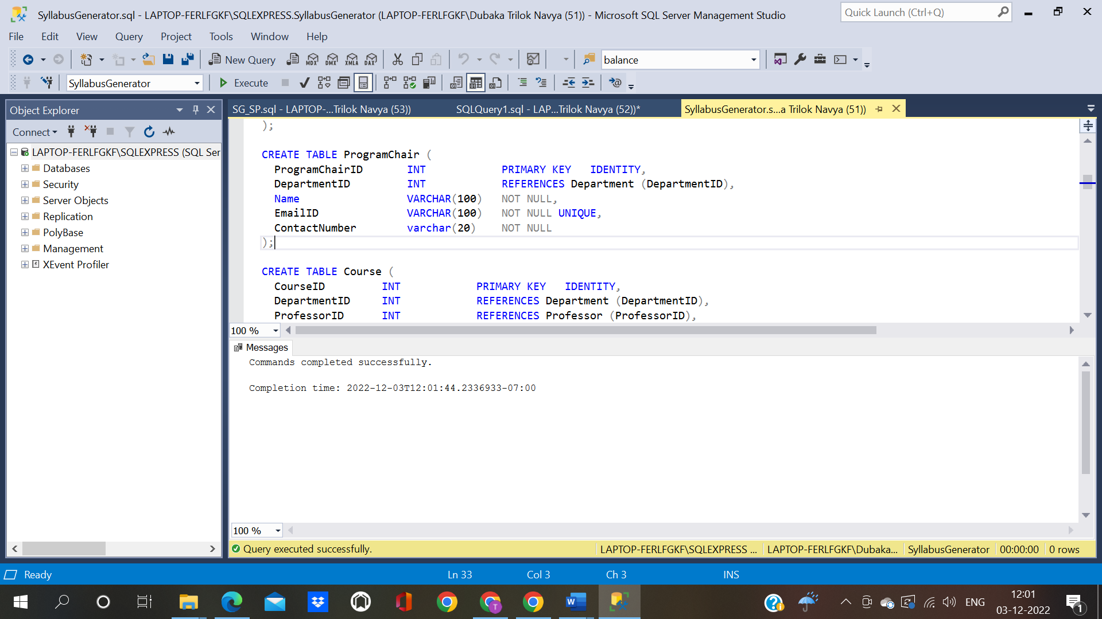

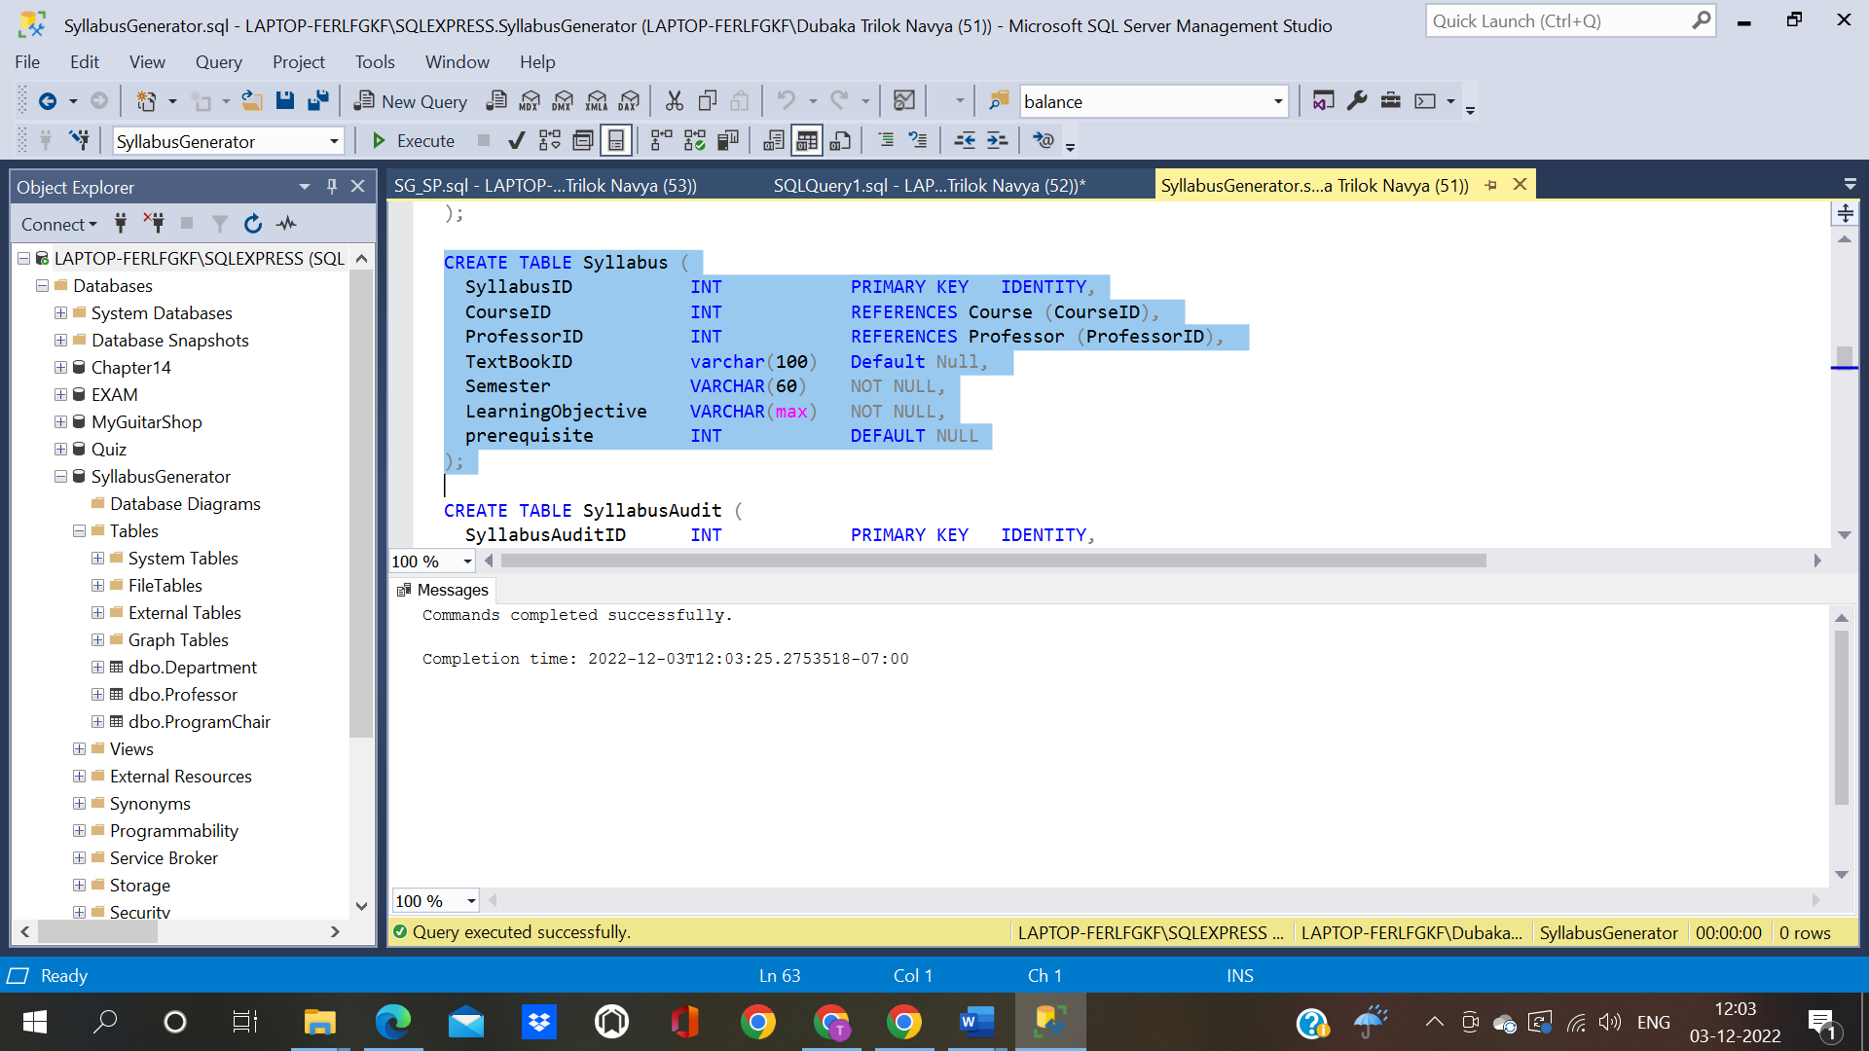

**Section 4**

**Relational Tables:**

**1)Department**

CREATE TABLE Department (

DepartmentID INT PRIMARY KEY IDENTITY,

DepartmentName VARCHAR(255) NOT NULL,

DepartmentCode VARCHAR(20) NOT NULL UNIQUE

);

SET IDENTITY_INSERT Department ON;

INSERT INTO Department (DepartmentID, DepartmentName, DepartmentCode) VALUES

(1, 'Information Technology', 'IFT'),

(2, 'Computer Science','CS'),

(3, 'Software Engineering','SE'),

(4, 'Computer Engineering', 'CE'),

(5, 'Construction Management', 'CMT');

SET IDENTITY_INSERT Department OFF;

**Department:**

Query: select * from Department with (nolock)

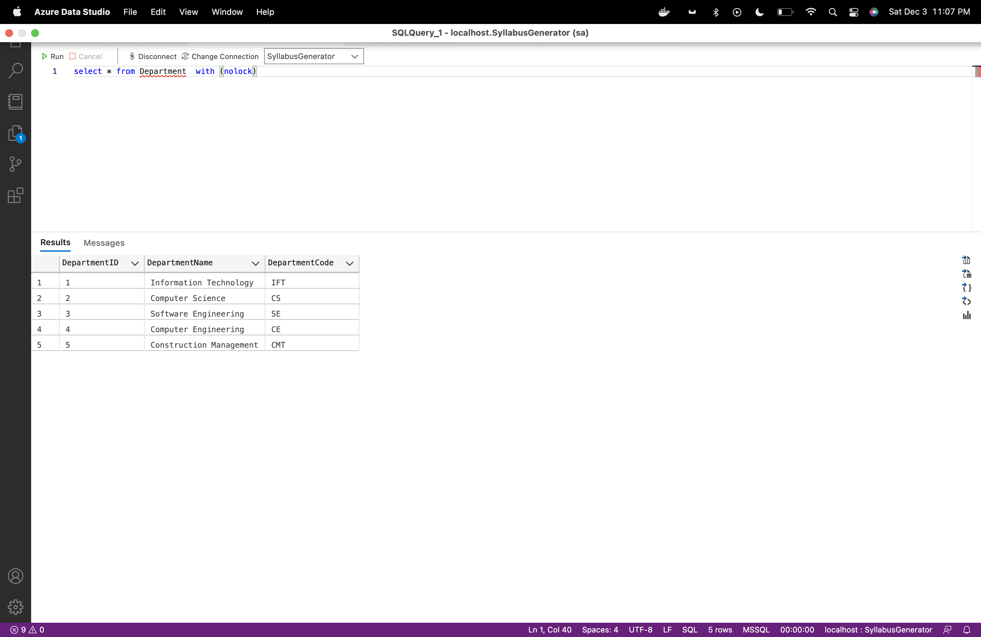

**2) Program Chair**

SET IDENTITY_INSERT ProgramChair ON;

INSERT INTO ProgramChair (ProgramChairID, DepartmentID, Name,EmailID,ContactNumber) VALUES

(1, 1, 'Tatiana Walsh','TatianaWalsh@asu.edu','6021111111'),

(2, 2, 'Dont Know','DontKnow@asu.edu','6021112222'),

(3, 3, 'Srividya Bansal','SrividyaBansal@asu.edu','6021113333'),

(4, 4, 'John Doe','JohnDoe@asu.edu','6021114444'),

(5, 5, 'Abc Xyz','AbcXyz@asu.edu','6021115555');

SET IDENTITY_INSERT ProgramChair OFF;

Query: select * from ProgramChair with (nolock)

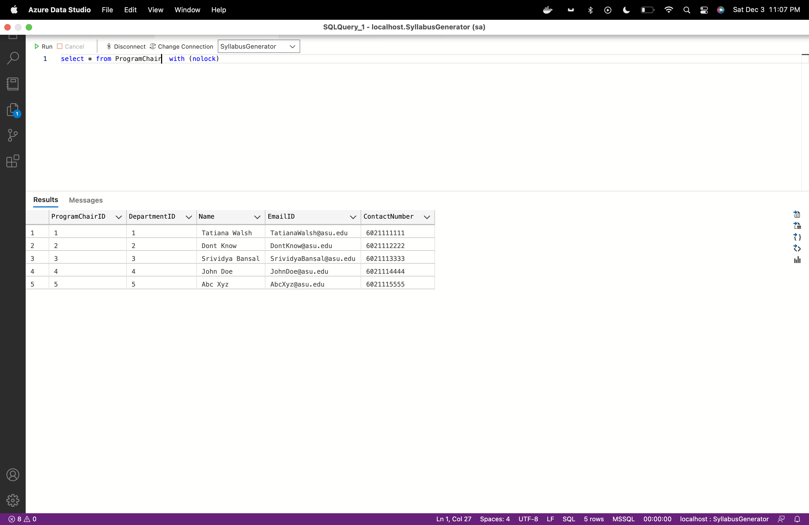

**3)Professor**

CREATE TABLE Professor (

ProfessorID INT PRIMARY KEY IDENTITY,

DepartmentID INT REFERENCES Department (DepartmentID),

Name VARCHAR(100) NOT NULL,

EmailID VARCHAR(100) NOT NULL UNIQUE,

ContactNumber varchar(20) NOT NULL

);

SET IDENTITY_INSERT Professor ON;

INSERT INTO Professor (ProfessorID, DepartmentID, Name,EmailID,ContactNumber) VALUES

(1, 1, 'Robert Rucker','RobertRucker@asu.edu','6022221111'),

(2, 1,'Asmaa Elbadrawy','AsmaaElbadrawy@asu.edu','6023331111'),

(3, 1,'Dinesh Sthapit','DineshSthapit@asu.edu','6024441111'),

(5, 2, 'Chris Bryan','ChrisBryan@asu.edu','6022222222'),

(6, 2, 'Hasan Davulcu','HasanDavulcu@asu.edu','6023332222'),

(7, 2, 'Samira Ghayekhloo','SamiraGhayekhloo@asu.edu','6024442222');

SET IDENTITY_INSERT Professor OFF;

Query:

select * from Professor with (nolock)

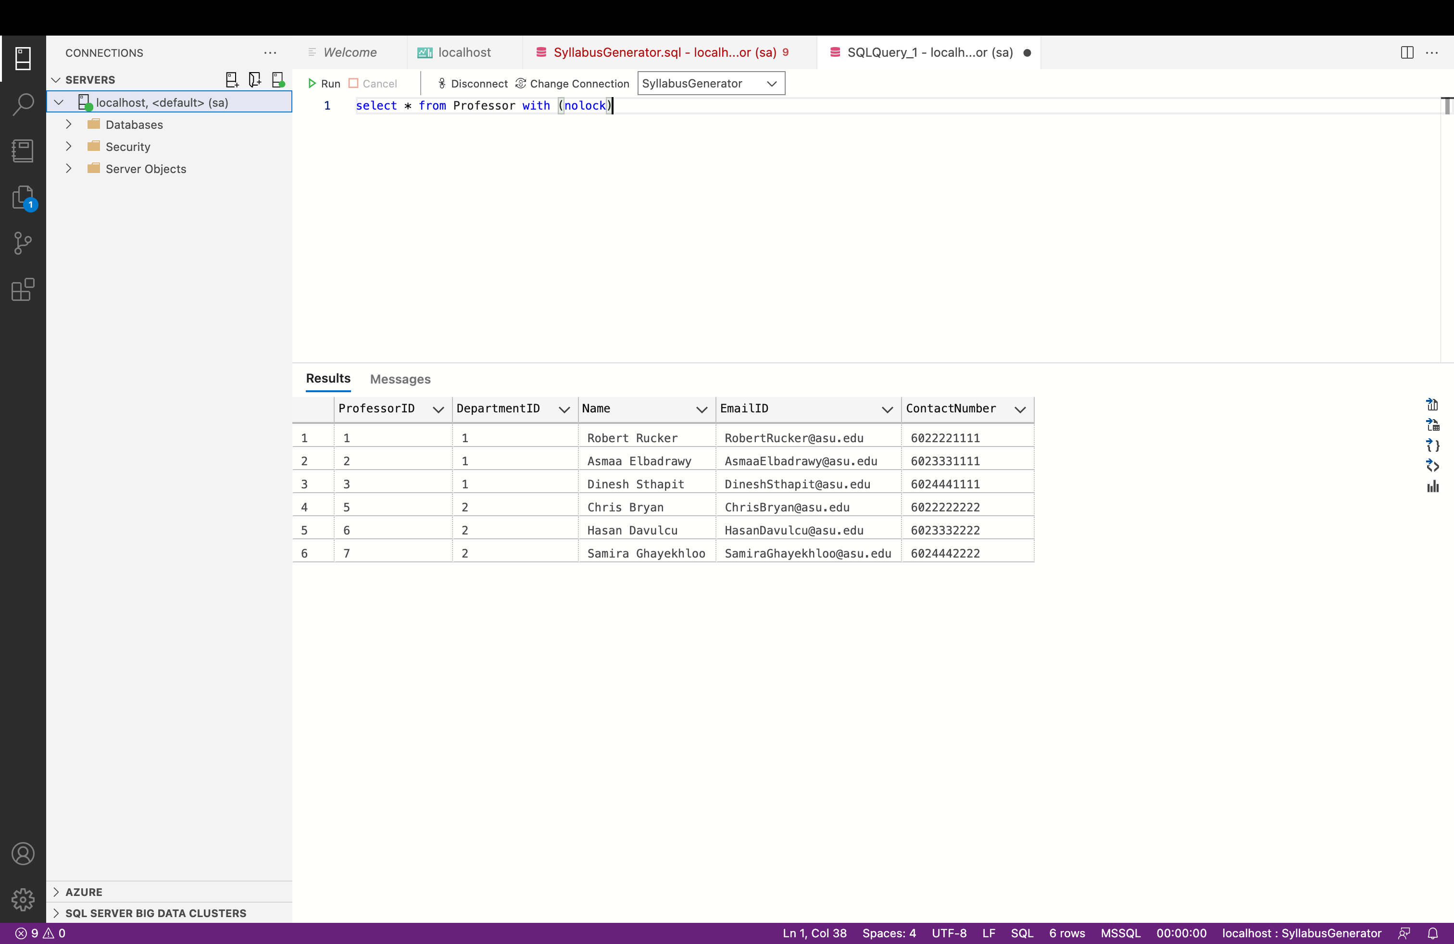

**4)TextBook Table**

CREATE TABLE TextBook (

TextBookID INT PRIMARY KEY IDENTITY,

TextBookName VARCHAR(255) NOT NULL,

Category VARCHAR(255) NOT NULL,

);

SET IDENTITY_INSERT TextBook ON;

INSERT INTO TextBook (TextBookID, TextBookName,Category) VALUES

(1, 'Murachs SQL server for developers','Database'),

(2, 'Halpin, Morgan( 2008) Information Modeling and Relational Databases 2nd edition, Kaufman','Database'),

(3, 'Data Science for Business by F. Provost and T. Fawcett','DataScience'),

(4, 'Mathematical Statistics with Applications, 7th edition, by Wackerly, Mendenhall, and Scheaffer, Brooks/Cole, Cengage Learning, 2008.','DataScience'),

(5, 'Basics of Python','Language');

SET IDENTITY_INSERT TextBook OFF;

Query:

select * from TextBook with (nolock)

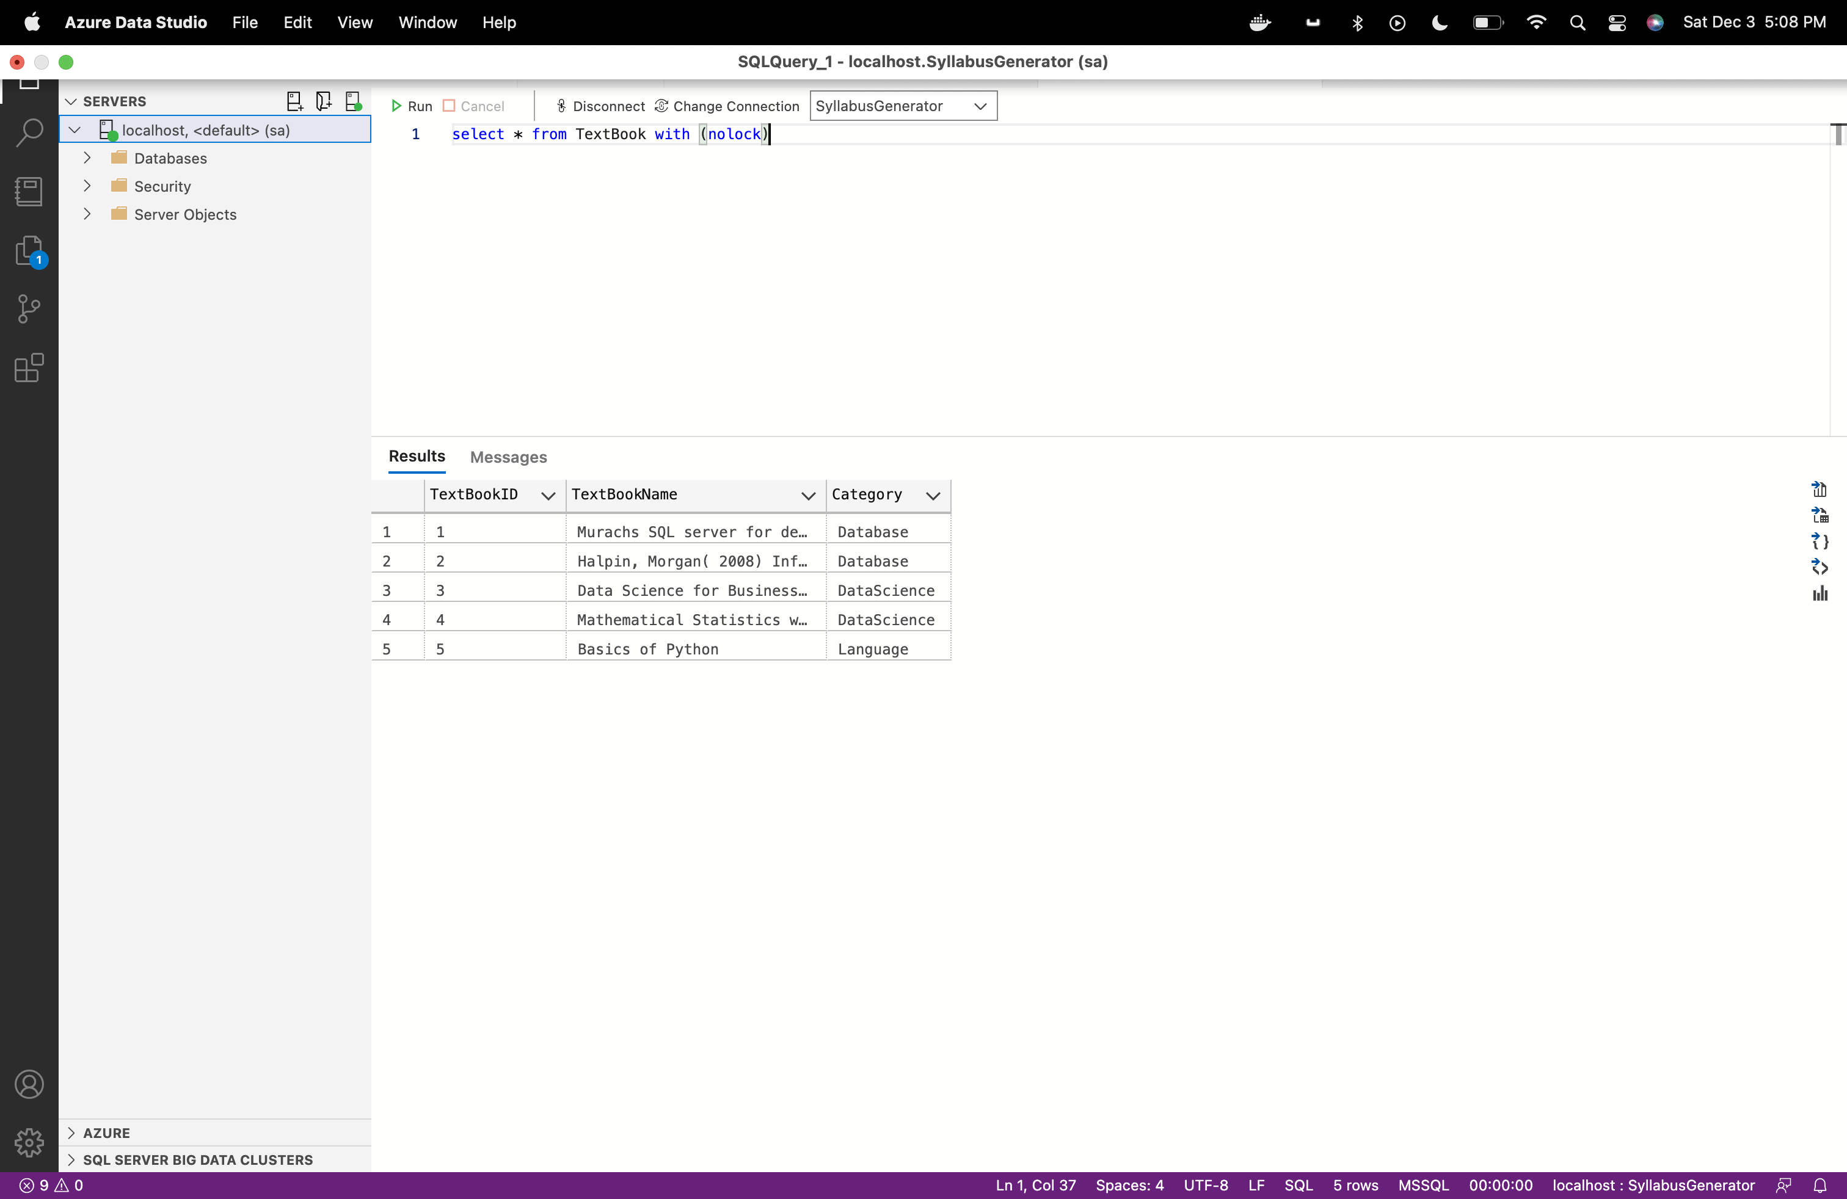

**5)Course**

CREATE TABLE Course (

CourseID INT PRIMARY KEY IDENTITY,

DepartmentID INT REFERENCES Department (DepartmentID),

ProfessorID INT REFERENCES Professor (ProfessorID),

CourseCode VARCHAR(50) NOT NULL UNIQUE,

CourseName VARCHAR(50) NOT NULL,

CourseType VARCHAR(10) NOT NULL

);

SET IDENTITY_INSERT course ON;

INSERT INTO course (CourseID, DepartmentID, ProfessorID,CourseCode,CourseName,CourseType) VALUES

(1, 1, 1,'IFT530','Advanced Database Management Systems','In-Person'),

(2, 1,2, 'IFT511','Analyzing Big Data','In-Person'),

(3, 1,1, 'IFT430','Database Management System','In-Person'),

(4, 1,2, 'IFT411','Fundamentals of Python','In-Person');

(5, 1,3, 'IFT510','Principles of Computer Information','In-Person');

SET IDENTITY_INSERT course OFF;

Query:

select * from Course with (nolock)

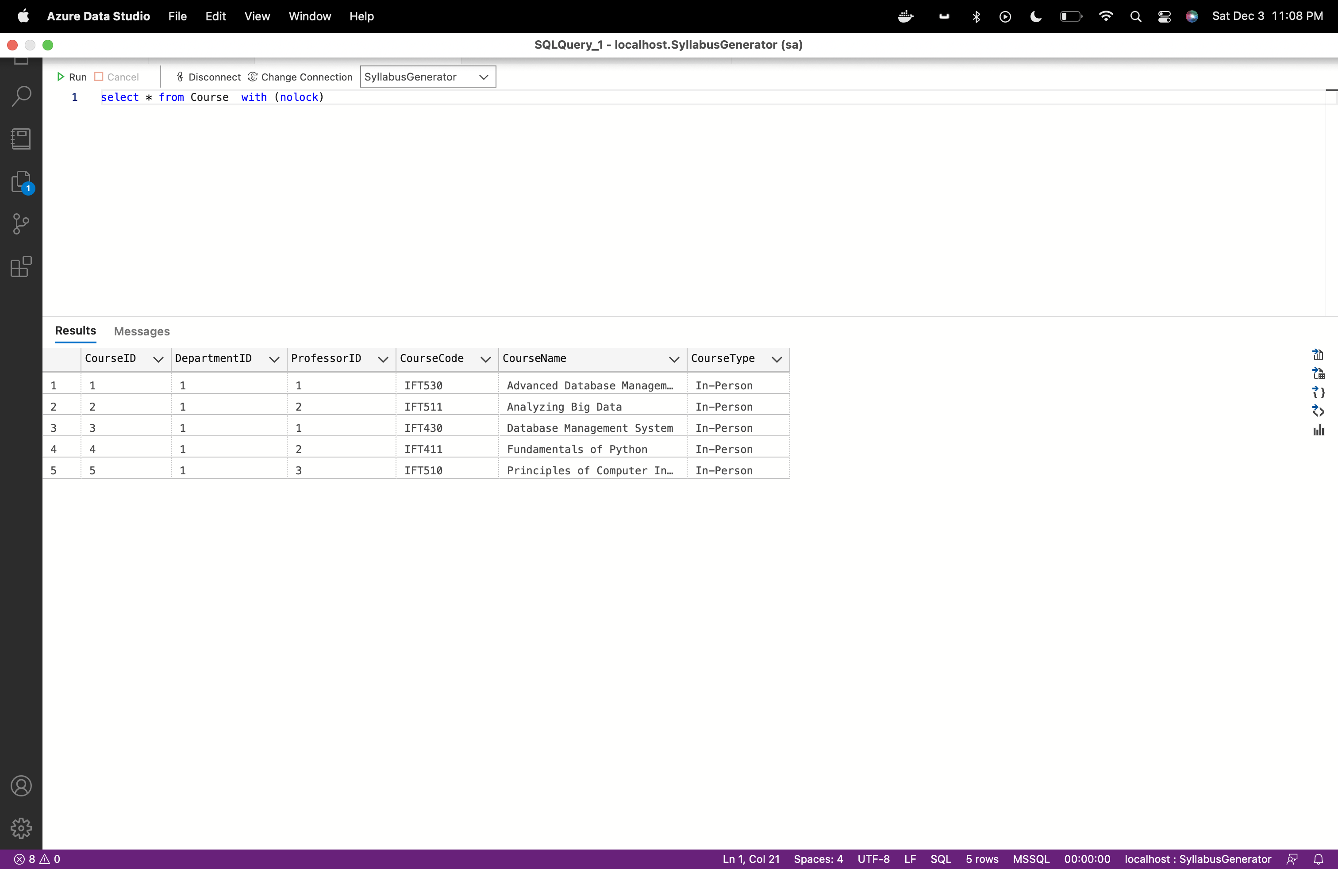

**6)Syllabus**

CREATE TABLE Syllabus (

SyllabusID INT PRIMARY KEY IDENTITY,

CourseID INT REFERENCES Course (CourseID),

ProfessorID INT REFERENCES Professor (ProfessorID),

TextBookID varchar(100) Default Null,

Semester VARCHAR(60) NOT NULL,

LearningObjective VARCHAR(max) NOT NULL,

prerequisite varchar(max) DEFAULT NULL

);

SET IDENTITY_INSERT Syllabus ON;

INSERT INTO Syllabus (SyllabusID, CourseID, ProfessorID,textbookid,Semester,LearningObjective, prerequisite) VALUES

(1, 1, 1,'1,2','Fall','1.Understand the principles of conceptual modeling,2.understand the use of scripts when implementing SQL code', '3'),

(2, 1, 1,'1,2','Spring','1.Understand the principles of conceptual modeling,2.understand the use of scripts when implementing SQL code', '3'),

(3, 2, 2,'3,4','Fall','1.Understand how data science can be used as tools to analyze large amounts of data for the purpose of extracting business value.', '4'),

(4, 2, 2,'3,4','Spring','1.Understand how data science can be used as tools to analyze large amounts of data for the purpose of extracting business value.', '4'),

(5, 3, 1,'1','Fall','1.basics of database , ACID properties, CRUD methods, normalization', NULL),

(6, 4, 2,'5','Fall','1.Understand the basics of Python, Python libraries', NULL);

SET IDENTITY_INSERT Syllabus OFF;

Query: select * from Syllabus with (nolock)

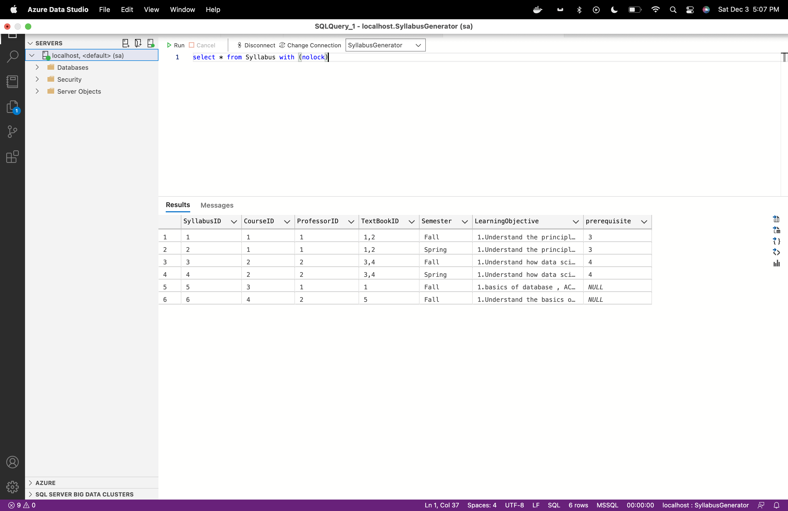

**7)Course Schedule**

CREATE TABLE CourseSchedule (

CourseScheduleID INT PRIMARY KEY IDENTITY,

SyllabusID INT REFERENCES Syllabus (SyllabusID),

CourseID INT REFERENCES Course (CourseID),

Module Varchar(20) NOT NULL,

CourseContents Varchar(max) NOT NULL,

StartDate Date NOT NULL,

EndDate Date NOT NULL

);

SET IDENTITY_INSERT CourseSchedule ON;

INSERT INTO CourseSchedule (CourseScheduleID, SyllabusID, CourseID,Module,CourseContents,StartDate, EndDate) VALUES

(1, 1, 1,'Module1','Understand the principles of conceptual modeling (ORM as an examplar).', '15 Aug 2022','30 Aug 2022'),

(2, 1, 1,'Module2','Basis of Primary keys, Uniqueness/ Mandatory constraints', '1 Sep 2022', '15 Sep 2022'),

(3, 1, 1,'Module3','basis for determining Foreign Keys, value and frequency constraints, dynamic SQL', '16 Sep 2022', '16 Oct 2022'),

(4, 1, 1,'Module4','Window functions, SQL++', '17 Oct 2022', '10 Nov 2022'),

(5, 1, 1,'Module5','Couchbase, Capella-DBaas', '11 Nov 2022', '30 Nov 2022'),

(6, 2, 1,'Module1','Understand the principles of conceptual modeling (ORM as an examplar).', '15 Aug 2022','30 Aug 2022'),

(7, 2, 1,'Module2','Basis of Primary keys, Uniqueness/ Mandatory constraints', '1 Sep 2022', '15 Sep 2022'),

(8, 2, 1,'Module3','basis for determining Foreign Keys, value and frequency constraints, dynamic SQL', '16 Sep 2022', '16 Oct 2022'),

(9, 2, 1,'Module4','Window functions, SQL++', '17 Oct 2022', '10 Nov 2022'),

(10, 2, 1,'Module5','Couchbase, Capella-DBaas', '11 Nov 2022', '30 Nov 2022');

SET IDENTITY_INSERT CourseSchedule OFF;

Query:

select * from CourseSchedule with (nolock)

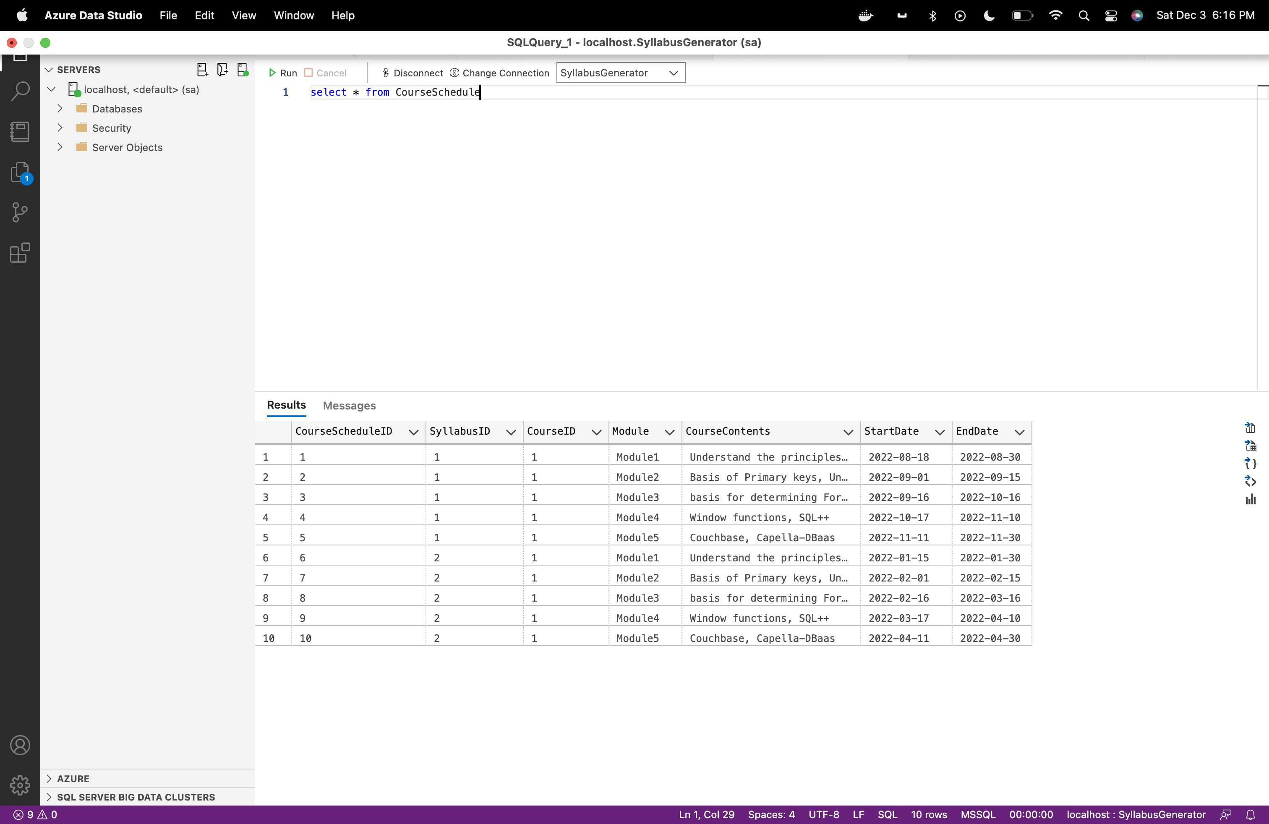

**Section 5**

**Section 5.1**

**SQL queries**

**Question1 :**

**Retrieving current department details**

SELECT DISTINCT d.DepartmentID

,DepartmentName

,DepartmentCode

,pc.Name AS Program_chair

,count(p.ProfessorID) OVER (PARTITION BY p.DepartmentID) AS Professor_count

FROM department d WITH (NOLOCK)

left OUTER JOIN professor p WITH (NOLOCK) ON d.DepartmentID = p.DepartmentID

INNER JOIN ProgramChair pc WITH (NOLOCK) ON d.DepartmentID = pc.DepartmentID

ORDER BY d.DepartmentID ASC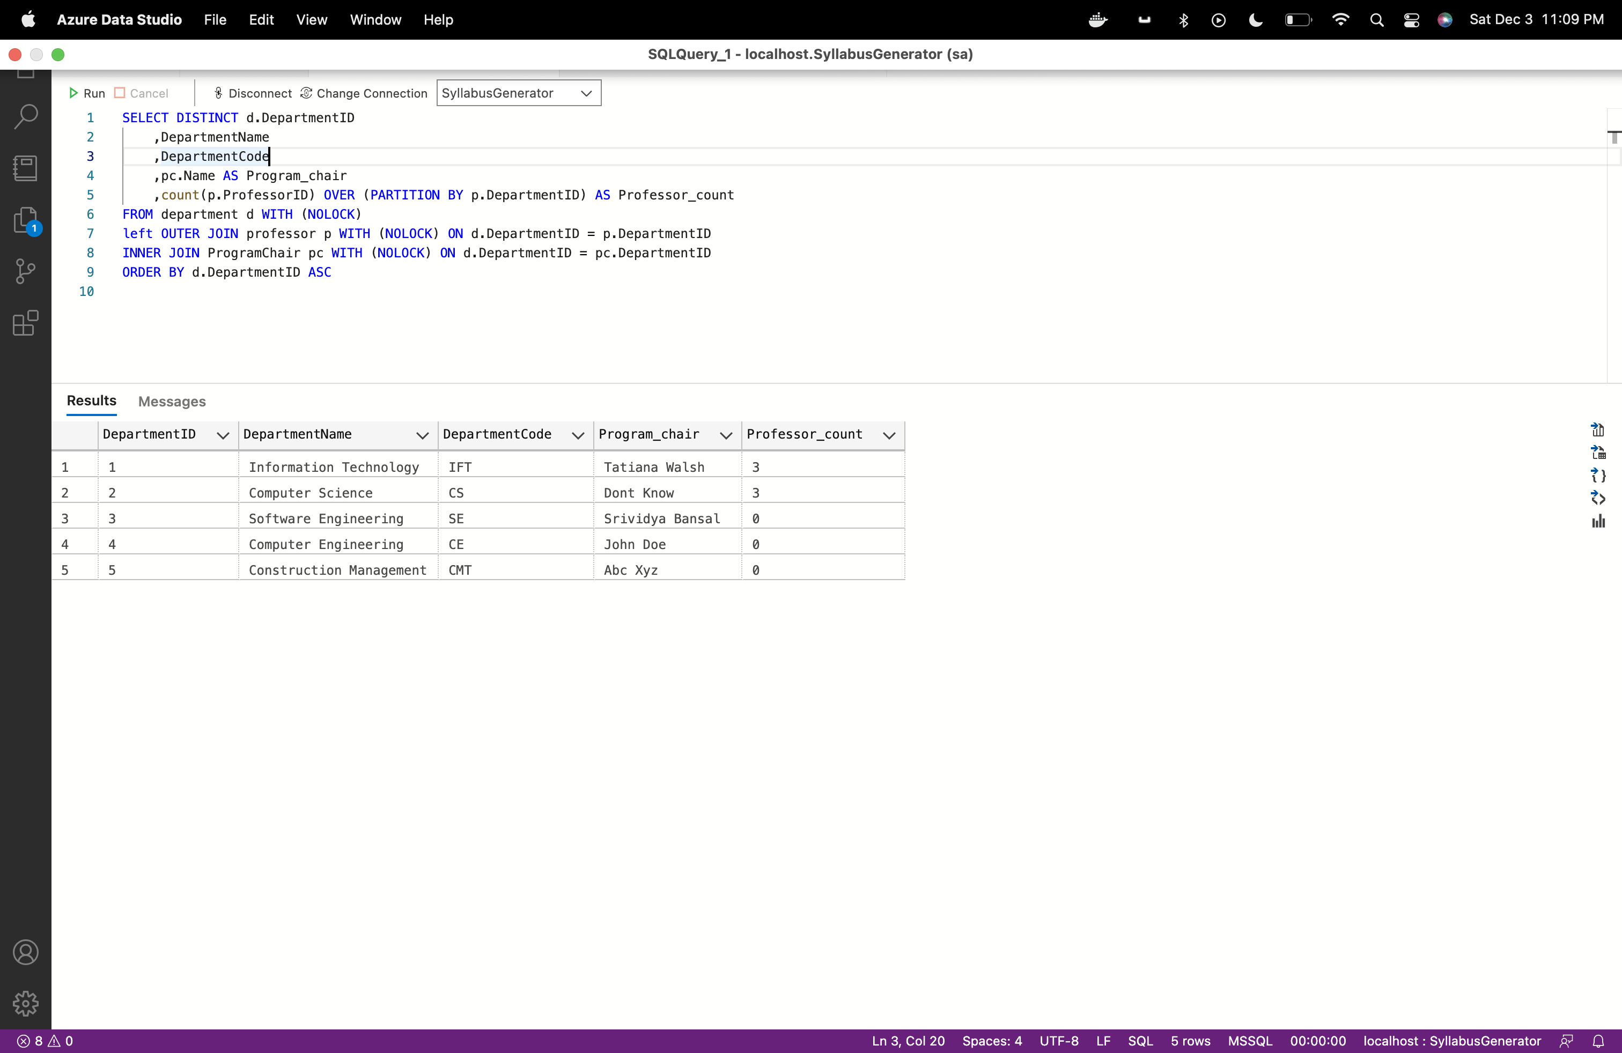

**Question2:**

**Department wise program chair and professor details**

SELECT DISTINCT d.DepartmentID

,DepartmentName

,DepartmentCode

,pc.Name AS Program_chair

,count(p.ProfessorID) OVER (PARTITION BY p.DepartmentID) AS Total_Professor_count

,p.Name AS Professor

FROM department d WITH (NOLOCK)

left OUTER JOIN professor p WITH (NOLOCK) ON d.DepartmentID = p.DepartmentID

INNER JOIN ProgramChair pc WITH (NOLOCK) ON d.DepartmentID = pc.DepartmentID

ORDER BY d.DepartmentID ASC

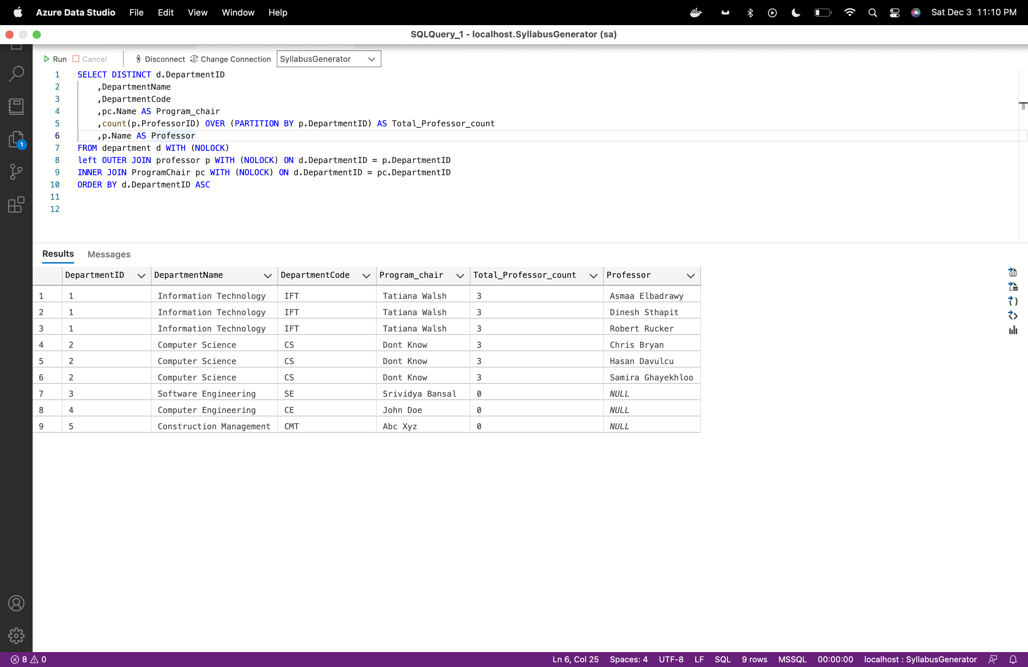

**Question3:**

**Retrieving Professor teaching particular course**

SELECT DISTINCT

p.ProfessorID

,p.Name AS professor

,count(c.CourseID) OVER (PARTITION BY p.ProfessorID) AS Total_Course_count

,c.CourseCode AS Course_Code

,c.CourseName AS Course_Name

,c.CourseType AS Course_Type

FROM Professor p WITH (NOLOCK)

left OUTER JOIN Course c WITH (NOLOCK) ON c.ProfessorID = p.ProfessorID

ORDER BY p.ProfessorID ASC

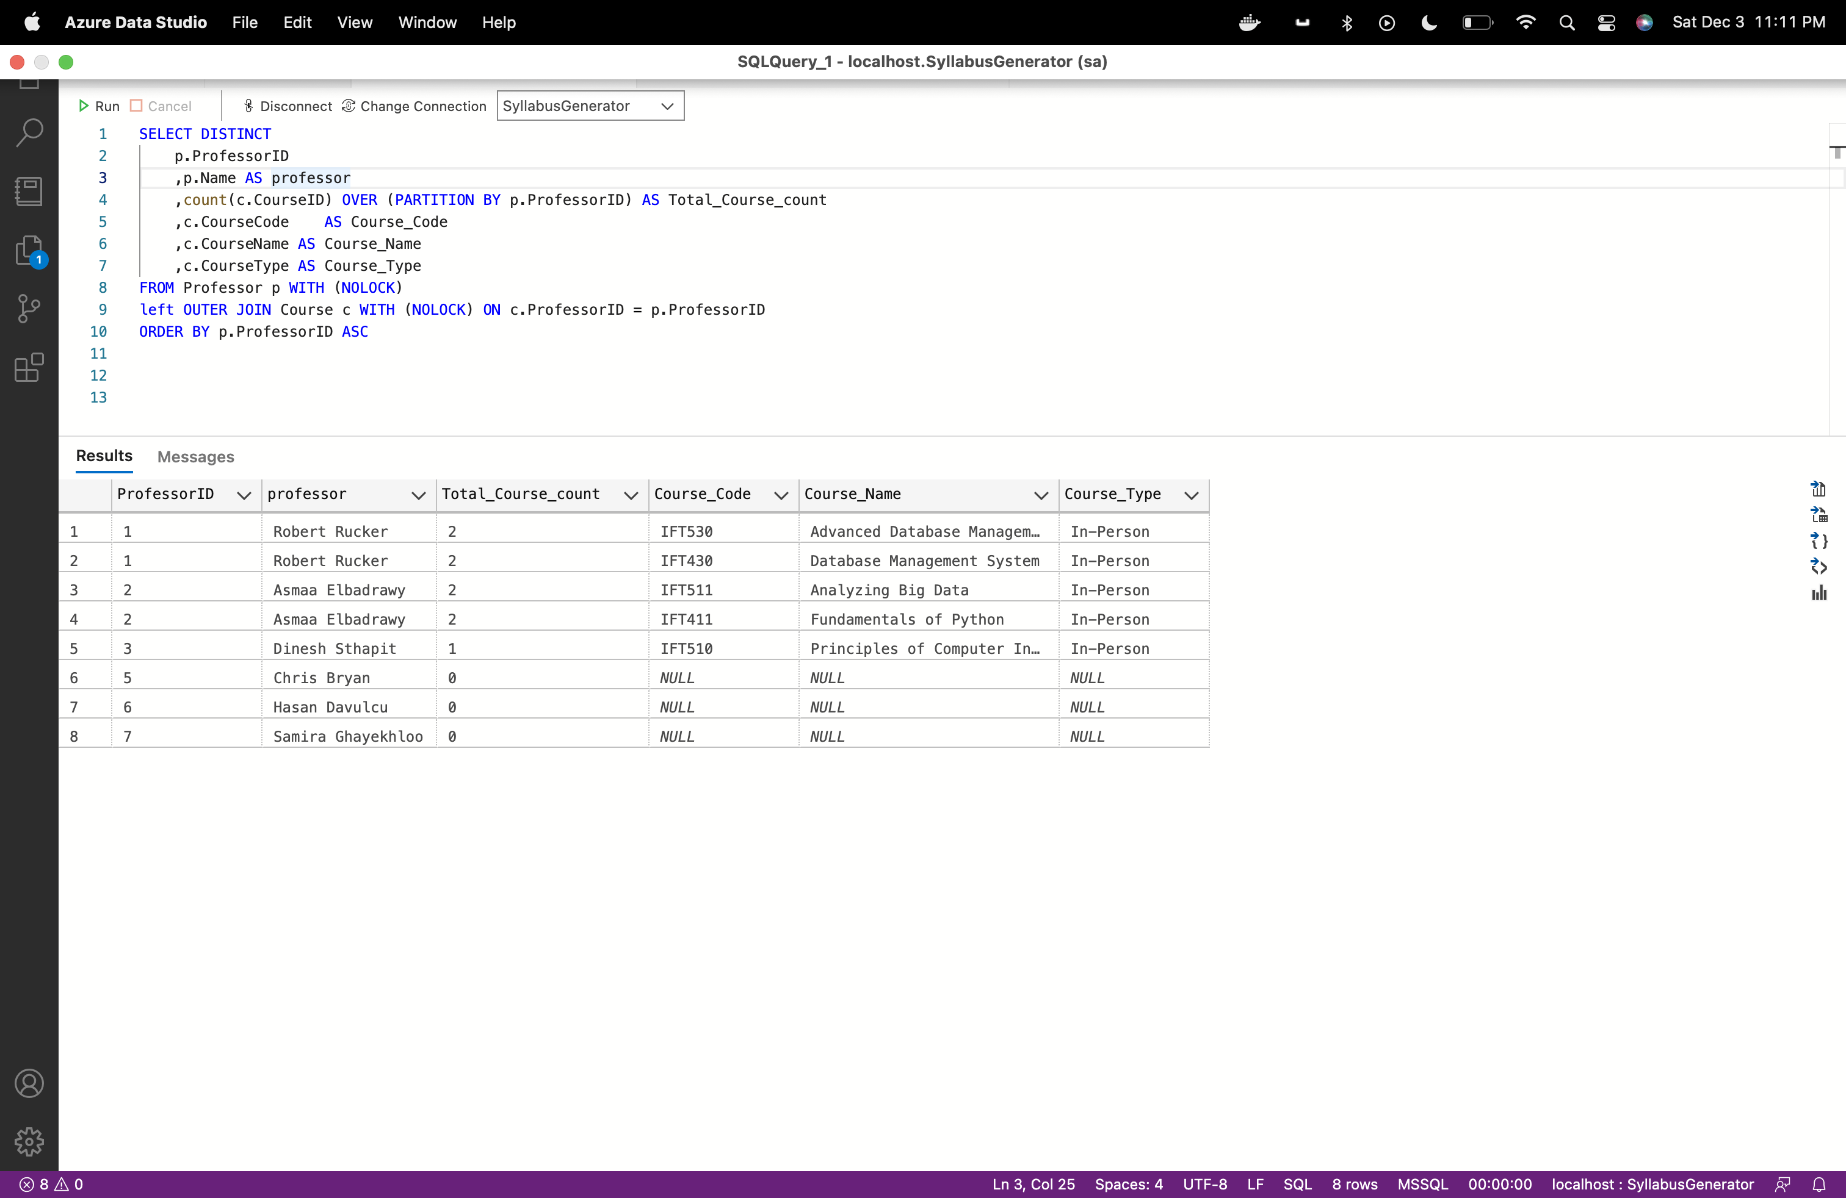

**Question4:**

**Professor and Program chair contact details**

(SELECT

p.Name AS Name

,p.ContactNumber AS Contact

,p.EmailID AS Email

,'Professor' as Role

FROM Professor p WITH (NOLOCK)

UNION

SELECT

pc.Name AS Name

,pc.ContactNumber AS Contact

,pc.EmailID AS Email

,'ProgramChair' as Role

FROM ProgramChair pc WITH (NOLOCK))

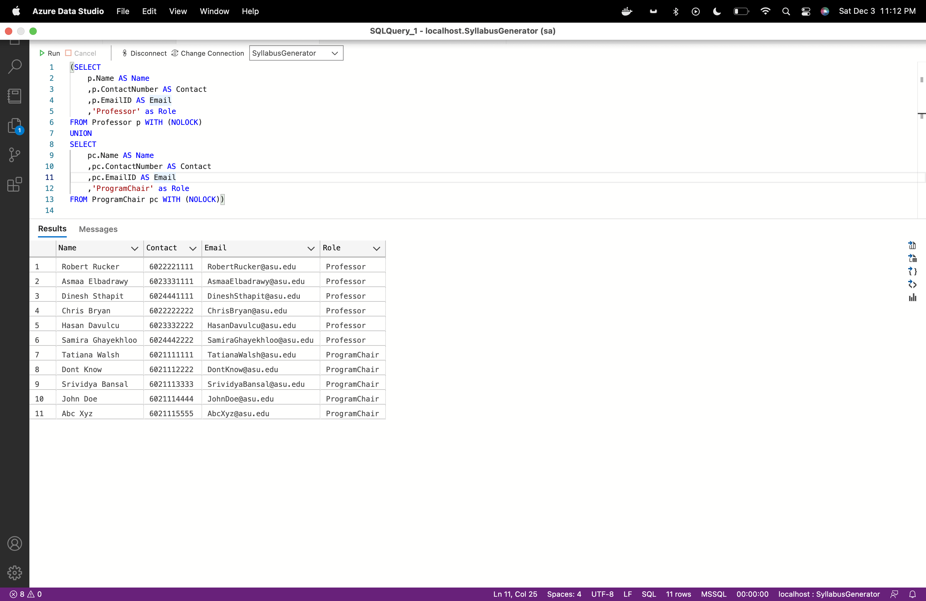

**Question5:**

**Retrieving start and end date of Syllabus**

SELECT DISTINCT

c.CourseName + '('+ s.Semester + ')' as CourseName

,min(cs.StartDate) over (PARTITION by cs.SyllabusID) as Course_start_date

,max(cs.EndDate) over (PARTITION by cs.SyllabusID) as Course_end_date

FROM Syllabus s WITH (NOLOCK)

INNER JOIN Course c WITH (NOLOCK) ON c.CourseID = s.CourseID

INNER JOIN CourseSchedule cs WITH (NOLOCK) ON cs.SyllabusID = s.SyllabusID

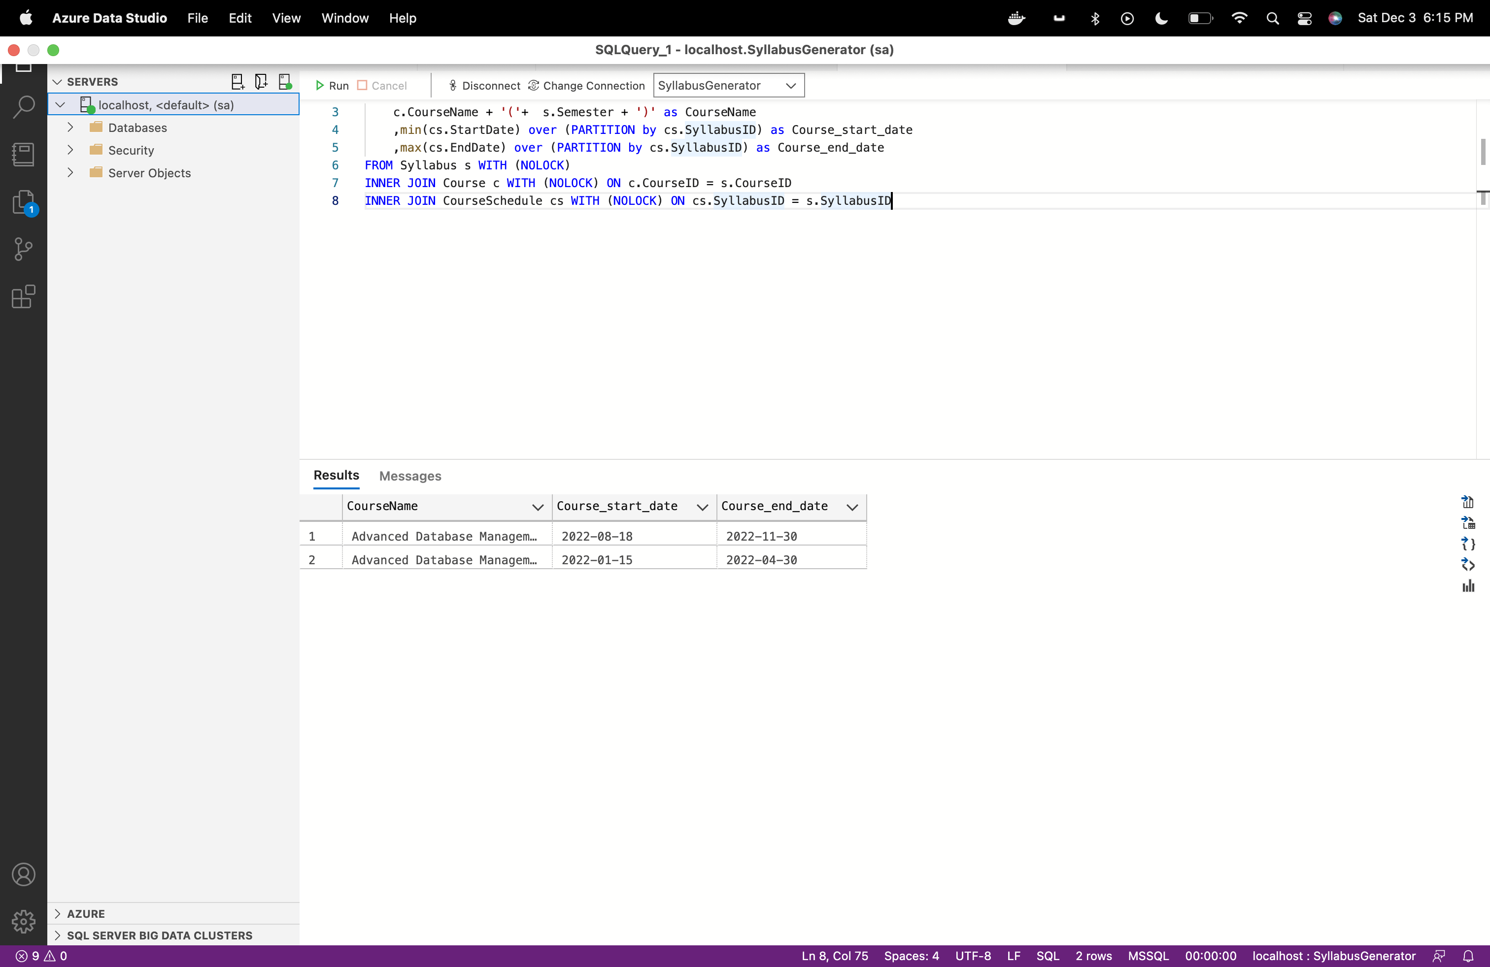

**Question 6:**

**Course wise textbook list**

SELECT DISTINCT

s.SyllabusID

,c.CourseName + '('+ s.Semester + ')' as CourseName

,t.TextBookName

FROM Syllabus s WITH (NOLOCK)

INNER JOIN Course c WITH (NOLOCK) ON c.CourseID = s.CourseID

,TextBook t WITH (NOLOCK)

where t.TextBookID in (select * from STRING_SPLIT((select TextBookID from Syllabus where SyllabusID = s.SyllabusID), ','))

order by s.SyllabusID asc

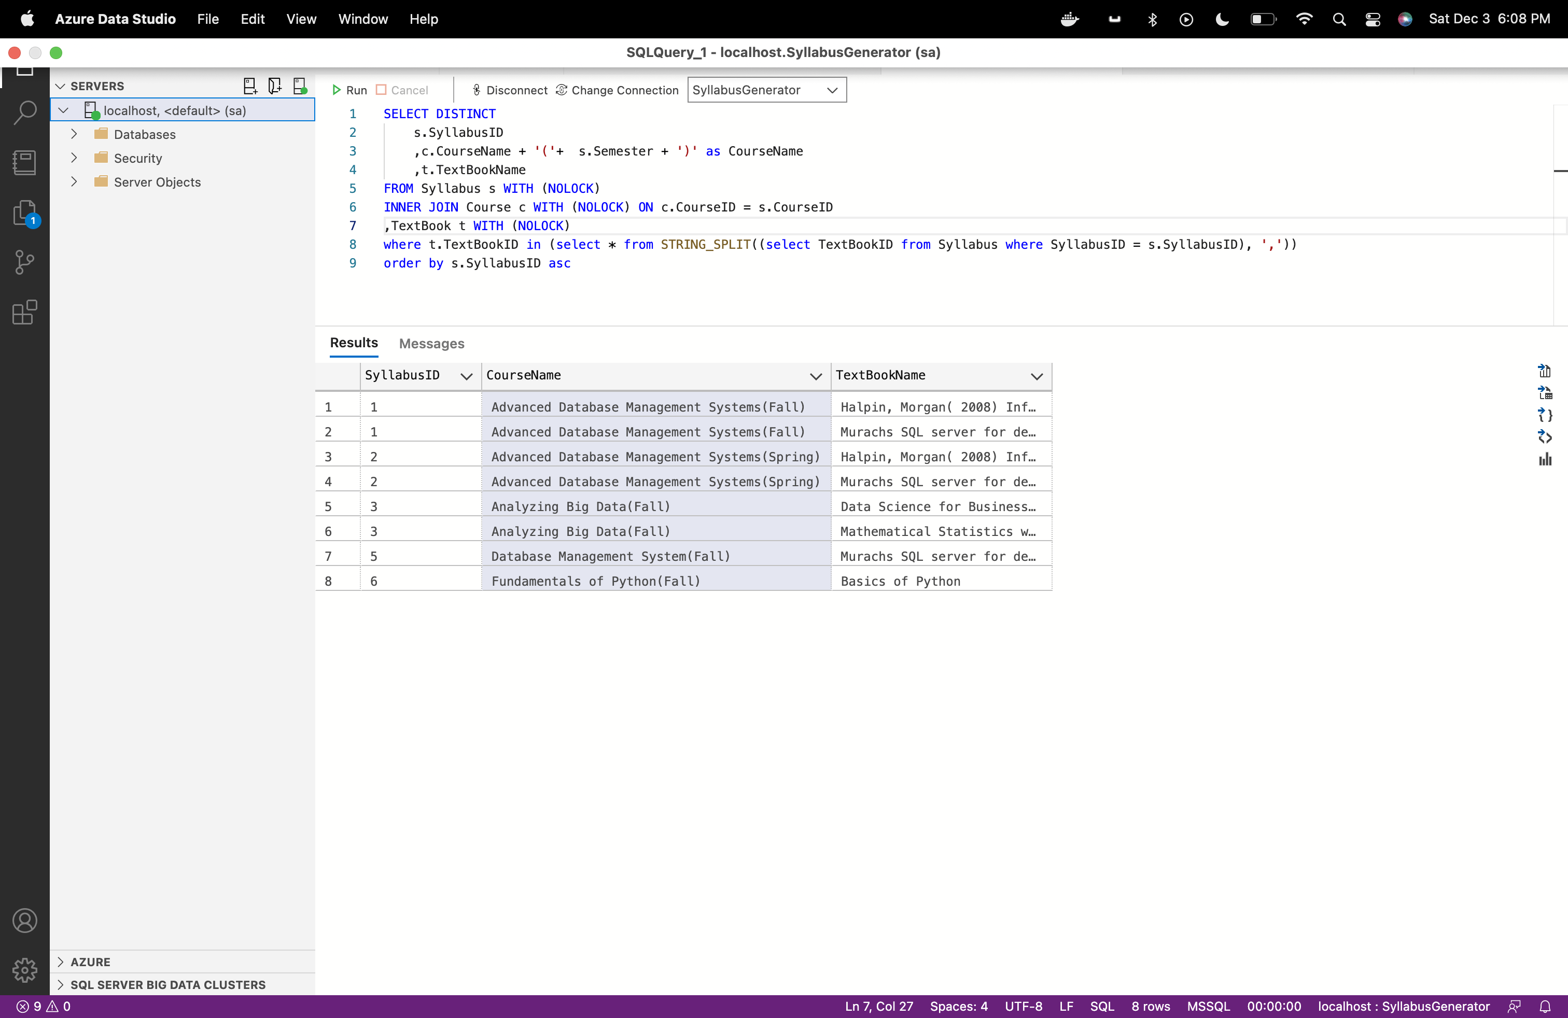

**Section 5**

**Additional Constraints**

**1.Stored procedure to fetch all courses of professor:**

Query:

use SyllabusGenerator

GO

IF EXISTS (SELECT * FROM sys.objects WHERE type = 'P' AND OBJECT_ID = OBJECT_ID('dbo.spFetchCourses'))

drop proc spFetchCourses

GO

Create proc spFetchCourses

@ProfessorID Int

AS

BEGIN

Select c.CourseCode as CourseCode

, c.CourseName + '('+ ss.Semester + ')' as CourseName

, c.CourseType as CourseType

, c.CourseID as CourseID

, d.DepartmentName as DepartmentName

, d.DepartmentCode as DepartmentCode

, d.DepartmentID as DepartmentID

, ss.SyllabusID

from SyllabusGenerator..course c with (nolock) inner join SyllabusGenerator..Syllabus ss with (nolock) on c.CourseID = ss.CourseID

inner join SyllabusGenerator..Department d with (nolock) on d.DepartmentID = c.DepartmentID

where c.ProfessorID = @ProfessorID

END

exec spFetchCourses 1

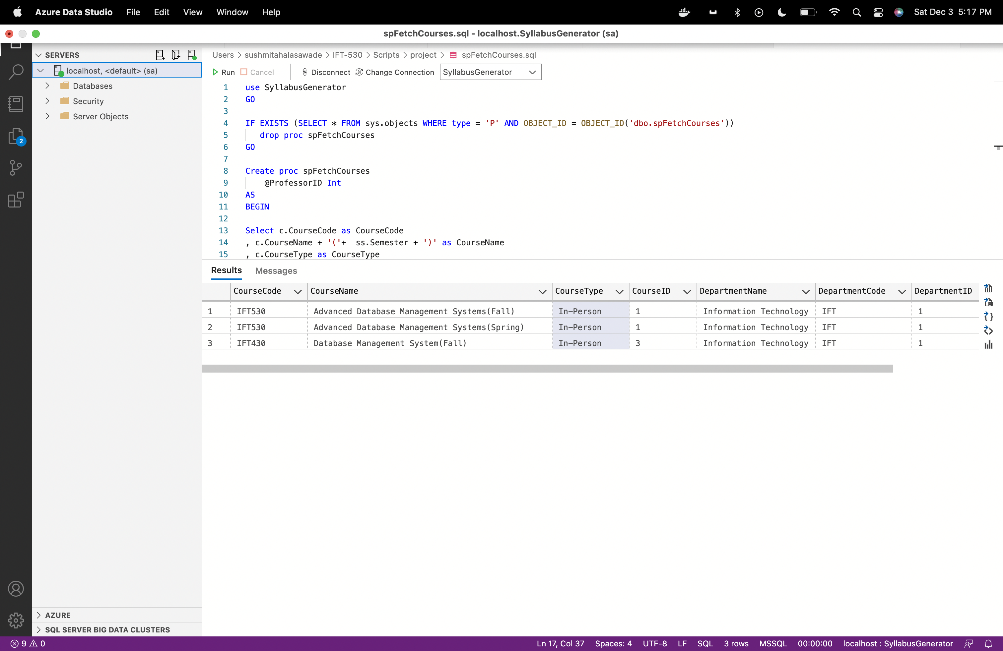

**2.Stored procedure to fetch Syllabus details of course taught by professor:**

Query:

use SyllabusGenerator

GO

IF EXISTS (SELECT * FROM sys.objects WHERE type = 'P' AND OBJECT_ID = OBJECT_ID('dbo.spFetchSyllabusDetails'))

drop proc spFetchSyllabusDetails

GO

Create proc spFetchSyllabusDetails

@ProfessorID Int ,

@SyllabusID Int

AS

BEGIN

Select c.CourseName + '('+ ss.Semester + ')' as CourseName,ss.LearningObjective,ss.TextBookID,ss.prerequisite,cs.[Module],cs.CourseContents,cs.StartDate,cs.EndDate

from SyllabusGenerator..syllabus ss with (nolock) inner join SyllabusGenerator..CourseSchedule cs with (nolock) on ss.SyllabusID = cs.SyllabusID

inner join SyllabusGenerator..course c with (nolock) on c.CourseID = ss.CourseID

where ss.SyllabusID = @SyllabusID and ss.ProfessorID = @ProfessorID

END

--

--exec spFetchSyllabusDetails 1, 1

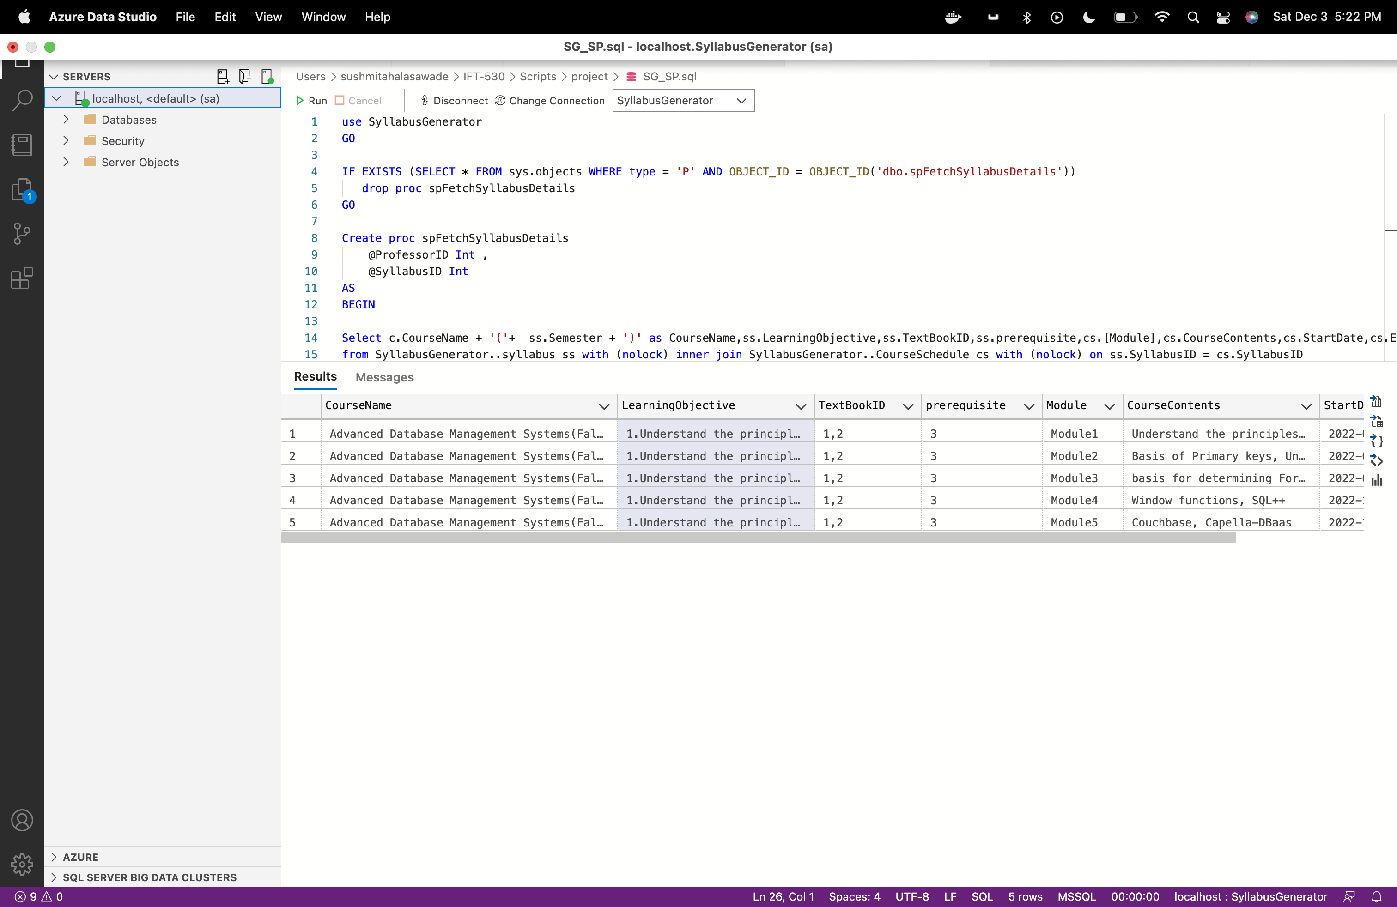

**3. Stored Procedure to insert or update the syllabus.**

Query:

use SyllabusGenerator

GO

IF EXISTS (SELECT * FROM sys.objects WHERE type = 'P' AND OBJECT_ID = OBJECT_ID('dbo.spInsertorUpdateSyllabus'))

drop proc spInsertorUpdateSyllabus

GO

Create proc spInsertorUpdateSyllabus

@SyllabusID varchar(10),

@textbookid varchar(100),

@LearningObjective varchar(max),

@prerequisite varchar(100),

@Module varchar(20),

@CourseContents varchar(max),

@StartDate DATE,

@EndDate DATE

AS

BEGIN

update Syllabus with (rowlock) set textbookid = @textbookid, LearningObjective= @LearningObjective, prerequisite= @prerequisite where SyllabusID = @SyllabusID

if Exists(select * from CourseSchedule where SyllabusID = @SyllabusID and module = @Module)

BEGIN

update CourseSchedule with (rowlock) set CourseContents = @CourseContents, StartDate= @StartDate, EndDate= @EndDate where SyllabusID = @SyllabusID and module = @Module

END

ELSE

BEGIN

INSERT INTO CourseSchedule ( SyllabusID, CourseID,Module,CourseContents,StartDate, EndDate) VALUES

( @SyllabusID, 1,@Module,@CourseContents, @StartDate,@EndDate)

END

END

Test:

--exec spInsertorUpdateSyllabus 1, '1,2', '1.Understand the principles of conceptual modeling,2.understand the use of scripts when implementing SQL code','3','Module1','Understand the principles of conceptual modeling(ORM).','18 Aug 2022','30 Aug 2022'

select CourseContents,StartDate,* from CourseSchedule where SyllabusID =1 and module = 'Module1'

This will update existing module content and start date.

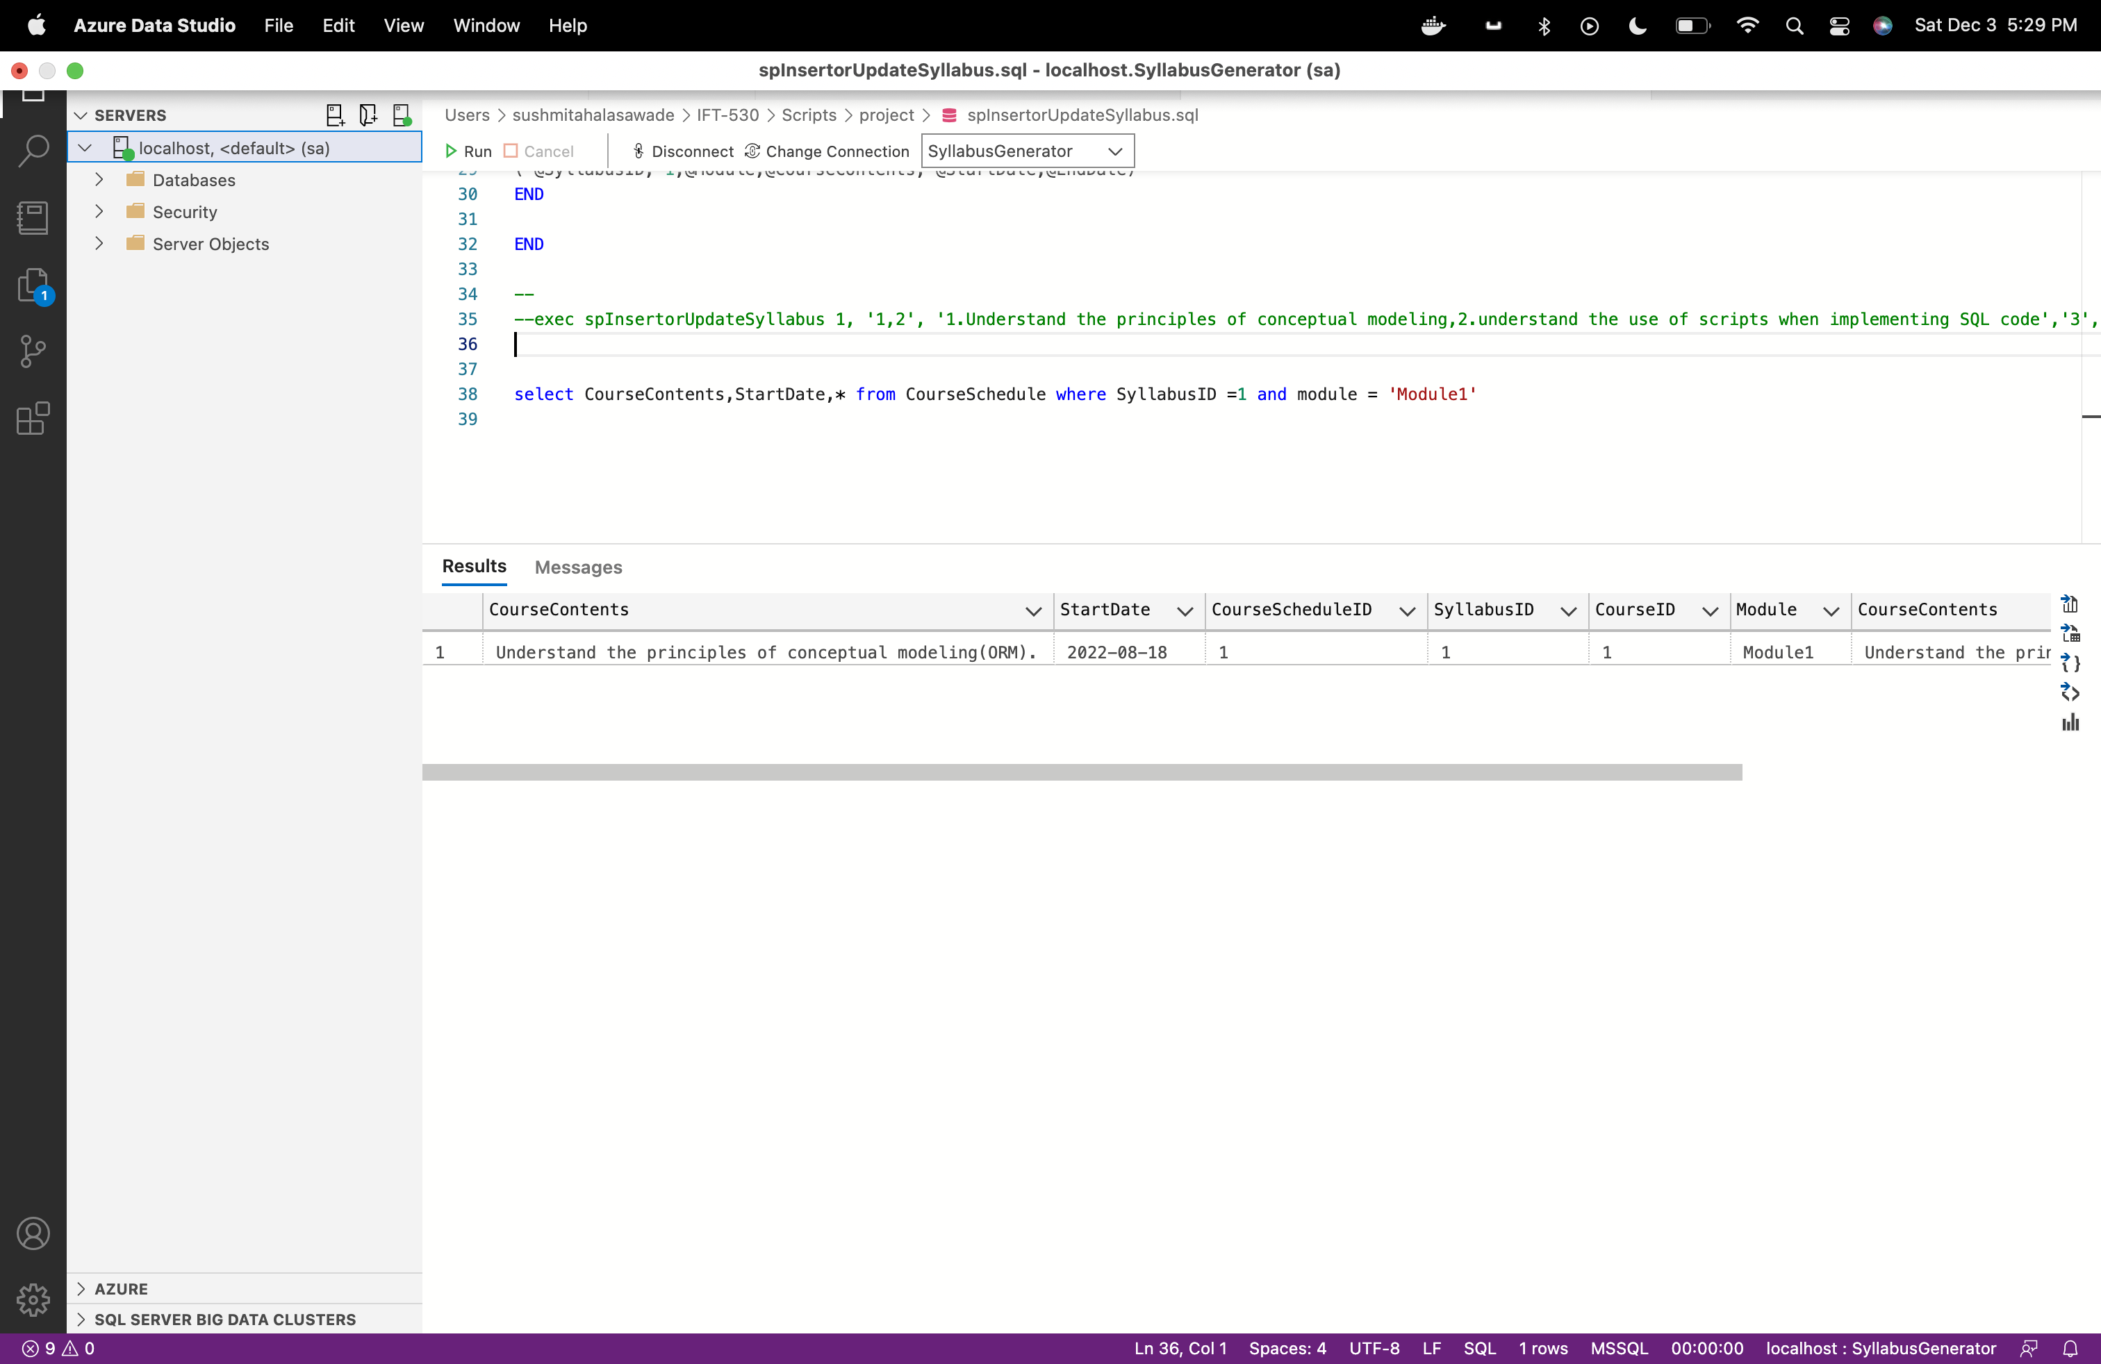

**4. Stored Procedure to delete complete syllabus.**

use SyllabusGenerator

GO

IF EXISTS (SELECT * FROM sys.objects WHERE type = 'P' AND OBJECT_ID = OBJECT_ID('dbo.spDeleteSyllabus'))

drop proc spDeleteSyllabus

GO

Create proc spDeleteSyllabus

@SyllabusID Int

AS

BEGIN

if exists(select * from SyllabusGenerator..CourseSchedule where SyllabusID = @SyllabusID)

begin

delete from SyllabusGenerator..CourseSchedule where SyllabusID = @SyllabusID

end

delete from SyllabusGenerator..Syllabus where SyllabusID = @SyllabusID

END

Test:

--exec spDeleteSyllabus 4

select * from Syllabus where SyllabusID = 4

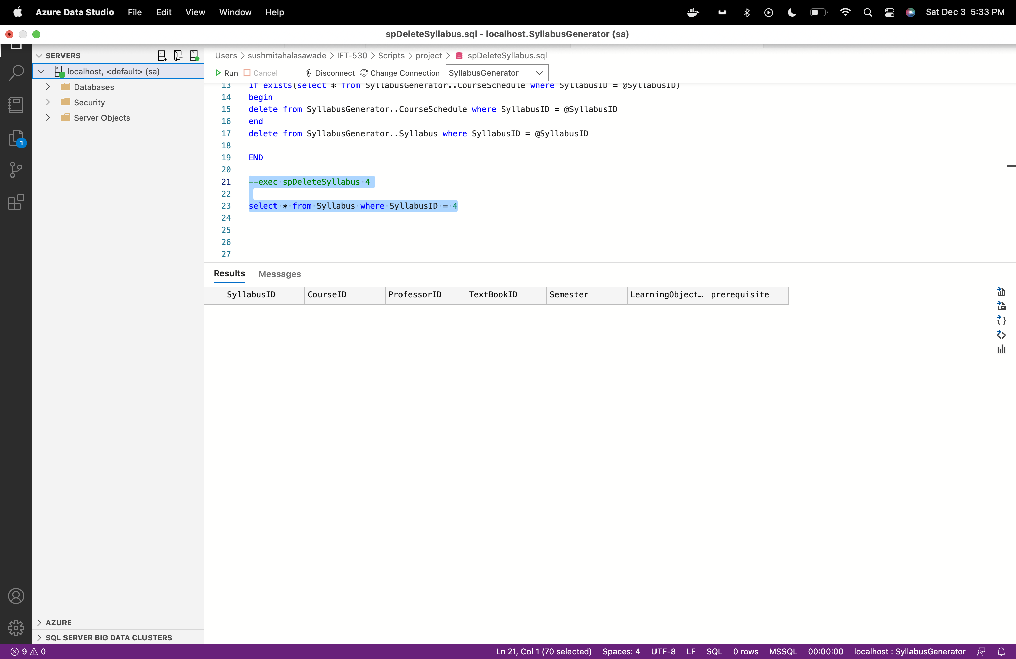

**Functions**

1. **Get textbook requirements of course:**

Query:

USE SyllabusGenerator;

GO

CREATE or ALTER FUNCTION fnGettextbookdetails

(@SyllabusID int

)

RETURNS table

RETURN

(

select TextBookName,TextBookID from TextBook where textbookid in (select * from STRING_SPLIT((select TextBookID from Syllabus where SyllabusID = @SyllabusID), ','))

)

--select * from dbo.fnGettextbookdetails(1)

Output:

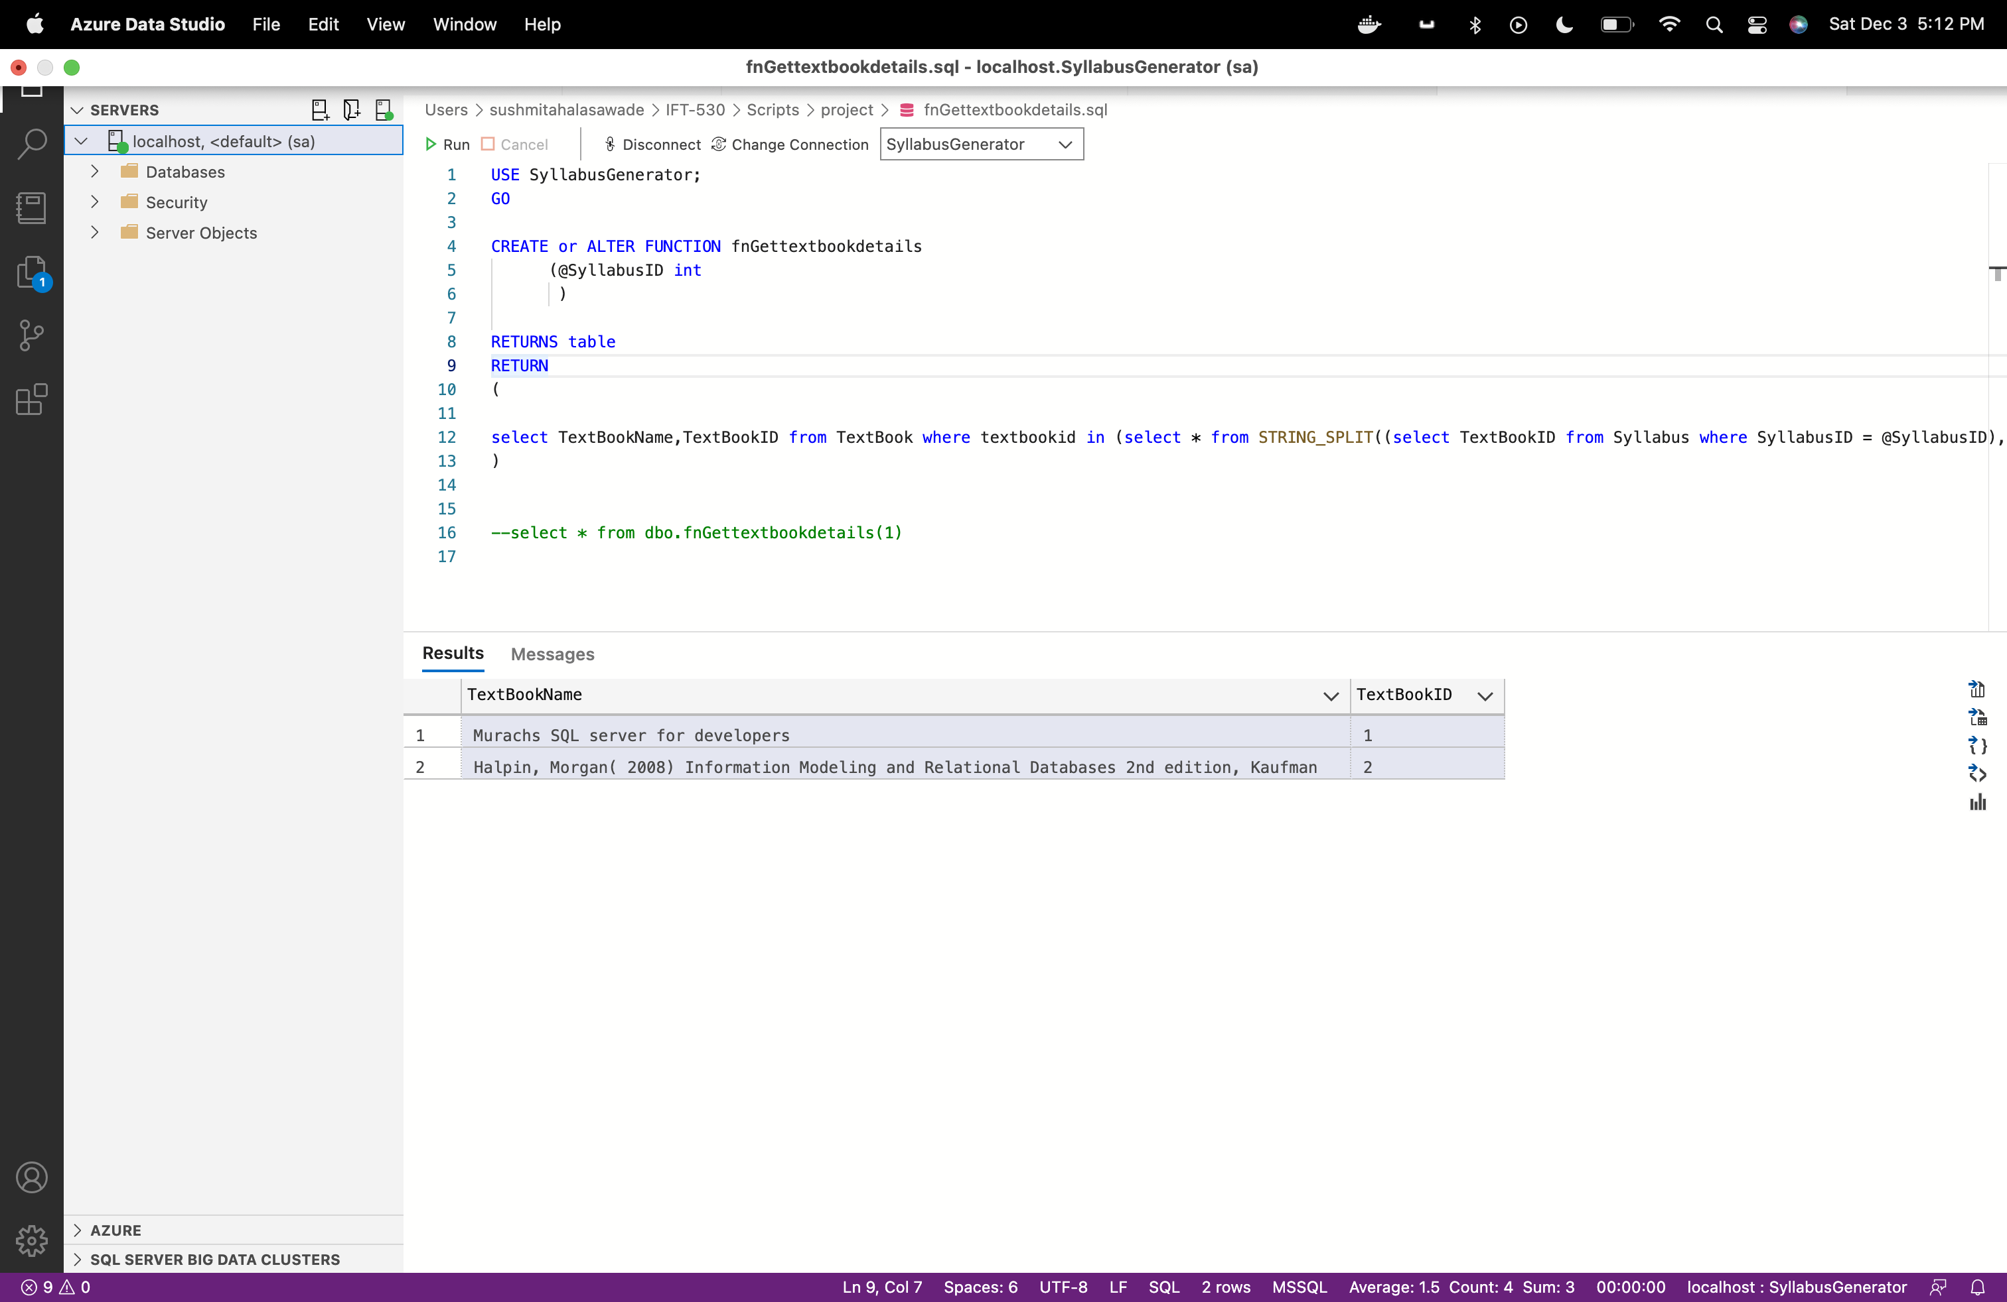

1. **Get prerequisite course list of course:**

Query:

USE SyllabusGenerator;

GO

CREATE or ALTER FUNCTION fnGetPrerequisite

(@SyllabusID int

)

RETURNS table

RETURN

(

select CourseID,CourseCode,CourseName from Course where CourseID in (select * from STRING_SPLIT((select prerequisite from Syllabus where SyllabusID = @SyllabusID), ','))

)

--select * from dbo.fnGetPrerequisite(1)

Output:

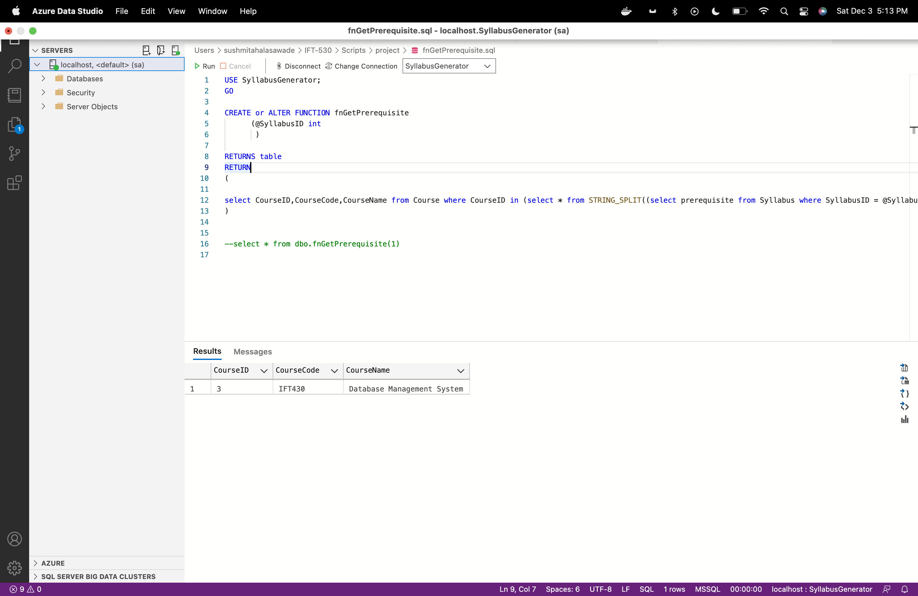

**Trigger :**

When professor deletes already existing Syllabus there should be some place where we can store the deleted syllabus. If professor wants to review the syllabus, he/she deleted they can always refer back to this SyllabusAudit table.

**SQL Trigger Code:**

1. **Delete trigger to audit deleted syllabus.**

USE syllabusGenerator

GO

CREATE or alter TRIGGER trInsteadofDeleteSyllabus

on Syllabus

After DELETE

AS

declare @SyllabusID INT

declare @CourseID int

declare @ProfessorID int

declare @textbookid nvarchar(100)

declare @Semester nvarchar(10)

declare @LearningObjective nvarchar(max)

declare @prerequisite nvarchar(50)

select @SyllabusID= d.SyllabusID from deleted as d;

select @CourseID= d.CourseID from deleted as d;

select @ProfessorID= d.ProfessorID from deleted as d;

select @textbookid= d.TextBookID from deleted as d;

select @Semester= d.Semester from deleted as d;

select @LearningObjective= d.LearningObjective from deleted as d;

select @prerequisite= d.prerequisite from deleted as d;

Insert into SyllabusAudit (SyllabusID, CourseID, ProfessorID,textbookid,Semester,LearningObjective, prerequisite,Audit_action, Action_by, Action_At, Remark)

values(@SyllabusID,@CourseID,@ProfessorID,@textbookid,@Semester,@LearningObjective,@prerequisite,'DELETE',@ProfessorID,GETDATE(),'Deleted Syllabus')

print('Record deleted -Instead of Delete trigger')

Test:

select * from syllabus where syllabusid = 4;

select * from syllabusaudit ;

When we executed delete syllabys stored procedure for Syllabus with id = 4, the audit record is added in the table with after delete trigger.

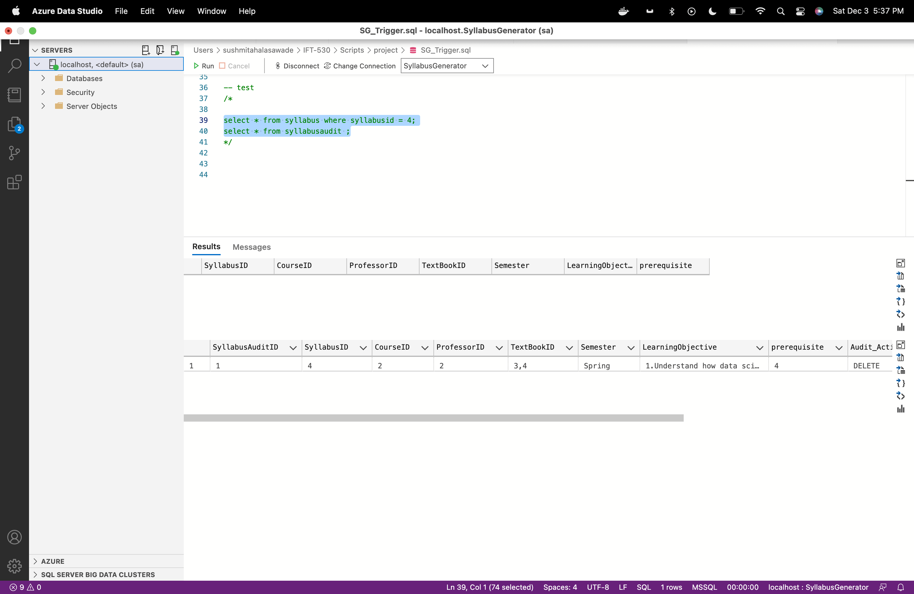

**Update Trigger**

CREATE TRIGGER trAfterUpdateSyllabus

on dbo.Syllabus

For UPDATE

AS

declare @textbookid varchar(100)

declare @LearningObjective varchar(max)

declare @prerequisite varchar(100)

declare @description varchar(50)

declare @SyllabusID int

declare @CourseID int

declare @ProfessorID int

declare @Semester int

select @textbookid= i.textbookid from inserted as i;

select @LearningObjective= i.LearningObjective from inserted as i;

select @prerequisite= i.prerequisite from inserted as i;

select @SyllabusID= i.SyllabusID from inserted as i;

select @CourseID= i.CourseID from inserted as i;

select @ProfessorID= i.ProfessorID from inserted as i;

select @Semester= i.Semester from inserted as i;

IF UPDATE(textbookid)

SET @description = 'Updated textbookid of the syllabus'

IF UPDATE(LearningObjective)

SET @description = 'Updated LearningObjective of the syllabus'

IF UPDATE(prerequisite)

SET @description = 'Updated prerequisite of the syllabus'

Insert into SyllabusAudit (SyllabusID, CourseID, ProfessorID,textbookid,Semester,LearningObjective, prerequisite,Audit_action, Action_by, Action_At, Remark)

values(@SyllabusID,@CourseID,@ProfessorID,@textbookid,@Semester,@LearningObjective,@prerequisite,'UPDATE',@ProfessorID,GETDATE(),@description)

-- test

/*

update syllabus with (rowlock) set textbookid = '1,2' where syllabusid =1;

select * from Syllabus where syllabusid =1;

select top 1 remark, * from SyllabusAudit where syllabusid =1 order by action_at desc;

*/

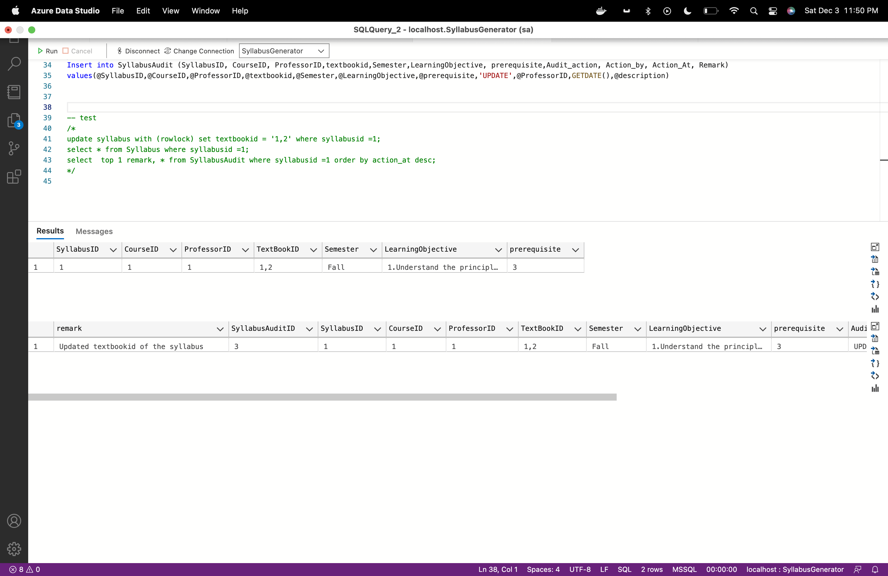

**Section 6**

**Couchbase – NoSQL**

**Section 6.1 ORM**

**Section 6.1** ( **ORM diagram from a NoSQL perspective**)

List which entities of your original ORM diagram you are extending by nesting.

We are extending the entities

* Course and Syllabus – Syllabus as nested document inside course document (represented with red boxes in screenshot below)
* Department, ProgramChair and Professor – Program chair as document inside department document((represented with green boxes in screenshot below)
* Course Schedule(represented in blue)

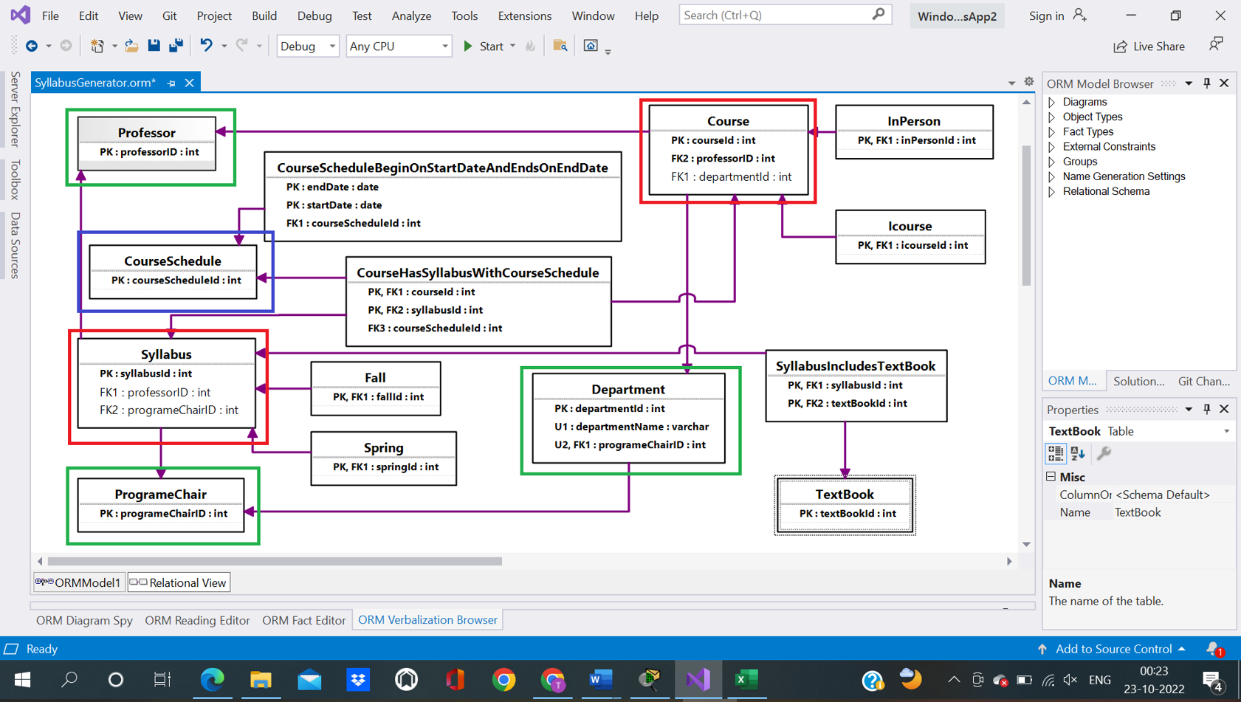

**Section 6.2 Buckets Creation**

We have created the buckets

1) Department

2) Course

3) Course Schedule

Department Bucket : SyllabusGenerator_Department

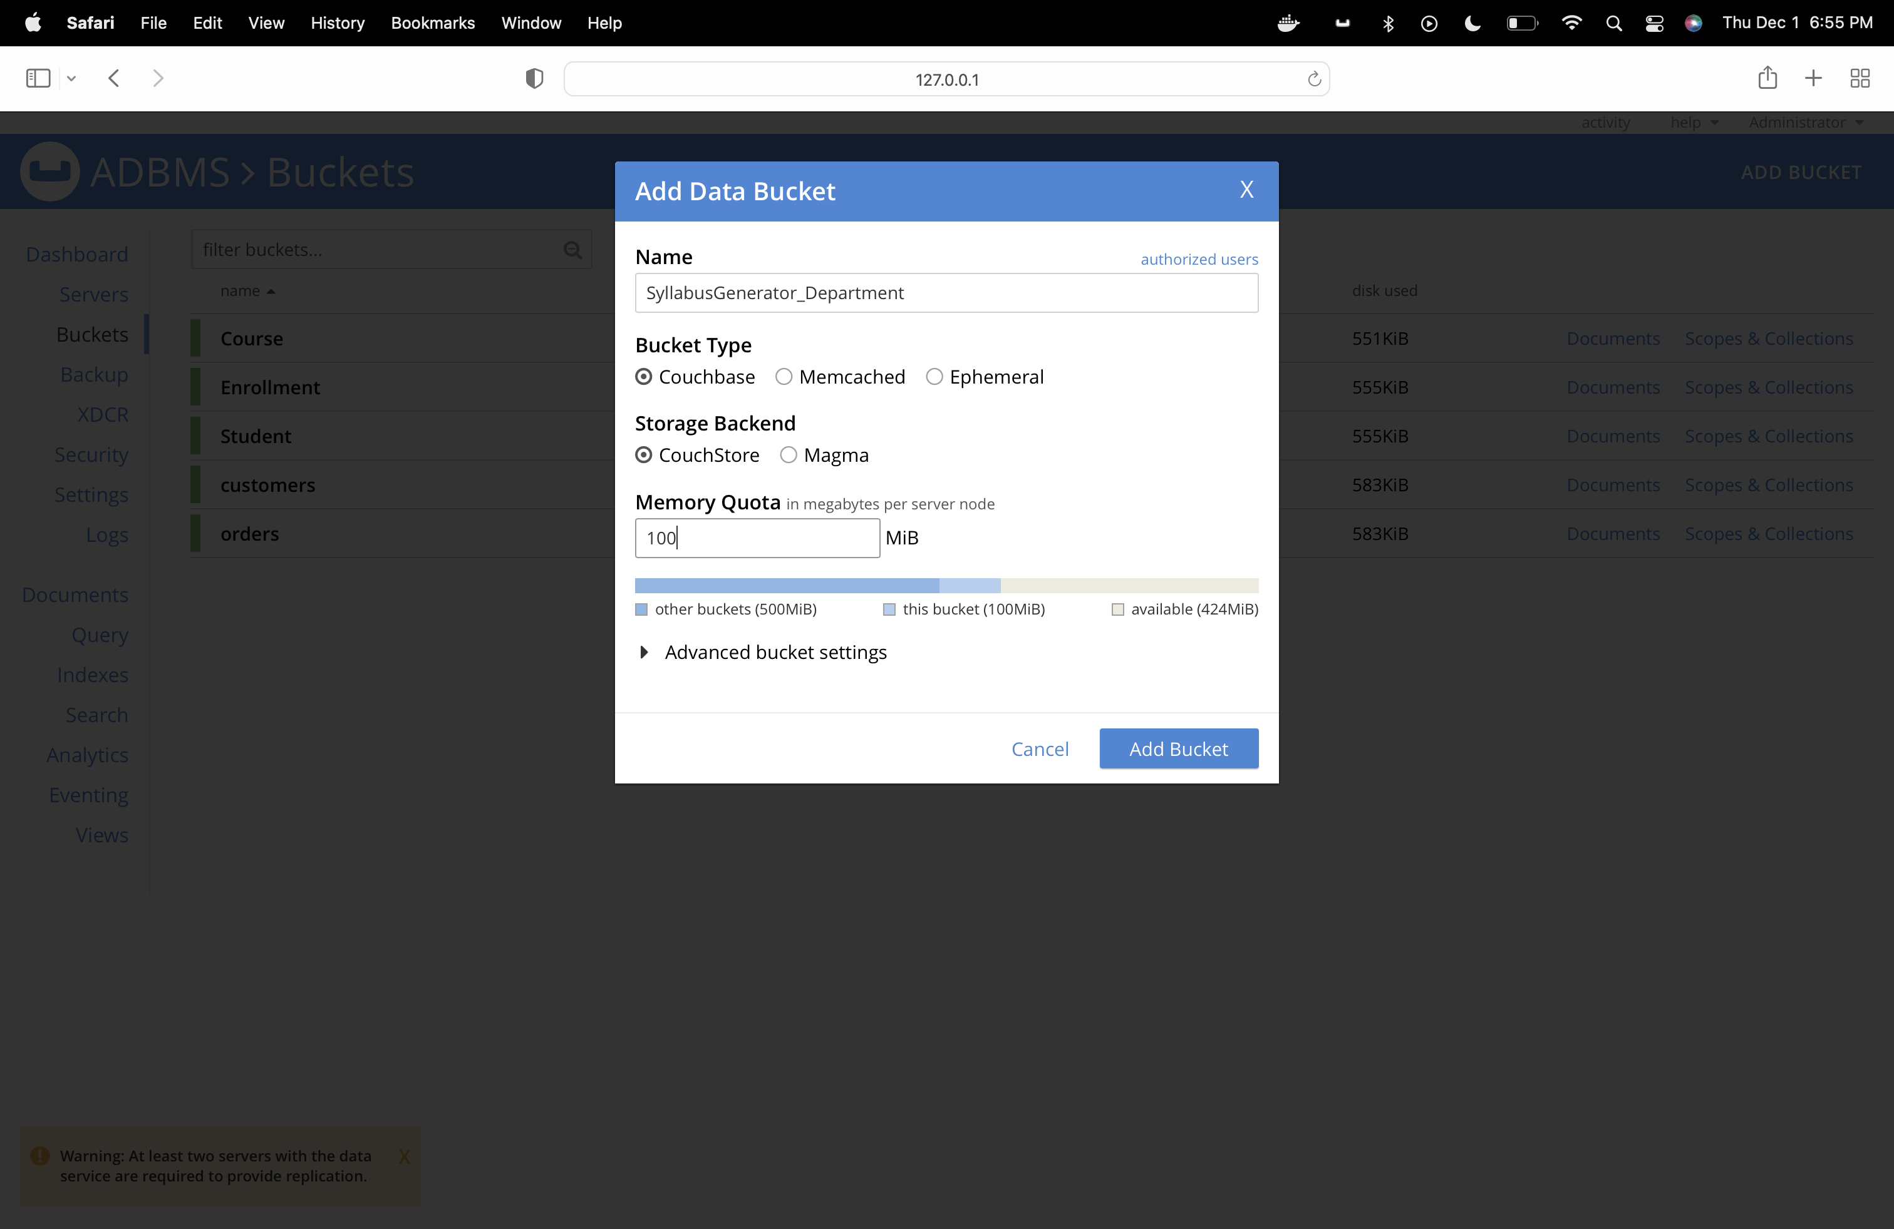

Course Bucket : SyllabusGenerator_Course

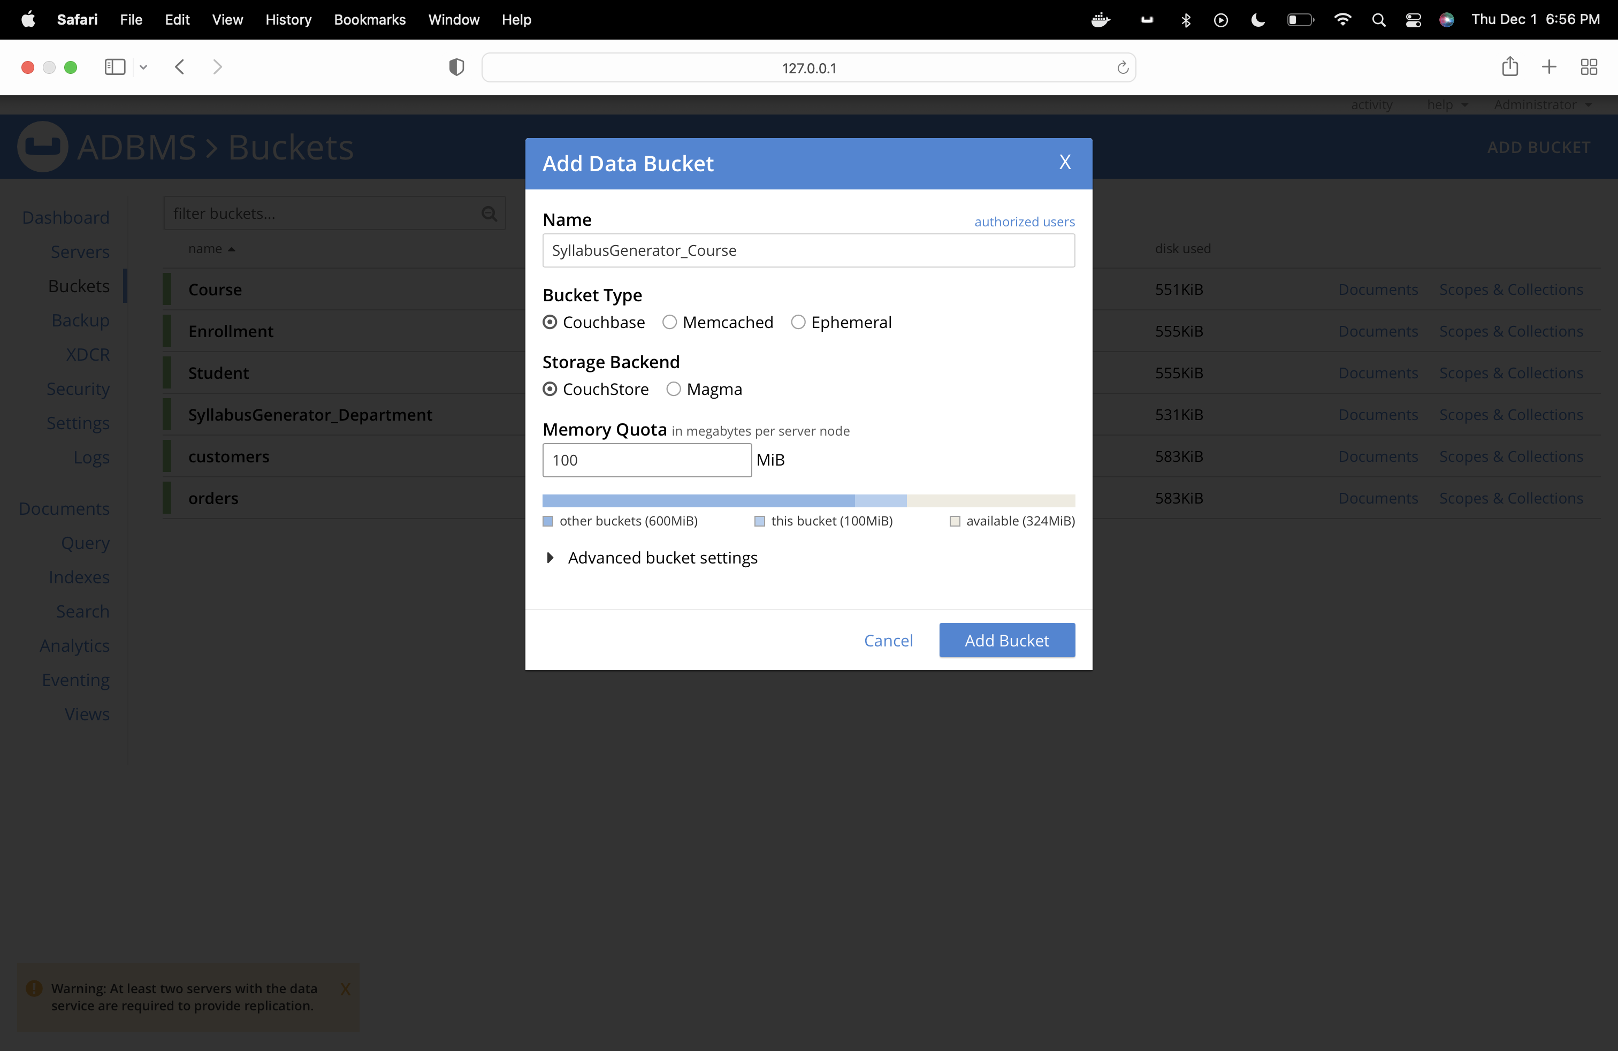

Course Schedule Bucket: SyllabusGenerator_CourseSchedule

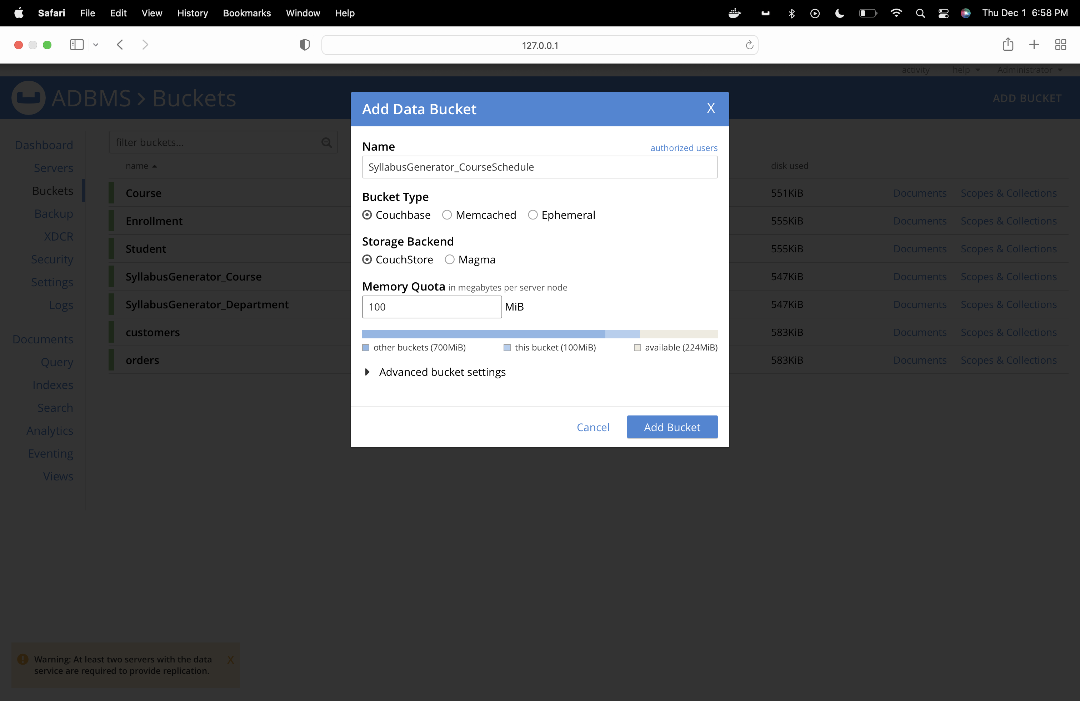

Adding Data

**Department Bucket**

Json:

insert into SyllabusGenerator_Department (key, value)

values ("1",

{ "DepartmentID": "1",

"DepartmentName": "Information Technology",

"DepartmentCode": "IFT",

"ProgramChair":

{ "ProgramChairID": "1",

"Name": "Tatiana Walsh",

"EmailID": "TatianaWalsh@asu.edu",

"ContactNumber": "6021111111"

},

"Professor":[

{ "ProfessorID": "1",

"Name": "Robert Rucker",

"EmailID": "RobertRucker@asu.edu",

"ContactNumber": "6022221111"

},

{ "ProfessorID": "2",

"Name": "Asmaa Elbadrawy",

"EmailID": "AsmaaElbadrawy@asu.edu",

"ContactNumber": "6023331111"

},

{ "ProfessorID": "3",

"Name": "Dinesh Sthapit",

"EmailID": "DineshSthapit@asu.edu",

"ContactNumber": "6024441111"

}

]

}

), ("2",

{ "DepartmentID": "2",

"DepartmentName": "Computer Science",

"DepartmentCode": "CS",

"ProgramChair":

{ "ProgramChairID": "4",

"Name": "Dont Know",

"EmailID": "DontKnow@asu.edu",

"ContactNumber": "6021112222"

},

"Professor":[

{ "ProfessorID": "5",

"Name": "Chris Bryan",

"EmailID": "ChrisBryan@asu.edu",

"ContactNumber": "6022222222"

},

{ "ProfessorID": "6",

"Name": "Hasan Davulcu",

"EmailID": "HasanDavulcu@asu.edu",

"ContactNumber": "6023332222"

},

{ "ProfessorID": "7",

"Name": "Samira Ghayekhloo",

"EmailID": "SamiraGhayekhloo@asu.edu",

"ContactNumber": "6024442222"

}

]

}

);

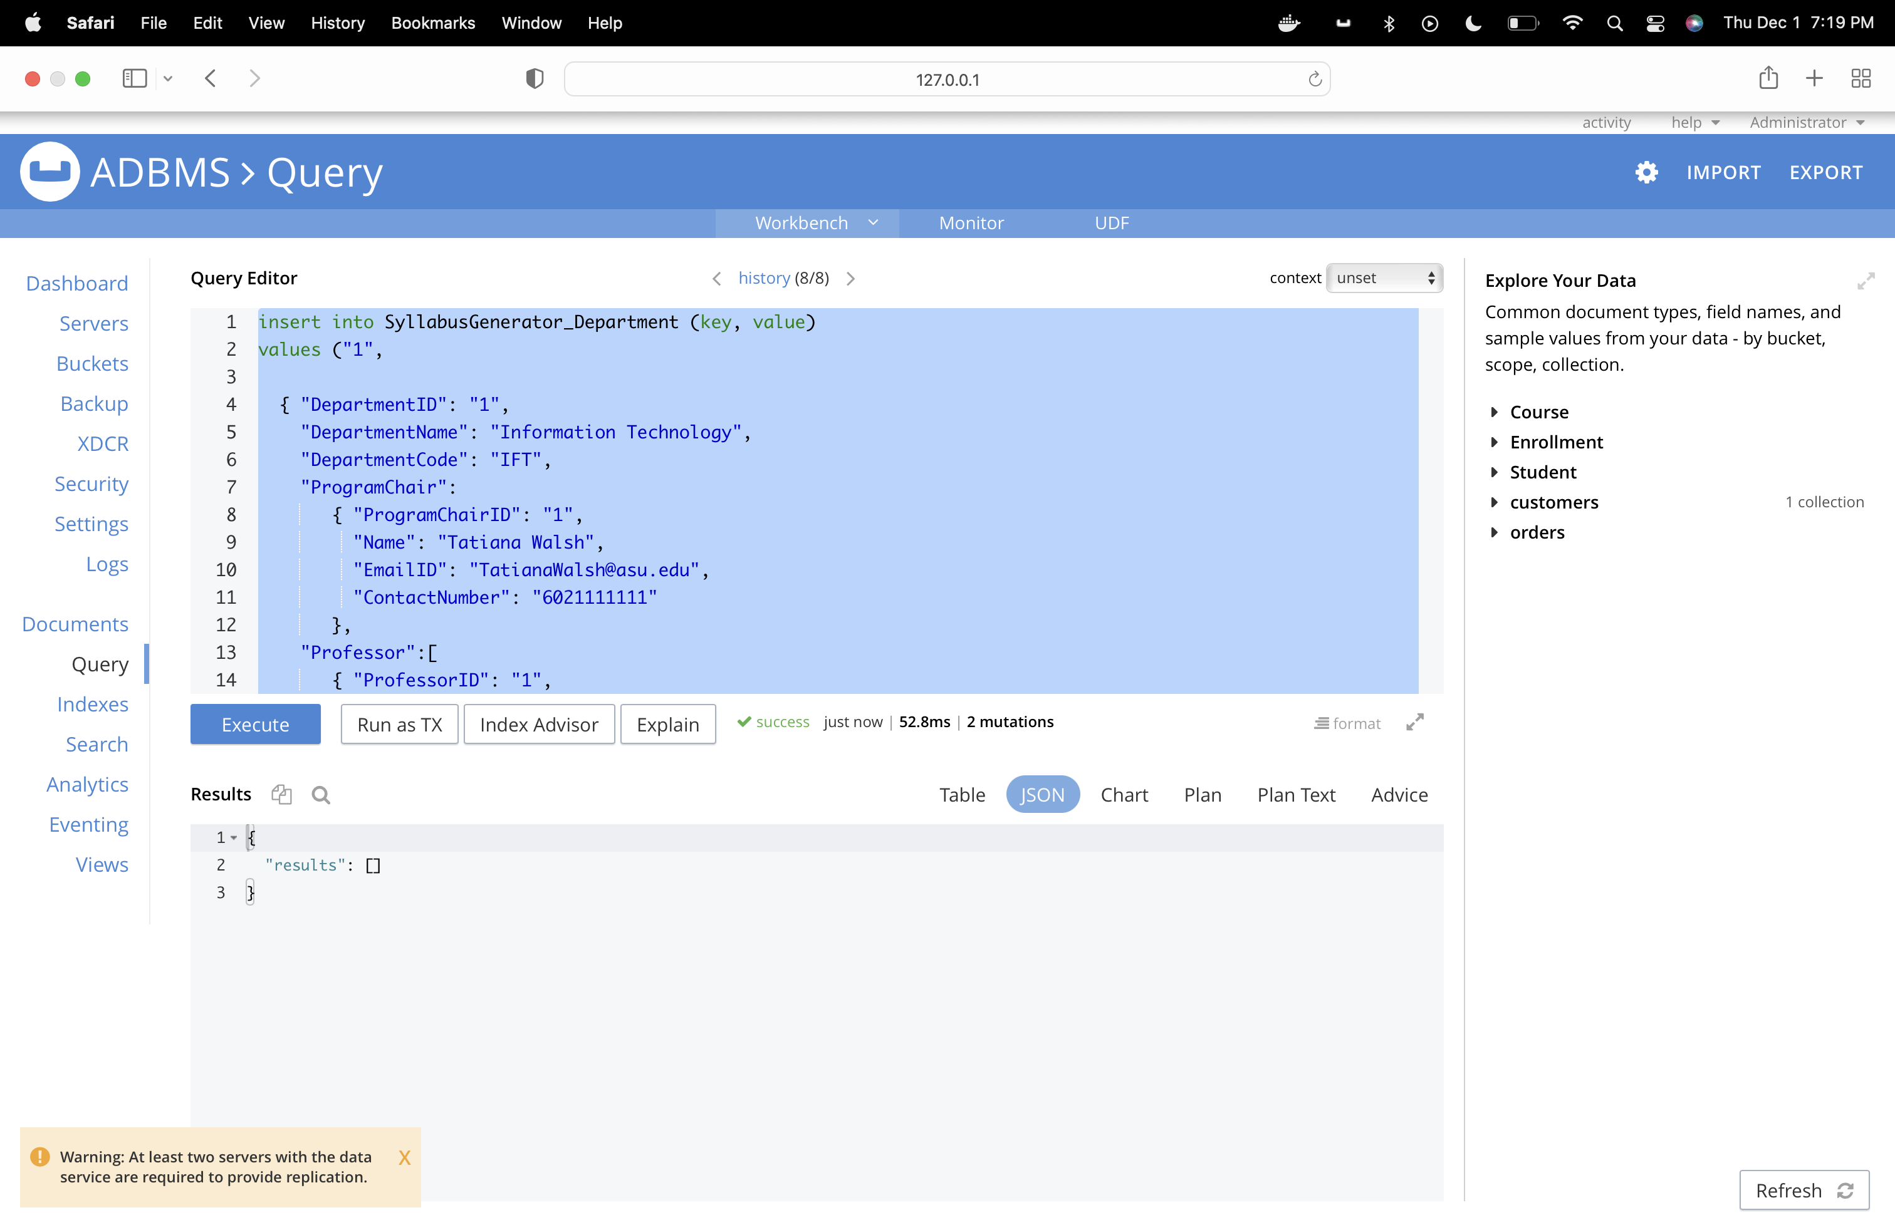

**Course Bucket :**

**Adding course documents:**

Json:

insert into SyllabusGenerator_Course (key, value)

values ("1",

{ "CourseID": "1",

"DepartmentID": "1",

"CourseName": "Advanced Database Management Systems",

"CourseCode": "IFT530",

"CourseType": "In-Person",

"ProfessorID": "2",

"Syllabus":[

{ "SyllabusID": "1",

"Semester": "Fall",

"TextbookID": "1,2",

"LearningObjective": "1.Understand the principles of conceptual modeling,2.understand the use of scripts when implementing SQL code",

"Prerequisite": "3"

},

{ "SyllabusID": "2",

"Semester": "Spring",

"TextbookID": "1,2",

"LearningObjective": "1.Understand the principles of conceptual modeling,2.understand the use of scripts when implementing SQL code",

"Prerequisite": "3"

}

]

}

), ("2",

{

"CourseID": "2",

"DepartmentID": "1",

"CourseName": "Analyzing Big Data",

"CourseCode": "IFT511",

"CourseType": "In-Person",

"ProfessorID": "3",

"Syllabus":[

{ "SyllabusID": "1",

"Semester": "Fall",

"TextbookID": "3,4",

"LearningObjective": "1.Understand how data science can be used as tools to analyze large amounts of data for the purpose of extracting business value.",

"Prerequisite": "4"

},

{ "SyllabusID": "2",

"Semester": "Spring",

"TextbookID": "3,4",

"LearningObjective": "1.Understand how data science can be used as tools to analyze large amounts of data for the purpose of extracting business value.",

"Prerequisite": "4"

}

]

}

),

("3",

{

"CourseID": "3",

"DepartmentID": "1",

"CourseName": "Database Management System",

"CourseCode": "IFT430",

"CourseType": "In-Person",

"ProfessorID": "2",

"Syllabus":""

}

),

("4",

{

"CourseID": "4",

"DepartmentID": "1",

"CourseName": "Fundamentals of Python",

"CourseCode": "IFT411",

"CourseType": "In-Person",

"ProfessorID": "3",

"Syllabus":""

}

);

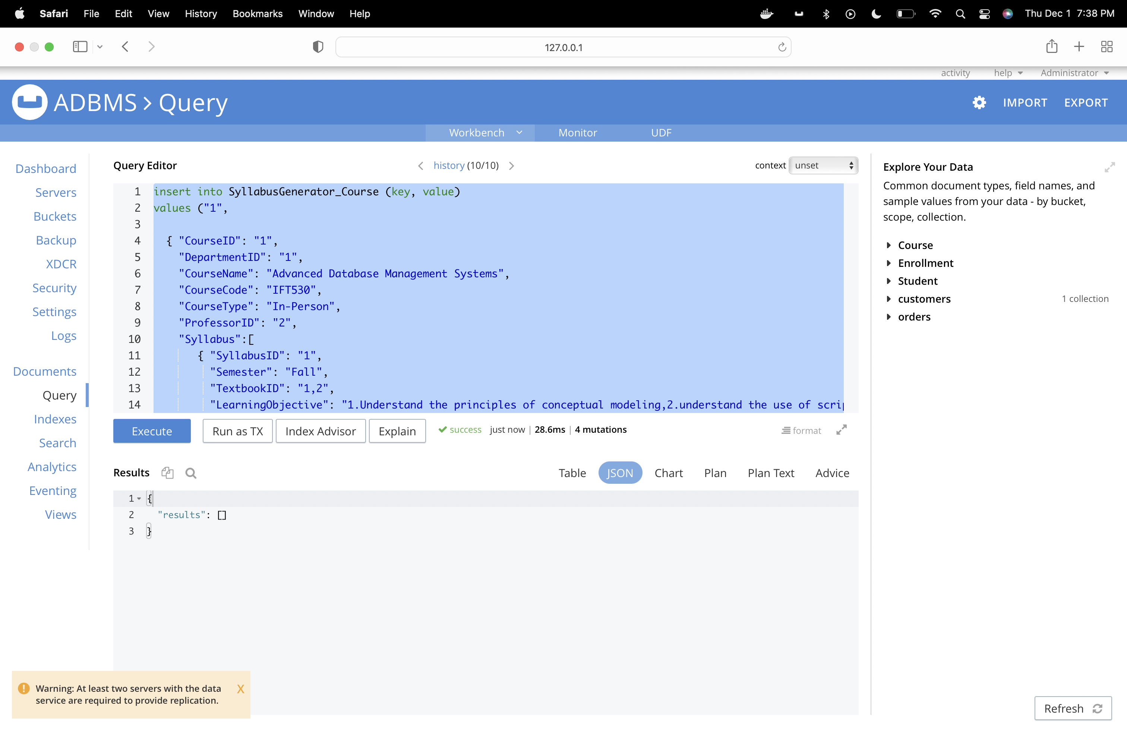

**Adding Course Schedule Documents**

JSON:

insert into SyllabusGenerator_CourseSchedule (key, value)

values ("1",

{ "CourseScheduleID": "1",

"SyllabusID": "1",

"CourseID": "1",

"Module":[

{ "ModuleName": "Module1",

"CourseContent": "Understand the principles of conceptual modeling (ORM as an examplar).",

"StartDate": "15 Aug 2022",

"EndDate": "30 Aug 2022"

},

{ "ModuleName": "Module2",

"CourseContent": "Basis of Primary keys, Uniqueness/ Mandatory constraints",

"StartDate": "1 Sept 2022",

"EndDate": "15 Sept 2022"

},

{ "ModuleName": "Module3",

"CourseContent": "basis for determining Foreign Keys, value and frequency constraints, dynamic SQL",

"StartDate": "16 Sept 2022",

"EndDate": "16 Oct 2022"

},

{ "ModuleName": "Module4",

"CourseContent": "Window functions, SQL++",

"StartDate": "17 Oct 2022",

"EndDate": "10 Nov 2022"

},

{ "ModuleName": "Module5",

"CourseContent": "Couchbase, Capella-DBaas",

"StartDate": "11 Nov 2022",

"EndDate": "30 Nov 2022"

}

]

}

), ("2",

{

"CourseScheduleID": "2",

"SyllabusID": "2",

"CourseID": "1",

"Module":[

{ "ModuleName": "Module1",

"CourseContent": "Understand the principles of conceptual modeling (ORM as an examplar).",

"StartDate": "15 Jan 2022",

"EndDate": "30 Jan 2022"

},

{ "ModuleName": "Module2",

"CourseContent": "Basis of Primary keys, Uniqueness/ Mandatory constraints",

"StartDate": "1 Feb 2022",

"EndDate": "15 Feb 2022"

},

{ "ModuleName": "Module3",

"CourseContent": "basis for determining Foreign Keys, value and frequency constraints, dynamic SQL",

"StartDate": "16 Feb 2022",

"EndDate": "16 Mar 2022"

},

{ "ModuleName": "Module4",

"CourseContent": "Window functions, SQL++",

"StartDate": "17 Mar 2022",

"EndDate": "10 Apr 2022"

},

{ "ModuleName": "Module5",

"CourseContent": "Couchbase, Capella-DBaas",

"StartDate": "11 Apr 2022",

"EndDate": "30 Apr 2022"

}

]

}

);

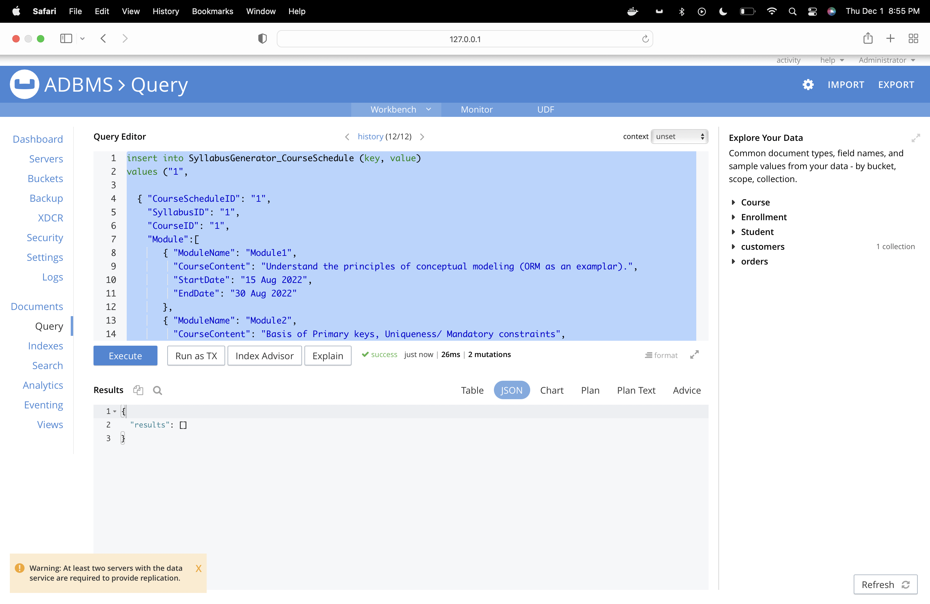

Creating dataset on SyllabusGenerator_Department

Query:

Create dataset on SyllabusGenerator_Department

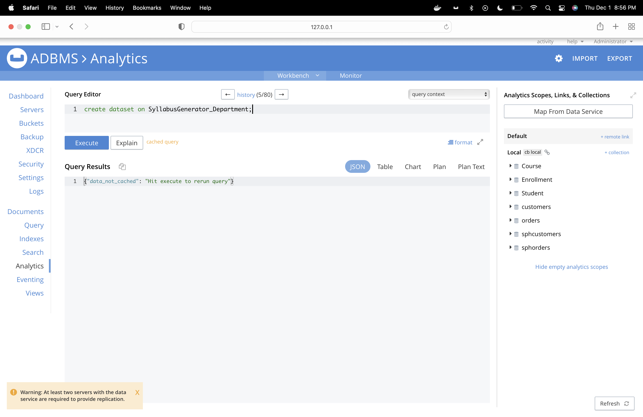

Creating dataset on SyllabusGenerator_Course

Query:

create dataset on SyllabusGenerator_Course

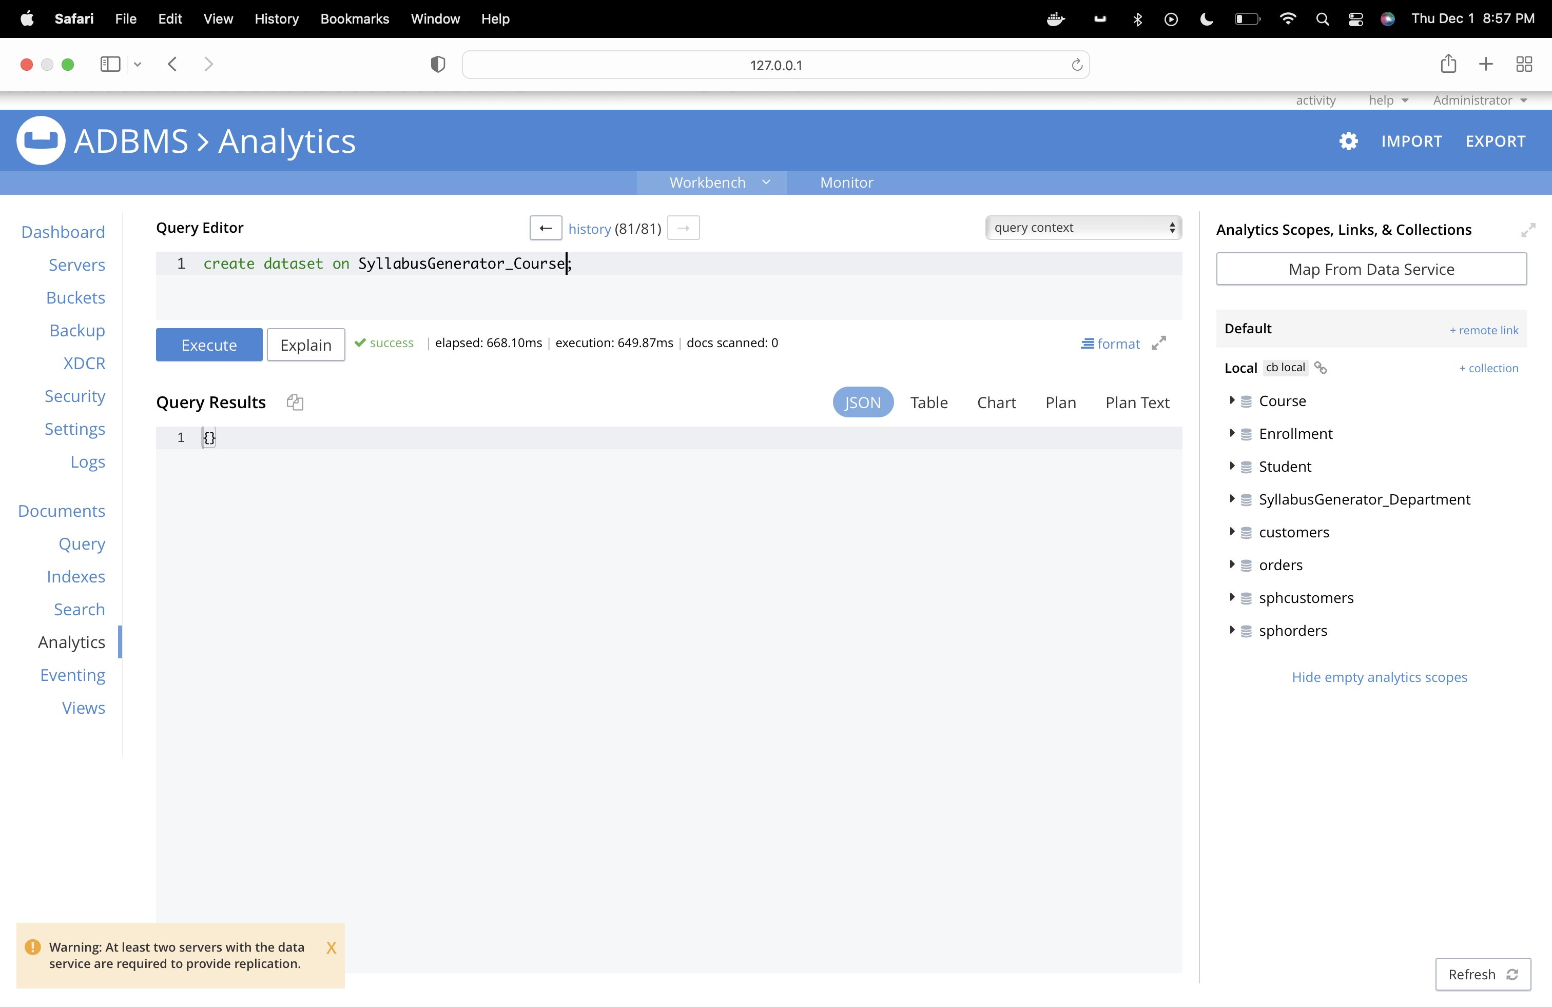

Creating dataset on:

Query

create dataset on SyllabusGenerator_CourseSchedule;

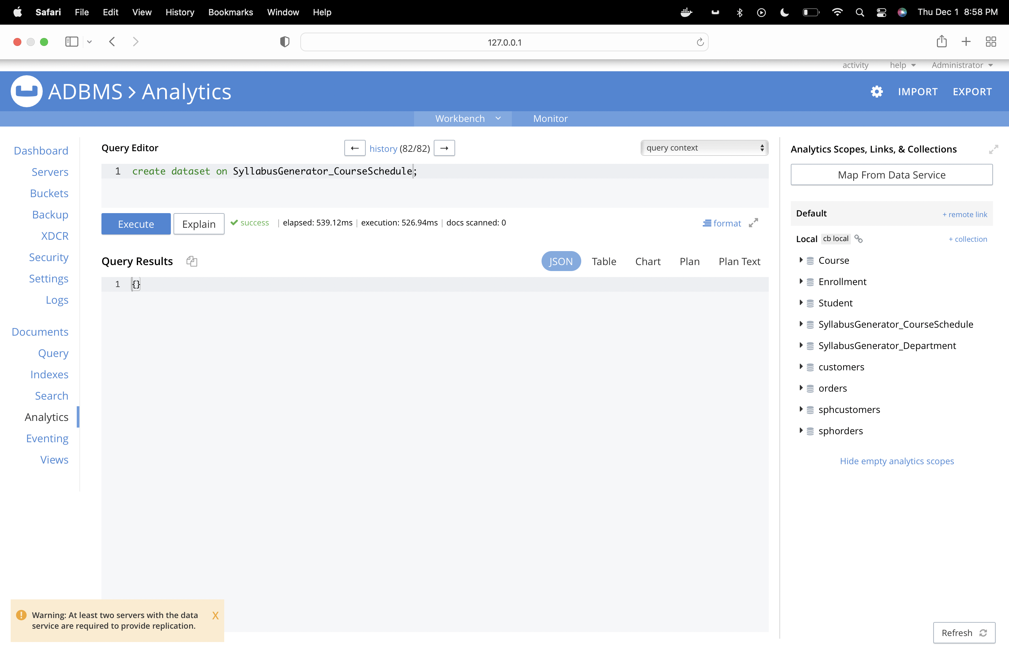

**Section 6.3**

Screenshots of JSON Documents from CouchBase

**Course Bucket**

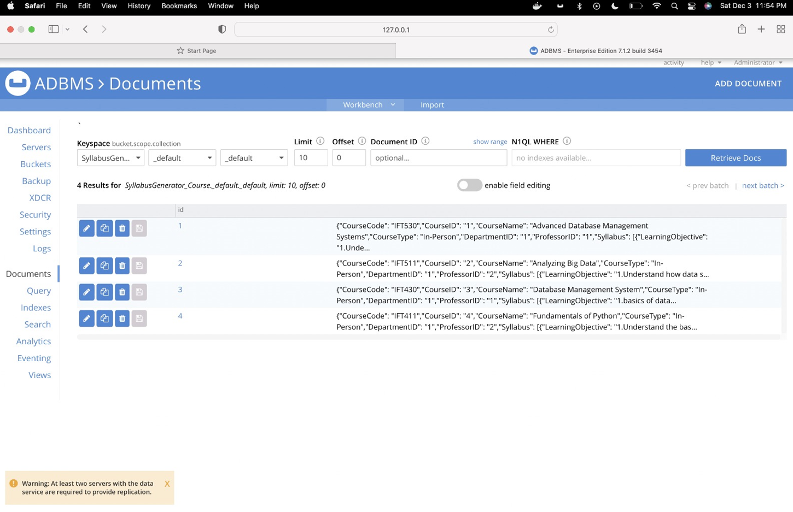

**Department Bucket**

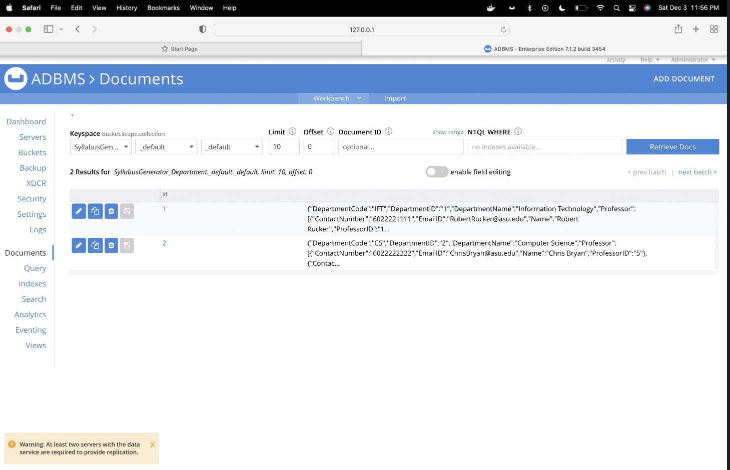

**Course Schedule Bucket**

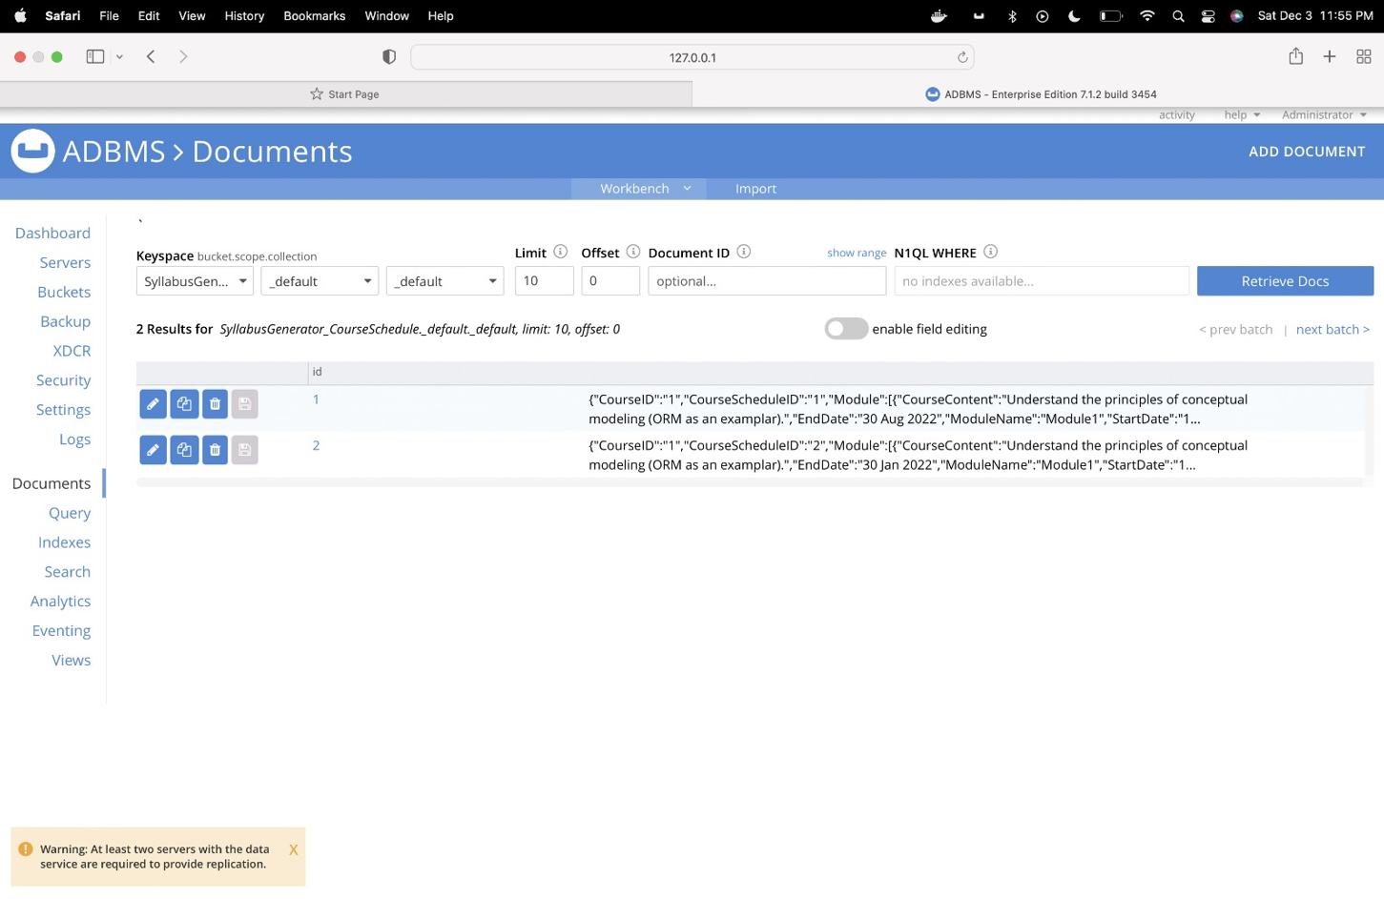

**Section 6.4**

**Query to get all fall courses detailed Syllabus**

Query 1:

FROM SyllabusGenerator_Course AS o, o.Syllabus AS i, SyllabusGenerator_CourseSchedule AS cs

where i.Semester = 'Fall' and cs.SyllabusID = i.SyllabusID

SELECT o.CourseName,o.CourseCode,i.Semester,i.LearningObjective,cs.Module

Output:

[

{

"CourseName": "Advanced Database Management Systems",

"CourseCode": "IFT530",

"Semester": "Fall",

"LearningObjective": "1.Understand the principles of conceptual modeling,2.understand the use of scripts when implementing SQL code",

"Module": [

{

"CourseContent": "Understand the principles of conceptual modeling (ORM as an examplar).",

"EndDate": "30 Aug 2022",

"ModuleName": "Module1",

"StartDate": "15 Aug 2022"

},

{

"CourseContent": "Basis of Primary keys, Uniqueness/ Mandatory constraints",

"EndDate": "15 Sept 2022",

"ModuleName": "Module2",

"StartDate": "1 Sept 2022"

},

{

"CourseContent": "basis for determining Foreign Keys, value and frequency constraints, dynamic SQL",

"EndDate": "16 Oct 2022",

"ModuleName": "Module3",

"StartDate": "16 Sept 2022"

},

{

"CourseContent": "Window functions, SQL++",

"EndDate": "10 Nov 2022",

"ModuleName": "Module4",

"StartDate": "17 Oct 2022"

},

{

"CourseContent": "Couchbase, Capella-DBaas",

"EndDate": "30 Nov 2022",

"ModuleName": "Module5",

"StartDate": "11 Nov 2022"

}

]

},

{

"CourseName": "Analyzing Big Data",

"CourseCode": "IFT511",

"Semester": "Fall",

"LearningObjective": "1.Understand how data science can be used as tools to analyze large amounts of data for the purpose of extracting business value.",

"Module": [

{

"CourseContent": "Understand the principles of conceptual modeling (ORM as an examplar).",

"EndDate": "30 Aug 2022",

"ModuleName": "Module1",

"StartDate": "15 Aug 2022"

},

{

"CourseContent": "Basis of Primary keys, Uniqueness/ Mandatory constraints",

"EndDate": "15 Sept 2022",

"ModuleName": "Module2",

"StartDate": "1 Sept 2022"

},

{

"CourseContent": "basis for determining Foreign Keys, value and frequency constraints, dynamic SQL",

"EndDate": "16 Oct 2022",

"ModuleName": "Module3",

"StartDate": "16 Sept 2022"

},

{

"CourseContent": "Window functions, SQL++",

"EndDate": "10 Nov 2022",

"ModuleName": "Module4",

"StartDate": "17 Oct 2022"

},

{

"CourseContent": "Couchbase, Capella-DBaas",

"EndDate": "30 Nov 2022",

"ModuleName": "Module5",

"StartDate": "11 Nov 2022"

}

]

}

]

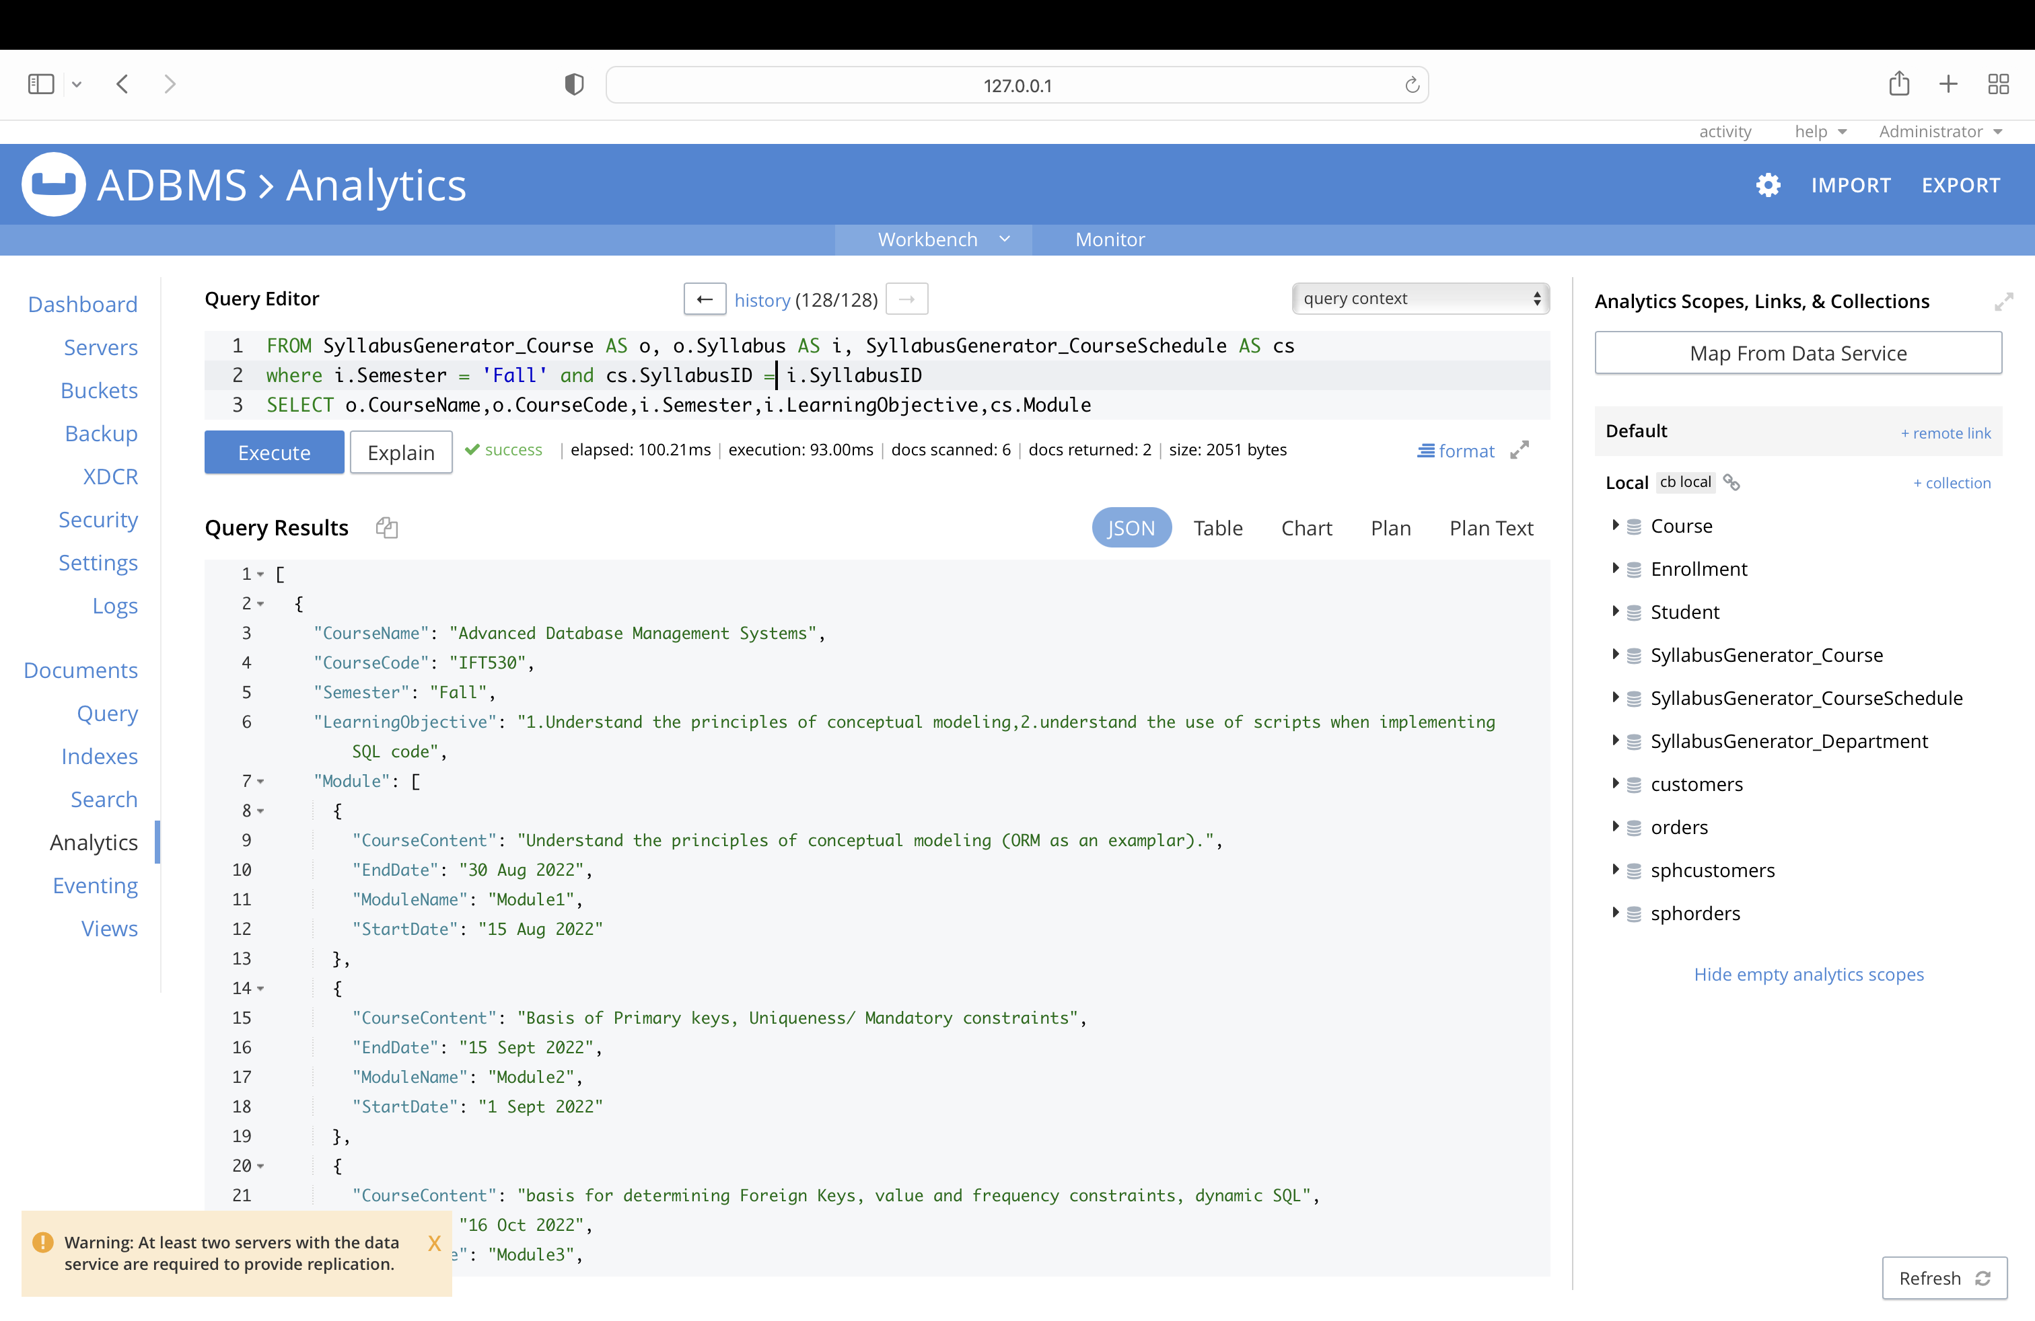

**Query 2**

Get list of courses with their professor: (using nested documents for join)

**Query:**

FROM SyllabusGenerator_Department as d, d.Professor as p join SyllabusGenerator_Course as c on p.ProfessorID = c.ProfessorID

select p.Name, c.CourseName, c.CourseCode, d.DepartmentName

**output:**

[

{

"Name": "Robert Rucker",

"CourseName": "Advanced Database Management Systems",

"CourseCode": "IFT530",

"DepartmentName": "Information Technology"

},

{

"Name": "Robert Rucker",

"CourseName": "Database Management System",

"CourseCode": "IFT430",

"DepartmentName": "Information Technology"

},

{

"Name": "Asmaa Elbadrawy",

"CourseName": "Analyzing Big Data",

"CourseCode": "IFT511",

"DepartmentName": "Information Technology"

},

{

"Name": "Asmaa Elbadrawy",

"CourseName": "Fundamentals of Python",

"CourseCode": "IFT411",

"DepartmentName": "Information Technology"

}

]

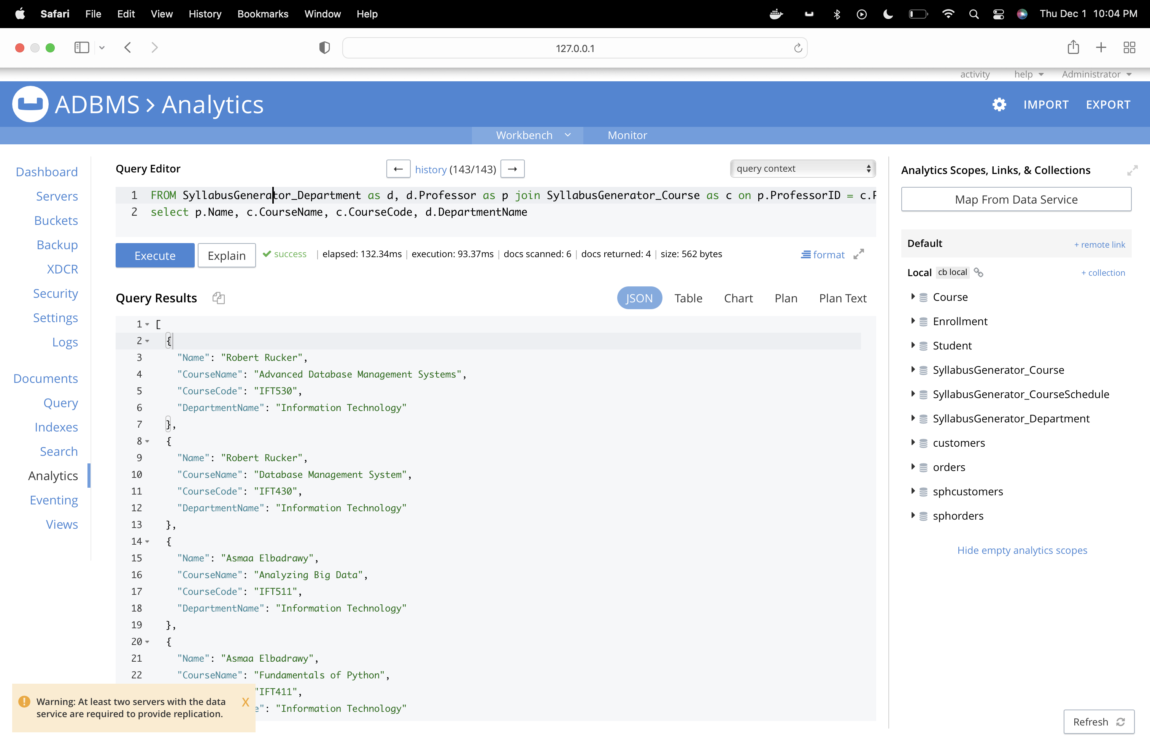

**Section – 7**

**Summary**

* Collected dataset to clearly define the entities in the University.
* We created the SQL tables, stored procedures, and triggers for the Syllabus generator. Professors can easily retrieve all the information regarding Syllabus pertaining to icourse or the in-person course, Fall semester course, Summer Semester course etc.,
* Identified relationship between the entities and included primary and foreign keys.
* Included the Object Role Modeling Diagram. Added the fall semester and spring semester as subtypes under the entity syllabus.
* Added the subtypes icourse and in-person course as subtypes under course.
* Included constrains and verified the verbalization for each entity. Generated relational view for the diagram.
* Added the delete trigger that will log the deleted action in the audit table so whenever professor deletes the syllabus, the deleted syllabus log is updated in the trigger. This way we can keep track of the deleted data.
* We have added triggers – update trigger and delete trigger
* Added Stored Procedure
* Added user defined functions
* One the Program Chair approves the syllabus designed by the professor the syllabus will be finalized and published.

**Conclusion**

In conclusion, a database is an efficient mechanism to store and organize the data. It allows for a centralized facility that can be modified and quickly shared among the multiple users. Syllabus Generator will help in quickly generating the syllabus for the professors and it can be implemented university wide to reduce the effort required to modify the syllabus.

It is one stop solution to the tedious task of maintaining syllabus. It is the convenient for both the professor and the program chair to look at this repository for any concerns regarding the program syllabus.

**References –**

[1]Object-Role Modeling Fundamentals A Practical Guide to Data Modeling with ORM (Terry Halpin)

[2]Murach’s SQL Server 2016 for Developers (Joel Murach) (z-lib.org)

[3]https://victormorgante.medium.com/why-learn-object-role-modeling-part-ii-8f29726c253c